UNITED STATES
SECURITIES AND EXCHANGE COMMISSION
Washington, D.C. 20549
_________________________________________________________
Form 8-K
_________________________________________________________
CURRENT REPORT
Pursuant to Section 13 or 15(d)
of the Securities Exchange Act of 1934
Date of Report (Date of earliest event reported): August 14, 2026

_________________________________________________________
Science Applications International Corporation
(Exact name of registrant as specified in its charter)
_________________________________________________________
Delaware |  |  |  |  |  | 001-35832 |  |  |  |  |  | 46-1932921
(State or other Jurisdiction  of Incorporation) |  |  |  |  |  | (Commission  File Number) |  |  |  |  |  | (IRS Employer  Identification No.)
12010 Sunset Hills Road, Reston, VA 20190
(Address of Principal Executive Offices) (Zip Code)
(703) 676-4300
Registrant’s telephone number, including area code
Not Applicable
(Former name or former address if changed since last report.)
Check the appropriate box below if the Form 8-K filing is intended to simultaneously satisfy the filing obligation of the registrant under any of the following provisions:
☐ |  |  | Written communications pursuant to Rule 425 under the Securities Act (17 CFR 230.425)
☐ |  |  | Soliciting material pursuant to Rule 14a-12 under the Exchange Act (17 CFR 240.14a-12)
☐ |  |  | Pre-commencement communications pursuant to Rule 14d-2(b) under the Exchange Act (17 CFR 240.14d-2(b))
☐ |  |  | Pre-commencement communications pursuant to Rule 13e-4(c) under the Exchange Act (17 CFR 240.13e-4(c))
Securities registered pursuant to Section 12(b) of the Act:
Title of each class |  |  | Trading Symbol(s) |  |  | Name of each exchange on which registered
Common Stock, par value $.0001 per share |  |  | SAIC |  |  | The Nasdaq Stock Market LLC
Indicate by check mark whether the registrant is an emerging growth company as defined in Rule 405 of the Securities Act of 1933 (§230.405 of this chapter) or Rule 12b-2 of the Securities Exchange Act of 1934 (§240.12b-2 of this chapter).
Emerging growth company ☐
If an emerging growth company, indicate by check mark if the registrant has elected not to use the extended transition period for complying with any new or revised financial accounting standards provided pursuant to Section 13(a) of the Exchange Act. ☐

Item 1.01. Entry into a Material Definitive Agreement
On August 14, 2026, Science Applications International Corporation (the "Company") entered into Amendment No.6 (the "Amendment") to the Master Accounts Receivable Purchase Agreement (the "Existing Purchase Agreement"), among the Company, as a seller and seller representative, and MUFG Bank, Ltd., as purchaser (the "Purchaser").
The current Amendment allows for the sale of up to $400 million of certain designated eligible receivables with the U.S. government, an increase from the previous facility limit of $300 million. The remaining material terms in the Existing Purchase Agreement are unchanged.
The foregoing description of the Amendment does not purport to be complete and is qualified in its entirety by reference to the Amendment, a copy of which is filed as Exhibit 10.1 hereto and incorporated by reference in this Current Report on Form 8-K.
Item 2.03. Creation of a Direct Financial Obligation or an Obligation under an Off-Balance Sheet Arrangement of a Registrant
The information included in Item 1.01 of this Current Report on Form 8-K is also incorporated by reference into this Item 2.03 of this Current Report on Form 8-K.
Item 9.01. Financial Statements and Exhibits
(d) Exhibits.
Exhibit  Number |  |  |  |  |  | Description of Exhibit
10.1 |  |  |  |  |  | Amendment No.6 to Master Accounts Receivable Purchase Agreement, dated August 14, 2026, among Science Applications International Corporation and MUFG Bank, Ltd.
104 |  |  |  |  |  | Cover Page Interactive Data File, formatted as Inline XBRL

SIGNATURES
Pursuant to the requirements of the Securities Exchange Act of 1934, the registrant has duly caused this report to be signed on its behalf by the undersigned hereunto duly authorized.
Date: August 19, 2026
Science Applications International Corporation
By: |  |  |  |  |  | /s/ Hilary L. Hageman
 |  |  |  |  |  | Hilary L. Hageman
 |  |  |  |  |  | Executive Vice President, General Counsel and Corporate Secretary

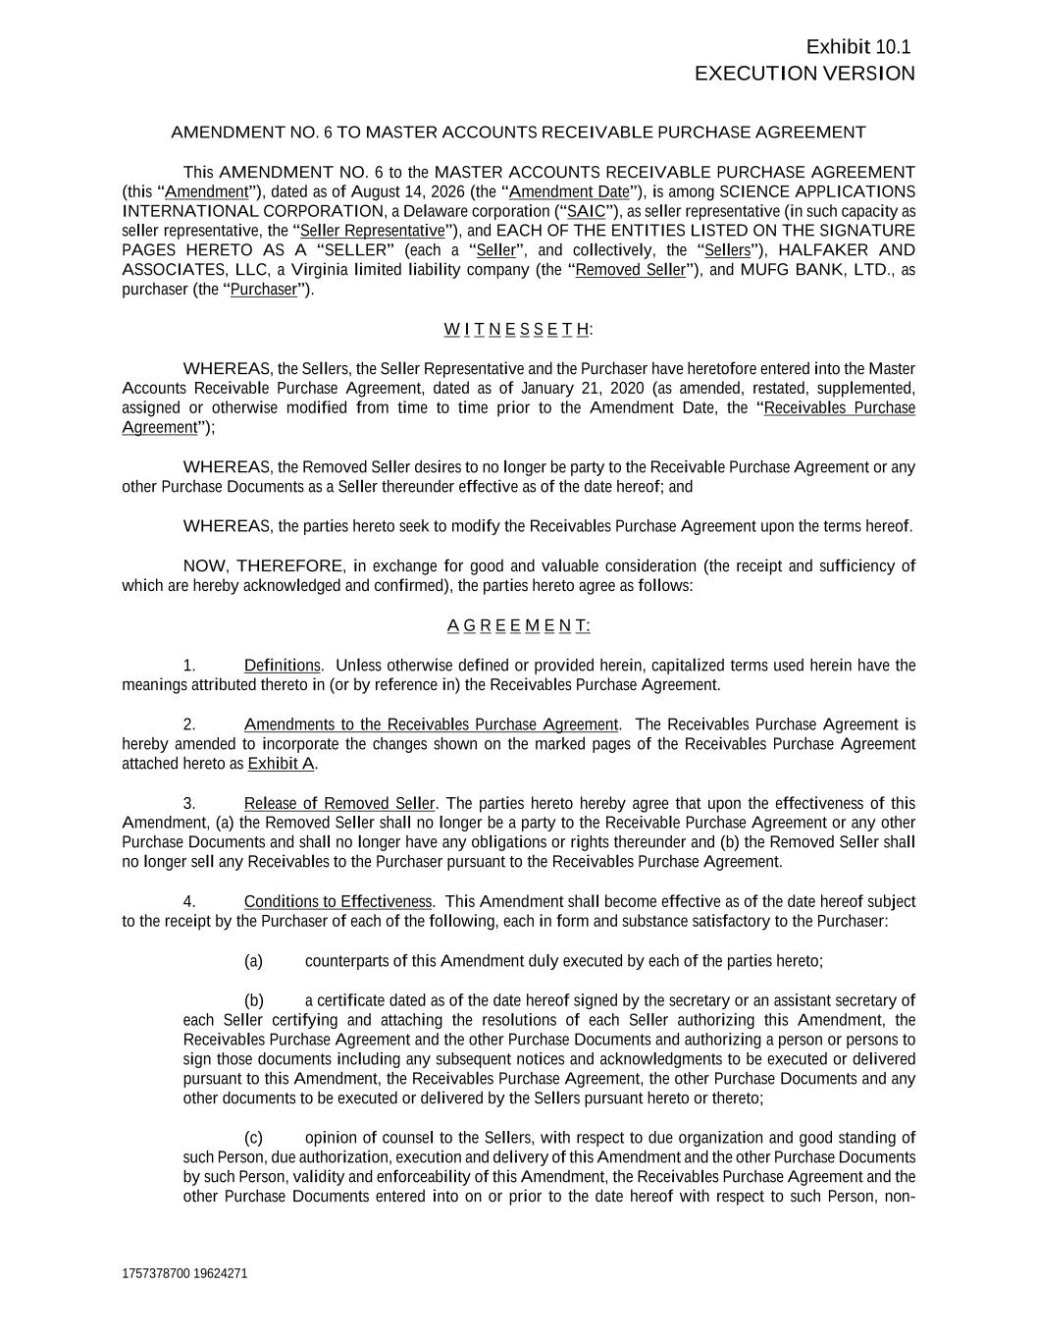

Exhibit 10.1 EXECUTION VERSION 1757378700 19624271 AMENDMENT NO. 6 TO MASTER ACCOUNTS RECEIVABLE PURCHASE AGREEMENT This AMENDMENT NO. 6 to the MASTER ACCOUNTS RECEIVABLE PURCHASE AGREEMENT (this “Amendment”), dated as of August 14, 2026 (the “Amendment Date”), is among SCIENCE APPLICATIONS INTERNATIONAL CORPORATION, a Delaware corporation (“SAIC”), as seller representative (in such capacity as seller representative, the “Seller Representative”), and EACH OF THE ENTITIES LISTED ON THE SIGNATURE PAGES HERETO AS A “SELLER” (each a “Seller”, and collectively, the “Sellers”), HALFAKER AND ASSOCIATES, LLC, a Virginia limited liability company (the “Removed Seller”), and MUFG BANK, LTD., as purchaser (the “Purchaser”). W I T N E S S E T H: WHEREAS, the Sellers, the Seller Representative and the Purchaser have heretofore entered into the Master Accounts Receivable Purchase Agreement, dated as of January 21, 2020 (as amended, restated, supplemented, assigned or otherwise modified from time to time prior to the Amendment Date, the “Receivables Purchase Agreement”); WHEREAS, the Removed Seller desires to no longer be party to the Receivable Purchase Agreement or any other Purchase Documents as a Seller thereunder effective as of the date hereof; and WHEREAS, the parties hereto seek to modify the Receivables Purchase Agreement upon the terms hereof. NOW, THEREFORE, in exchange for good and valuable consideration (the receipt and sufficiency of which are hereby acknowledged and confirmed), the parties hereto agree as follows: A G R E E M E N T: 1. Definitions. Unless otherwise defined or provided herein, capitalized terms used herein have the meanings attributed thereto in (or by reference in) the Receivables Purchase Agreement. 2. Amendments to the Receivables Purchase Agreement. The Receivables Purchase Agreement is hereby amended to incorporate the changes shown on the marked pages of the Receivables Purchase Agreement attached hereto as Exhibit A. 3. Release of Removed Seller. The parties hereto hereby agree that upon the effectiveness of this Amendment, (a) the Removed Seller shall no longer be a party to the Receivable Purchase Agreement or any other Purchase Documents and shall no longer have any obligations or rights thereunder and (b) the Removed Seller shall no longer sell any Receivables to the Purchaser pursuant to the Receivables Purchase Agreement. 4. Conditions to Effectiveness. This Amendment shall become effective as of the date hereof subject to the receipt by the Purchaser of each of the following, each in form and substance satisfactory to the Purchaser: (a) counterparts of this Amendment duly executed by each of the parties hereto; (b) a certificate dated as of the date hereof signed by the secretary or an assistant secretary of each Seller certifying and attaching the resolutions of each Seller authorizing this Amendment, the Receivables Purchase Agreement and the other Purchase Documents and authorizing a person or persons to sign those documents including any subsequent notices and acknowledgments to be executed or delivered pursuant to this Amendment, the Receivables Purchase Agreement, the other Purchase Documents and any other documents to be executed or delivered by the Sellers pursuant hereto or thereto; (c) opinion of counsel to the Sellers, with respect to due organization and good standing of such Person, due authorization, execution and delivery of this Amendment and the other Purchase Documents by such Person, validity and enforceability of this Amendment, the Receivables Purchase Agreement and the other Purchase Documents entered into on or prior to the date hereof with respect to such Person, non-

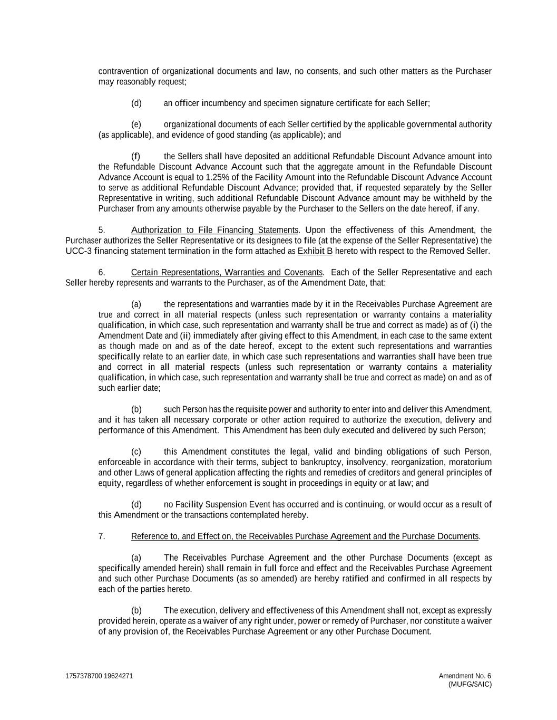
1757378700 19624271 Amendment No. 6 (MUFG/SAIC) contravention of organizational documents and law, no consents, and such other matters as the Purchaser may reasonably request; (d) an officer incumbency and specimen signature certificate for each Seller; (e) organizational documents of each Seller certified by the applicable governmental authority (as applicable), and evidence of good standing (as applicable); and (f) the Sellers shall have deposited an additional Refundable Discount Advance amount into the Refundable Discount Advance Account such that the aggregate amount in the Refundable Discount Advance Account is equal to 1.25% of the Facility Amount into the Refundable Discount Advance Account to serve as additional Refundable Discount Advance; provided that, if requested separately by the Seller Representative in writing, such additional Refundable Discount Advance amount may be withheld by the Purchaser from any amounts otherwise payable by the Purchaser to the Sellers on the date hereof, if any. 5. Authorization to File Financing Statements. Upon the effectiveness of this Amendment, the Purchaser authorizes the Seller Representative or its designees to file (at the expense of the Seller Representative) the UCC-3 financing statement termination in the form attached as Exhibit B hereto with respect to the Removed Seller. 6. Certain Representations, Warranties and Covenants. Each of the Seller Representative and each Seller hereby represents and warrants to the Purchaser, as of the Amendment Date, that: (a) the representations and warranties made by it in the Receivables Purchase Agreement are true and correct in all material respects (unless such representation or warranty contains a materiality qualification, in which case, such representation and warranty shall be true and correct as made) as of (i) the Amendment Date and (ii) immediately after giving effect to this Amendment, in each case to the same extent as though made on and as of the date hereof, except to the extent such representations and warranties specifically relate to an earlier date, in which case such representations and warranties shall have been true and correct in all material respects (unless such representation or warranty contains a materiality qualification, in which case, such representation and warranty shall be true and correct as made) on and as of such earlier date; (b) such Person has the requisite power and authority to enter into and deliver this Amendment, and it has taken all necessary corporate or other action required to authorize the execution, delivery and performance of this Amendment. This Amendment has been duly executed and delivered by such Person; (c) this Amendment constitutes the legal, valid and binding obligations of such Person, enforceable in accordance with their terms, subject to bankruptcy, insolvency, reorganization, moratorium and other Laws of general application affecting the rights and remedies of creditors and general principles of equity, regardless of whether enforcement is sought in proceedings in equity or at law; and (d) no Facility Suspension Event has occurred and is continuing, or would occur as a result of this Amendment or the transactions contemplated hereby. 7. Reference to, and Effect on, the Receivables Purchase Agreement and the Purchase Documents. (a) The Receivables Purchase Agreement and the other Purchase Documents (except as specifically amended herein) shall remain in full force and effect and the Receivables Purchase Agreement and such other Purchase Documents (as so amended) are hereby ratified and confirmed in all respects by each of the parties hereto. (b) The execution, delivery and effectiveness of this Amendment shall not, except as expressly provided herein, operate as a waiver of any right under, power or remedy of Purchaser, nor constitute a waiver of any provision of, the Receivables Purchase Agreement or any other Purchase Document.

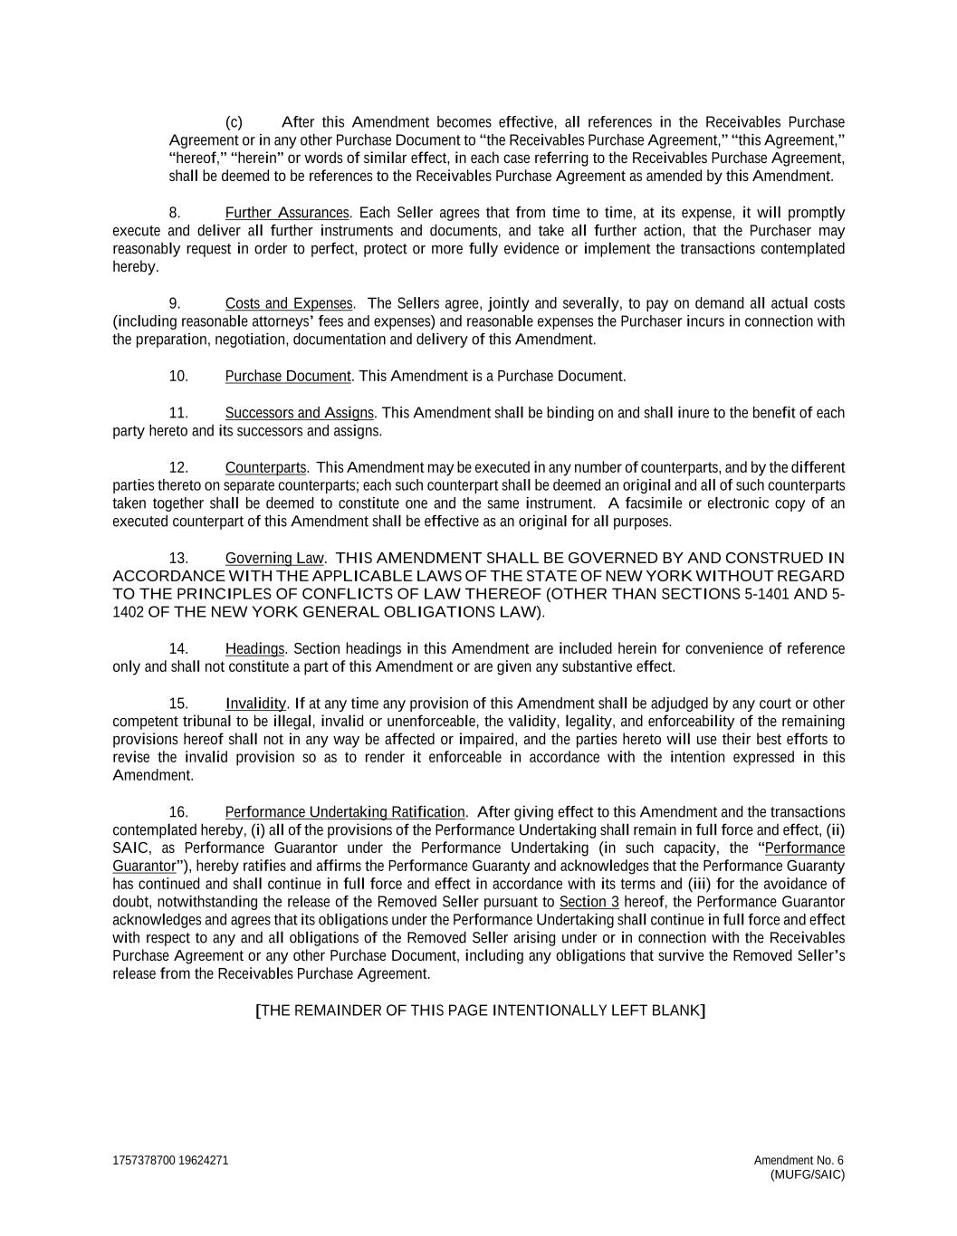
1757378700 19624271 Amendment No. 6 (MUFG/SAIC) (c) After this Amendment becomes effective, all references in the Receivables Purchase Agreement or in any other Purchase Document to “the Receivables Purchase Agreement,” “this Agreement,” “hereof,” “herein” or words of similar effect, in each case referring to the Receivables Purchase Agreement, shall be deemed to be references to the Receivables Purchase Agreement as amended by this Amendment. 8. Further Assurances. Each Seller agrees that from time to time, at its expense, it will promptly execute and deliver all further instruments and documents, and take all further action, that the Purchaser may reasonably request in order to perfect, protect or more fully evidence or implement the transactions contemplated hereby. 9. Costs and Expenses. The Sellers agree, jointly and severally, to pay on demand all actual costs (including reasonable attorneys’ fees and expenses) and reasonable expenses the Purchaser incurs in connection with the preparation, negotiation, documentation and delivery of this Amendment. 10. Purchase Document. This Amendment is a Purchase Document. 11. Successors and Assigns. This Amendment shall be binding on and shall inure to the benefit of each party hereto and its successors and assigns. 12. Counterparts. This Amendment may be executed in any number of counterparts, and by the different parties thereto on separate counterparts; each such counterpart shall be deemed an original and all of such counterparts taken together shall be deemed to constitute one and the same instrument. A facsimile or electronic copy of an executed counterpart of this Amendment shall be effective as an original for all purposes. 13. Governing Law. THIS AMENDMENT SHALL BE GOVERNED BY AND CONSTRUED IN ACCORDANCE WITH THE APPLICABLE LAWS OF THE STATE OF NEW YORK WITHOUT REGARD TO THE PRINCIPLES OF CONFLICTS OF LAW THEREOF (OTHER THAN SECTIONS 5-1401 AND 5- 1402 OF THE NEW YORK GENERAL OBLIGATIONS LAW). 14. Headings. Section headings in this Amendment are included herein for convenience of reference only and shall not constitute a part of this Amendment or are given any substantive effect. 15. Invalidity. If at any time any provision of this Amendment shall be adjudged by any court or other competent tribunal to be illegal, invalid or unenforceable, the validity, legality, and enforceability of the remaining provisions hereof shall not in any way be affected or impaired, and the parties hereto will use their best efforts to revise the invalid provision so as to render it enforceable in accordance with the intention expressed in this Amendment. 16. Performance Undertaking Ratification. After giving effect to this Amendment and the transactions contemplated hereby, (i) all of the provisions of the Performance Undertaking shall remain in full force and effect, (ii) SAIC, as Performance Guarantor under the Performance Undertaking (in such capacity, the “Performance Guarantor”), hereby ratifies and affirms the Performance Guaranty and acknowledges that the Performance Guaranty has continued and shall continue in full force and effect in accordance with its terms and (iii) for the avoidance of doubt, notwithstanding the release of the Removed Seller pursuant to Section 3 hereof, the Performance Guarantor acknowledges and agrees that its obligations under the Performance Undertaking shall continue in full force and effect with respect to any and all obligations of the Removed Seller arising under or in connection with the Receivables Purchase Agreement or any other Purchase Document, including any obligations that survive the Removed Seller’s release from the Receivables Purchase Agreement. [THE REMAINDER OF THIS PAGE INTENTIONALLY LEFT BLANK]

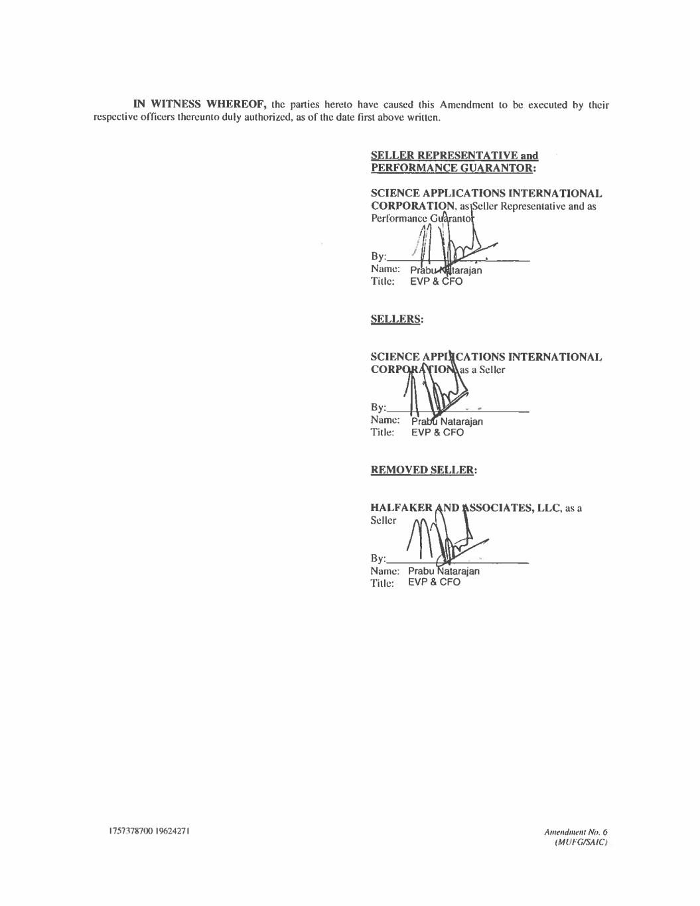

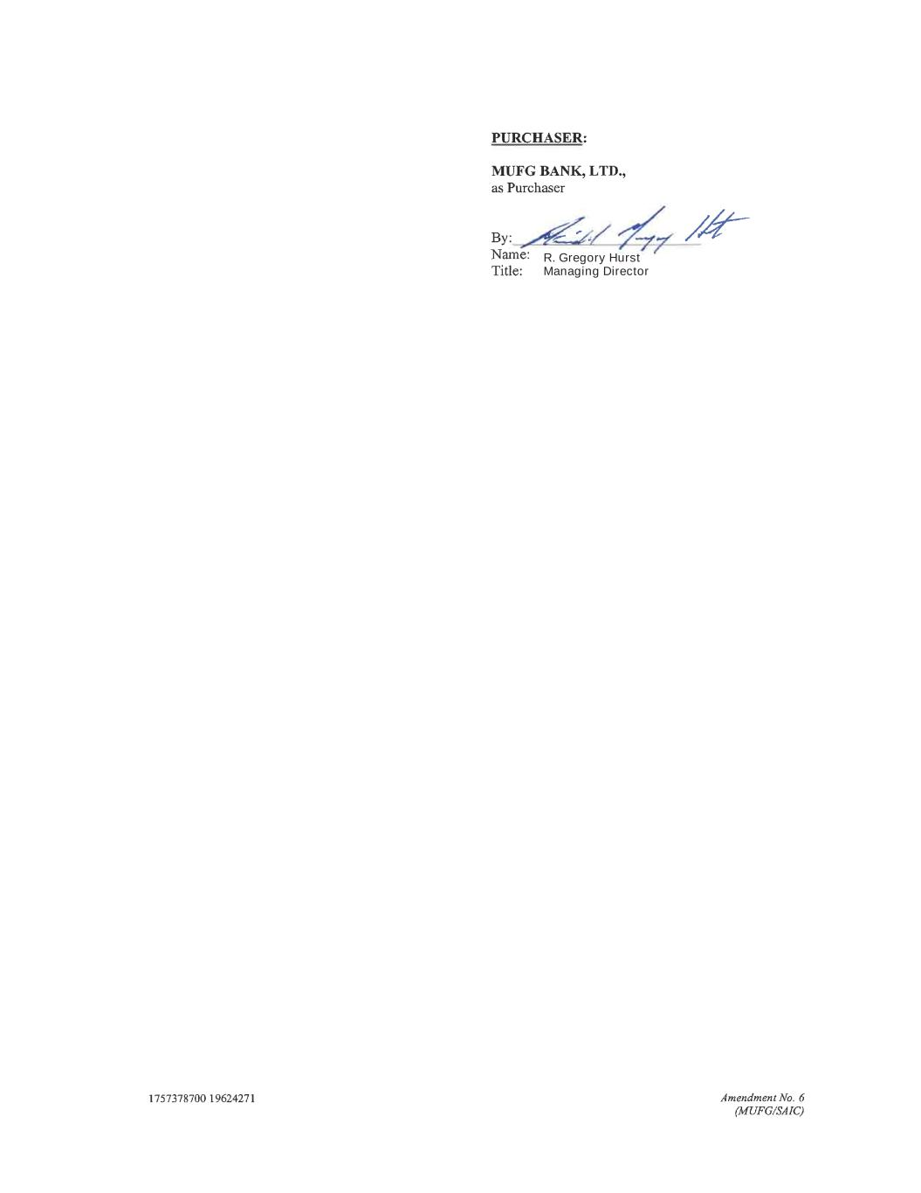
R. Gregory Hurst Managing Director


EXHIBIT A [Attached]

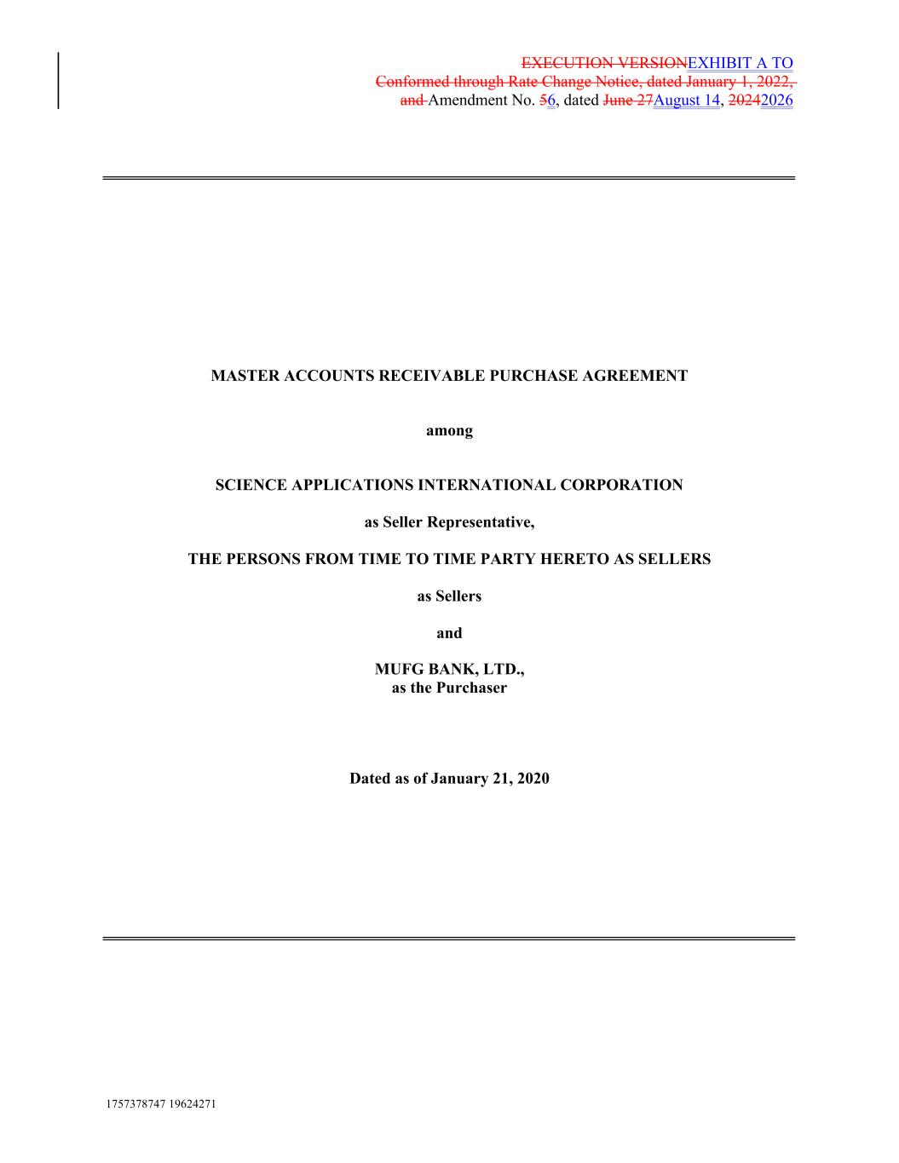
EXECUTION VERSIONEXHIBIT A TO Conformed through Rate Change Notice, dated January 1, 2022, and Amendment No. 56, dated June 27August 14, 20242026 MASTER ACCOUNTS RECEIVABLE PURCHASE AGREEMENT among SCIENCE APPLICATIONS INTERNATIONAL CORPORATION as Seller Representative, THE PERSONS FROM TIME TO TIME PARTY HERETO AS SELLERS as Sellers and MUFG BANK, LTD., as the Purchaser Dated as of January 21, 2020 1757378747 19624271

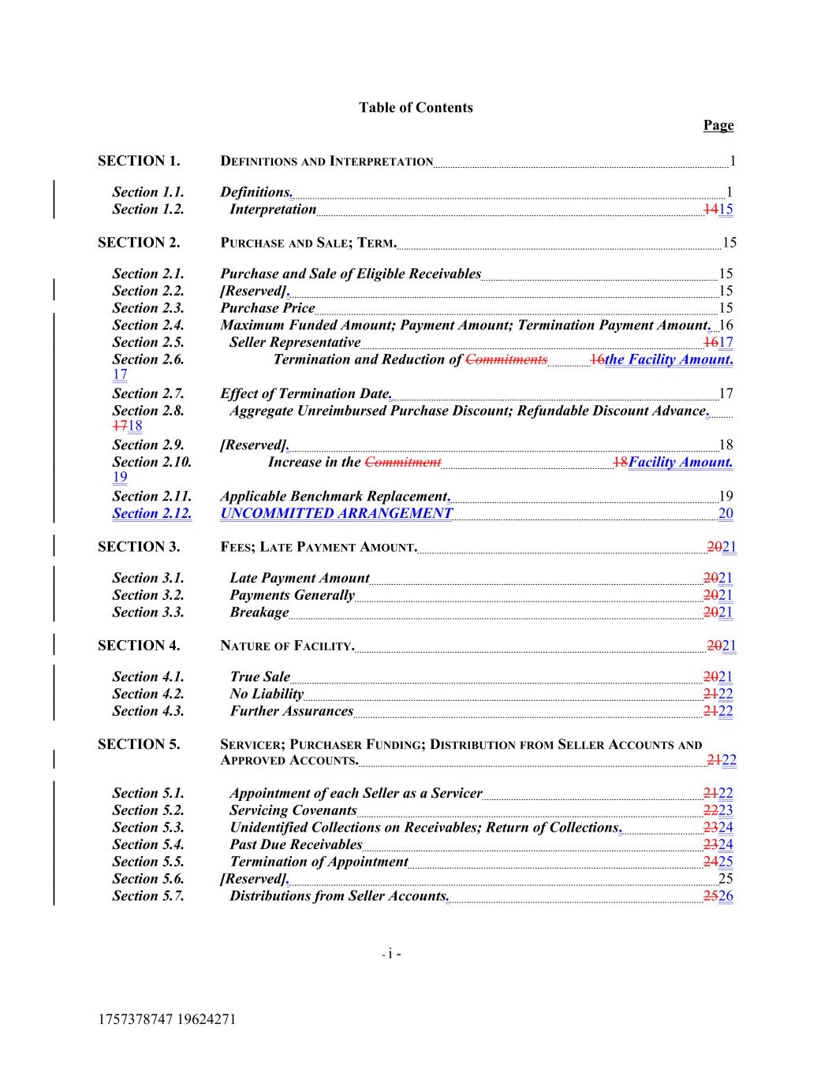
Table of Contents Page SECTION 1. DEFINITIONS AND INTERPRETATION 1 Section 1.1. Definitions. 1 Section 1.2. Interpretation 1415 SECTION 2. PURCHASE AND SALE; TERM. 15 Section 2.1. Purchase and Sale of Eligible Receivables 15 Section 2.2. [Reserved]. 15 Section 2.3. Purchase Price 15 Section 2.4. Maximum Funded Amount; Payment Amount; Termination Payment Amount. 16 Section 2.5. Seller Representative 1617 Section 2.6. Termination and Reduction of Commitments 16the Facility Amount. 17 Section 2.7. Effect of Termination Date. 17 Section 2.8. Aggregate Unreimbursed Purchase Discount; Refundable Discount Advance. 1718 Section 2.9. [Reserved]. 18 Section 2.10. Increase in the Commitment 18Facility Amount. 19 Section 2.11. Applicable Benchmark Replacement. 19 Section 2.12. UNCOMMITTED ARRANGEMENT 20 SECTION 3. FEES; LATE PAYMENT AMOUNT. 2021 Section 3.1. Late Payment Amount 2021 Section 3.2. Payments Generally 2021 Section 3.3. Breakage 2021 SECTION 4. NATURE OF FACILITY. 2021 Section 4.1. True Sale 2021 Section 4.2. No Liability 2122 Section 4.3. Further Assurances 2122 SECTION 5. SERVICER; PURCHASER FUNDING; DISTRIBUTION FROM SELLER ACCOUNTS AND APPROVED ACCOUNTS. 2122 Section 5.1. Appointment of each Seller as a Servicer 2122 Section 5.2. Servicing Covenants 2223 Section 5.3. Unidentified Collections on Receivables; Return of Collections. 2324 Section 5.4. Past Due Receivables 2324 Section 5.5. Termination of Appointment 2425 Section 5.6. [Reserved]. 25 Section 5.7. Distributions from Seller Accounts. 2526 - i - 1757378747 19624271

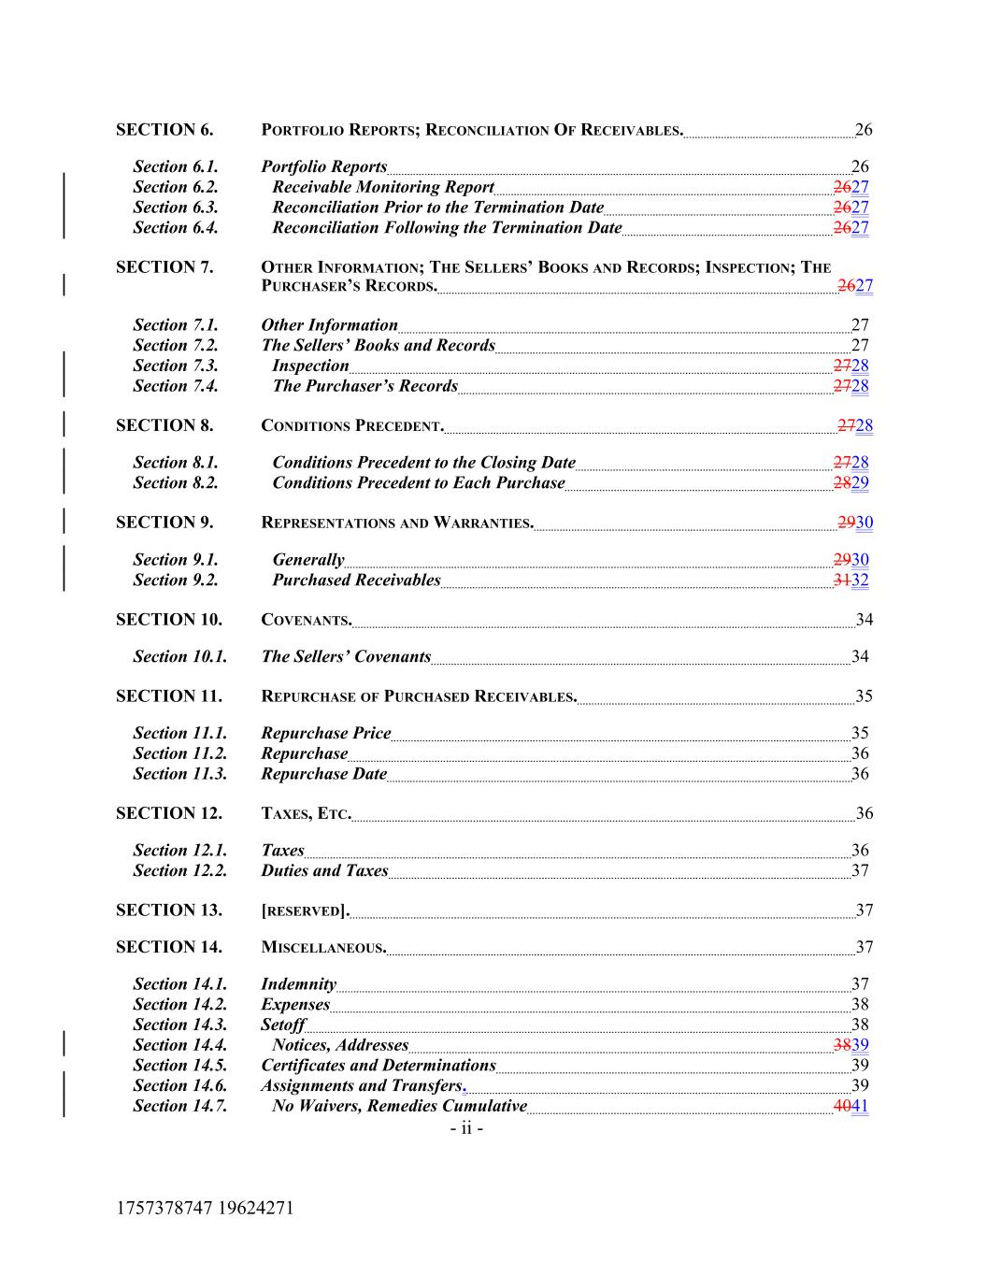
SECTION 6. PORTFOLIO REPORTS; RECONCILIATION OF RECEIVABLES. 26 Section 6.1. Portfolio Reports 26 Section 6.2. Receivable Monitoring Report 2627 Section 6.3. Reconciliation Prior to the Termination Date 2627 Section 6.4. Reconciliation Following the Termination Date 2627 SECTION 7. OTHER INFORMATION; THE SELLERS’ BOOKS AND RECORDS; INSPECTION; THE PURCHASER’S RECORDS. 2627 Section 7.1. Other Information 27 Section 7.2. The Sellers’ Books and Records 27 Section 7.3. Inspection 2728 Section 7.4. The Purchaser’s Records 2728 SECTION 8. CONDITIONS PRECEDENT. 2728 Section 8.1. Conditions Precedent to the Closing Date 2728 Section 8.2. Conditions Precedent to Each Purchase 2829 SECTION 9. REPRESENTATIONS AND WARRANTIES. 2930 Section 9.1. Generally 2930 Section 9.2. Purchased Receivables 3132 SECTION 10. COVENANTS. 34 Section 10.1. The Sellers’ Covenants 34 SECTION 11. REPURCHASE OF PURCHASED RECEIVABLES. 35 Section 11.1. Repurchase Price 35 Section 11.2. Repurchase 36 Section 11.3. Repurchase Date 36 SECTION 12. TAXES, ETC. 36 Section 12.1. Taxes 36 Section 12.2. Duties and Taxes 37 SECTION 13. [RESERVED]. 37 SECTION 14. MISCELLANEOUS. 37 Section 14.1. Indemnity 37 Section 14.2. Expenses 38 Section 14.3. Setoff 38 Section 14.4. Notices, Addresses 3839 Section 14.5. Certificates and Determinations 39 Section 14.6. Assignments and Transfers. 39 Section 14.7. No Waivers, Remedies Cumulative 4041 - ii - 1757378747 19624271

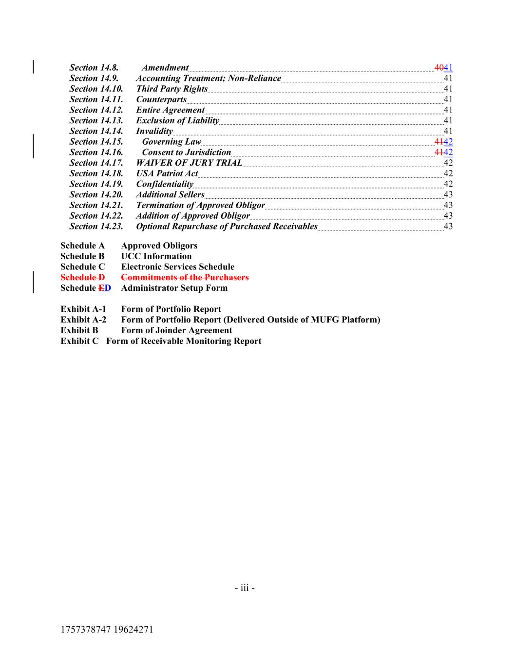
Section 14.8. Amendment 4041 Section 14.9. Accounting Treatment; Non-Reliance 41 Section 14.10. Third Party Rights 41 Section 14.11. Counterparts 41 Section 14.12. Entire Agreement 41 Section 14.13. Exclusion of Liability 41 Section 14.14. Invalidity 41 Section 14.15. Governing Law 4142 Section 14.16. Consent to Jurisdiction 4142 Section 14.17. WAIVER OF JURY TRIAL 42 Section 14.18. USA Patriot Act 42 Section 14.19. Confidentiality 42 Section 14.20. Additional Sellers 43 Section 14.21. Termination of Approved Obligor 43 Section 14.22. Addition of Approved Obligor 43 Section 14.23. Optional Repurchase of Purchased Receivables 43 Schedule A Approved Obligors Schedule B UCC Information Schedule C Electronic Services Schedule Schedule D Commitments of the Purchasers Schedule ED Administrator Setup Form Exhibit A-1 Form of Portfolio Report Exhibit A-2 Form of Portfolio Report (Delivered Outside of MUFG Platform) Exhibit B Form of Joinder Agreement Exhibit C Form of Receivable Monitoring Report - iii - 1757378747 19624271

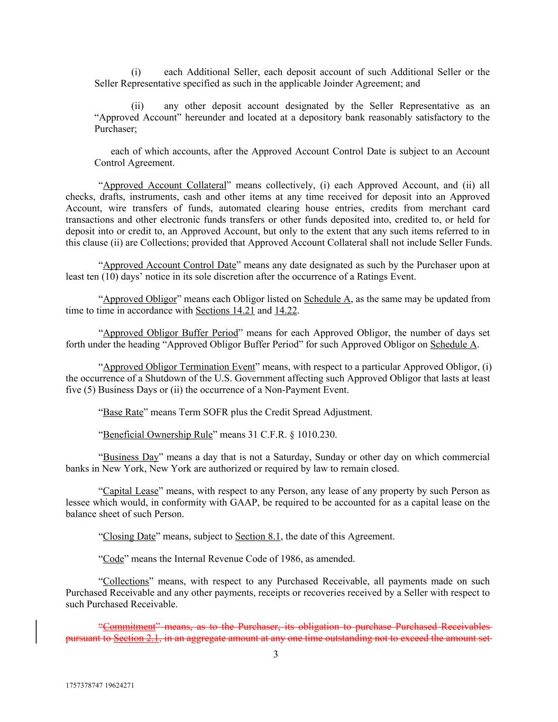
1757378747 19624271 3 (i) each Additional Seller, each deposit account of such Additional Seller or the Seller Representative specified as such in the applicable Joinder Agreement; and (ii) any other deposit account designated by the Seller Representative as an “Approved Account” hereunder and located at a depository bank reasonably satisfactory to the Purchaser; each of which accounts, after the Approved Account Control Date is subject to an Account Control Agreement. “Approved Account Collateral” means collectively, (i) each Approved Account, and (ii) all checks, drafts, instruments, cash and other items at any time received for deposit into an Approved Account, wire transfers of funds, automated clearing house entries, credits from merchant card transactions and other electronic funds transfers or other funds deposited into, credited to, or held for deposit into or credit to, an Approved Account, but only to the extent that any such items referred to in this clause (ii) are Collections; provided that Approved Account Collateral shall not include Seller Funds. “Approved Account Control Date” means any date designated as such by the Purchaser upon at least ten (10) days’ notice in its sole discretion after the occurrence of a Ratings Event. “Approved Obligor” means each Obligor listed on Schedule A, as the same may be updated from time to time in accordance with Sections 14.21 and 14.22. “Approved Obligor Buffer Period” means for each Approved Obligor, the number of days set forth under the heading “Approved Obligor Buffer Period” for such Approved Obligor on Schedule A. “Approved Obligor Termination Event” means, with respect to a particular Approved Obligor, (i) the occurrence of a Shutdown of the U.S. Government affecting such Approved Obligor that lasts at least five (5) Business Days or (ii) the occurrence of a Non-Payment Event. “Base Rate” means Term SOFR plus the Credit Spread Adjustment. “Beneficial Ownership Rule” means 31 C.F.R. § 1010.230. “Business Day” means a day that is not a Saturday, Sunday or other day on which commercial banks in New York, New York are authorized or required by law to remain closed. “Capital Lease” means, with respect to any Person, any lease of any property by such Person as lessee which would, in conformity with GAAP, be required to be accounted for as a capital lease on the balance sheet of such Person. “Closing Date” means, subject to Section 8.1, the date of this Agreement. “Code” means the Internal Revenue Code of 1986, as amended. “Collections” means, with respect to any Purchased Receivable, all payments made on such Purchased Receivable and any other payments, receipts or recoveries received by a Seller with respect to such Purchased Receivable. “Commitment” means, as to the Purchaser, its obligation to purchase Purchased Receivables pursuant to Section 2.1, in an aggregate amount at any one time outstanding not to exceed the amount set

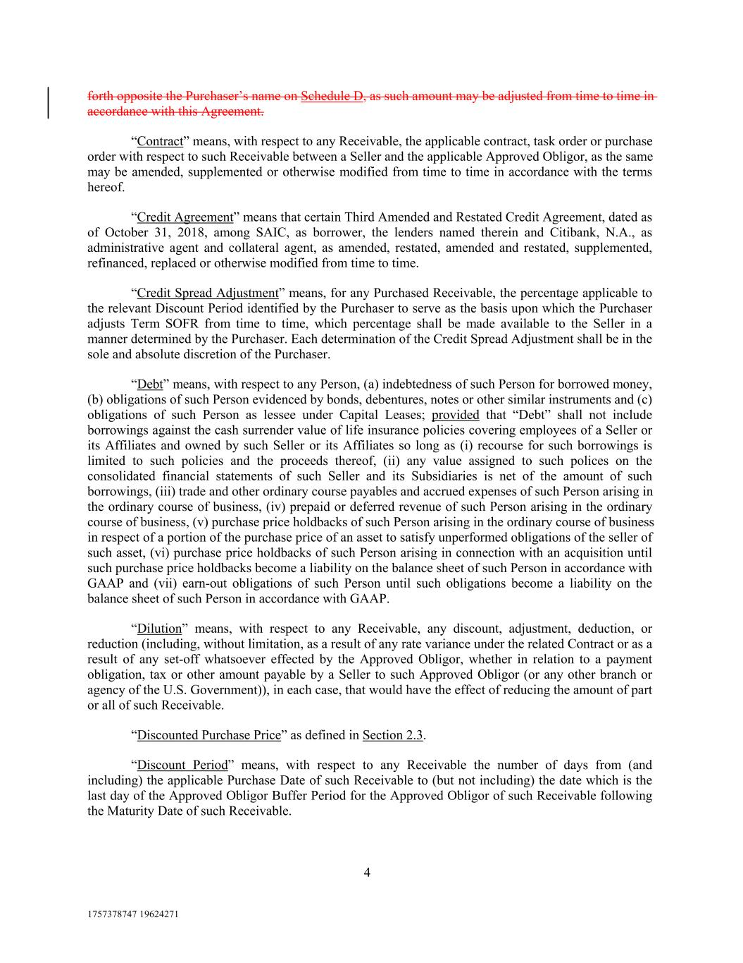
1757378747 19624271 4 forth opposite the Purchaser’s name on Schedule D, as such amount may be adjusted from time to time in accordance with this Agreement. “Contract” means, with respect to any Receivable, the applicable contract, task order or purchase order with respect to such Receivable between a Seller and the applicable Approved Obligor, as the same may be amended, supplemented or otherwise modified from time to time in accordance with the terms hereof. “Credit Agreement” means that certain Third Amended and Restated Credit Agreement, dated as of October 31, 2018, among SAIC, as borrower, the lenders named therein and Citibank, N.A., as administrative agent and collateral agent, as amended, restated, amended and restated, supplemented, refinanced, replaced or otherwise modified from time to time. “Credit Spread Adjustment” means, for any Purchased Receivable, the percentage applicable to the relevant Discount Period identified by the Purchaser to serve as the basis upon which the Purchaser adjusts Term SOFR from time to time, which percentage shall be made available to the Seller in a manner determined by the Purchaser. Each determination of the Credit Spread Adjustment shall be in the sole and absolute discretion of the Purchaser. “Debt” means, with respect to any Person, (a) indebtedness of such Person for borrowed money, (b) obligations of such Person evidenced by bonds, debentures, notes or other similar instruments and (c) obligations of such Person as lessee under Capital Leases; provided that “Debt” shall not include borrowings against the cash surrender value of life insurance policies covering employees of a Seller or its Affiliates and owned by such Seller or its Affiliates so long as (i) recourse for such borrowings is limited to such policies and the proceeds thereof, (ii) any value assigned to such polices on the consolidated financial statements of such Seller and its Subsidiaries is net of the amount of such borrowings, (iii) trade and other ordinary course payables and accrued expenses of such Person arising in the ordinary course of business, (iv) prepaid or deferred revenue of such Person arising in the ordinary course of business, (v) purchase price holdbacks of such Person arising in the ordinary course of business in respect of a portion of the purchase price of an asset to satisfy unperformed obligations of the seller of such asset, (vi) purchase price holdbacks of such Person arising in connection with an acquisition until such purchase price holdbacks become a liability on the balance sheet of such Person in accordance with GAAP and (vii) earn-out obligations of such Person until such obligations become a liability on the balance sheet of such Person in accordance with GAAP. “Dilution” means, with respect to any Receivable, any discount, adjustment, deduction, or reduction (including, without limitation, as a result of any rate variance under the related Contract or as a result of any set-off whatsoever effected by the Approved Obligor, whether in relation to a payment obligation, tax or other amount payable by a Seller to such Approved Obligor (or any other branch or agency of the U.S. Government)), in each case, that would have the effect of reducing the amount of part or all of such Receivable. “Discounted Purchase Price” as defined in Section 2.3. “Discount Period” means, with respect to any Receivable the number of days from (and including) the applicable Purchase Date of such Receivable to (but not including) the date which is the last day of the Approved Obligor Buffer Period for the Approved Obligor of such Receivable following the Maturity Date of such Receivable.

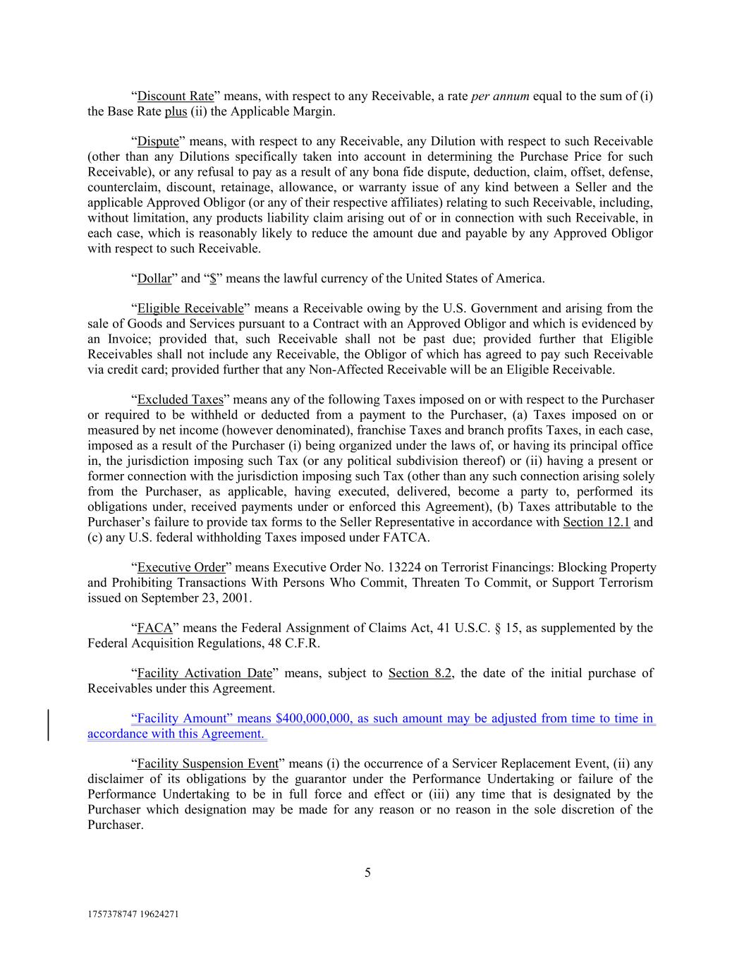
1757378747 19624271 5 “Discount Rate” means, with respect to any Receivable, a rate per annum equal to the sum of (i) the Base Rate plus (ii) the Applicable Margin. “Dispute” means, with respect to any Receivable, any Dilution with respect to such Receivable (other than any Dilutions specifically taken into account in determining the Purchase Price for such Receivable), or any refusal to pay as a result of any bona fide dispute, deduction, claim, offset, defense, counterclaim, discount, retainage, allowance, or warranty issue of any kind between a Seller and the applicable Approved Obligor (or any of their respective affiliates) relating to such Receivable, including, without limitation, any products liability claim arising out of or in connection with such Receivable, in each case, which is reasonably likely to reduce the amount due and payable by any Approved Obligor with respect to such Receivable. “Dollar” and “$” means the lawful currency of the United States of America. “Eligible Receivable” means a Receivable owing by the U.S. Government and arising from the sale of Goods and Services pursuant to a Contract with an Approved Obligor and which is evidenced by an Invoice; provided that, such Receivable shall not be past due; provided further that Eligible Receivables shall not include any Receivable, the Obligor of which has agreed to pay such Receivable via credit card; provided further that any Non-Affected Receivable will be an Eligible Receivable. “Excluded Taxes” means any of the following Taxes imposed on or with respect to the Purchaser or required to be withheld or deducted from a payment to the Purchaser, (a) Taxes imposed on or measured by net income (however denominated), franchise Taxes and branch profits Taxes, in each case, imposed as a result of the Purchaser (i) being organized under the laws of, or having its principal office in, the jurisdiction imposing such Tax (or any political subdivision thereof) or (ii) having a present or former connection with the jurisdiction imposing such Tax (other than any such connection arising solely from the Purchaser, as applicable, having executed, delivered, become a party to, performed its obligations under, received payments under or enforced this Agreement), (b) Taxes attributable to the Purchaser’s failure to provide tax forms to the Seller Representative in accordance with Section 12.1 and (c) any U.S. federal withholding Taxes imposed under FATCA. “Executive Order” means Executive Order No. 13224 on Terrorist Financings: Blocking Property and Prohibiting Transactions With Persons Who Commit, Threaten To Commit, or Support Terrorism issued on September 23, 2001. “FACA” means the Federal Assignment of Claims Act, 41 U.S.C. § 15, as supplemented by the Federal Acquisition Regulations, 48 C.F.R. “Facility Activation Date” means, subject to Section 8.2, the date of the initial purchase of Receivables under this Agreement. “Facility Amount” means $400,000,000, as such amount may be adjusted from time to time in accordance with this Agreement. “Facility Suspension Event” means (i) the occurrence of a Servicer Replacement Event, (ii) any disclaimer of its obligations by the guarantor under the Performance Undertaking or failure of the Performance Undertaking to be in full force and effect or (iii) any time that is designated by the Purchaser which designation may be made for any reason or no reason in the sole discretion of the Purchaser.

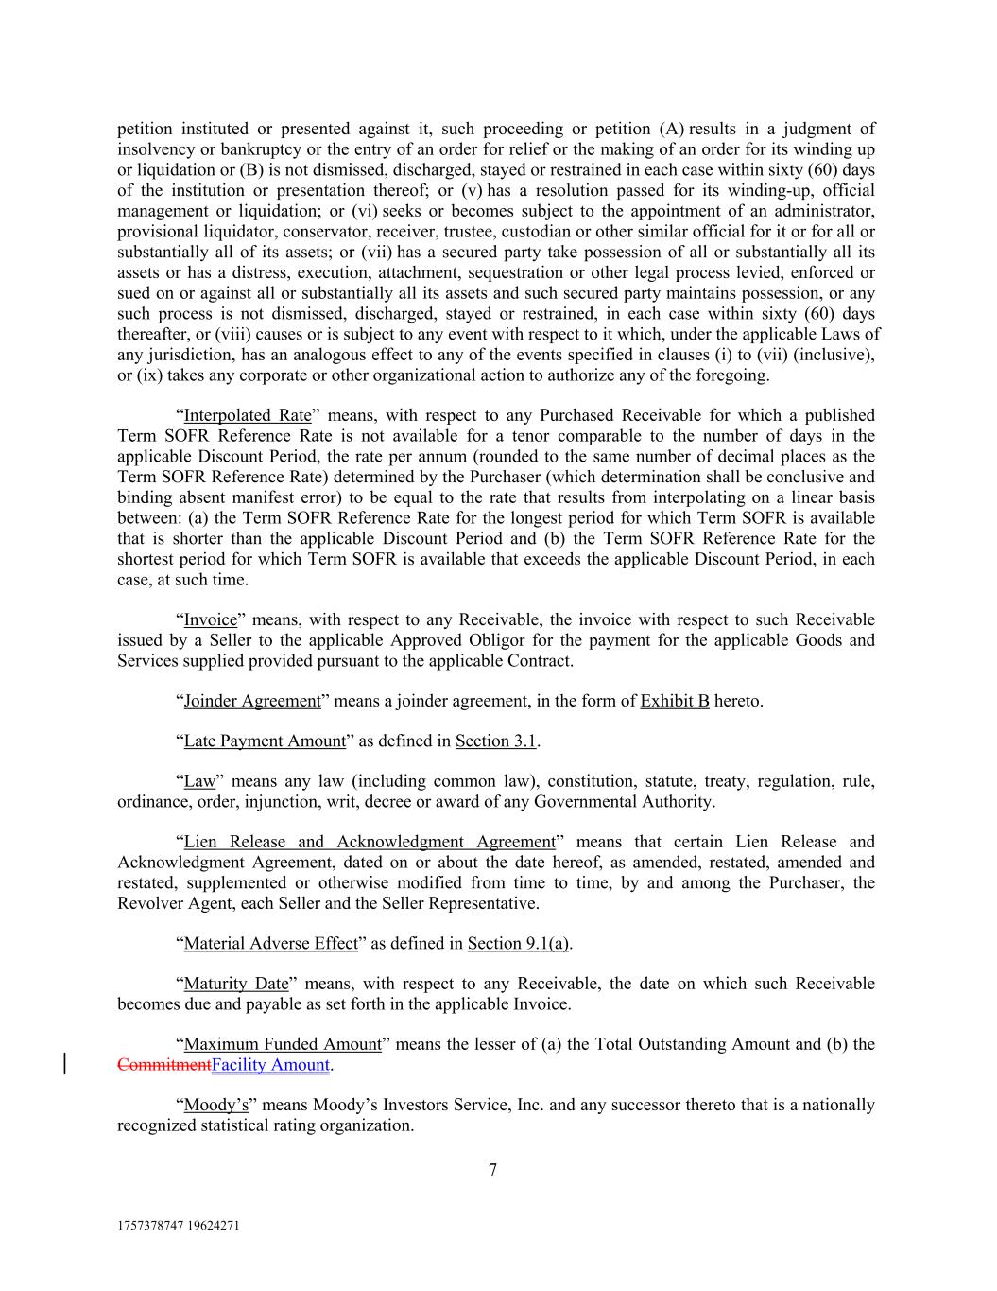
1757378747 19624271 7 petition instituted or presented against it, such proceeding or petition (A) results in a judgment of insolvency or bankruptcy or the entry of an order for relief or the making of an order for its winding up or liquidation or (B) is not dismissed, discharged, stayed or restrained in each case within sixty (60) days of the institution or presentation thereof; or (v) has a resolution passed for its winding-up, official management or liquidation; or (vi) seeks or becomes subject to the appointment of an administrator, provisional liquidator, conservator, receiver, trustee, custodian or other similar official for it or for all or substantially all of its assets; or (vii) has a secured party take possession of all or substantially all its assets or has a distress, execution, attachment, sequestration or other legal process levied, enforced or sued on or against all or substantially all its assets and such secured party maintains possession, or any such process is not dismissed, discharged, stayed or restrained, in each case within sixty (60) days thereafter, or (viii) causes or is subject to any event with respect to it which, under the applicable Laws of any jurisdiction, has an analogous effect to any of the events specified in clauses (i) to (vii) (inclusive), or (ix) takes any corporate or other organizational action to authorize any of the foregoing. “Interpolated Rate” means, with respect to any Purchased Receivable for which a published Term SOFR Reference Rate is not available for a tenor comparable to the number of days in the applicable Discount Period, the rate per annum (rounded to the same number of decimal places as the Term SOFR Reference Rate) determined by the Purchaser (which determination shall be conclusive and binding absent manifest error) to be equal to the rate that results from interpolating on a linear basis between: (a) the Term SOFR Reference Rate for the longest period for which Term SOFR is available that is shorter than the applicable Discount Period and (b) the Term SOFR Reference Rate for the shortest period for which Term SOFR is available that exceeds the applicable Discount Period, in each case, at such time. “Invoice” means, with respect to any Receivable, the invoice with respect to such Receivable issued by a Seller to the applicable Approved Obligor for the payment for the applicable Goods and Services supplied provided pursuant to the applicable Contract. “Joinder Agreement” means a joinder agreement, in the form of Exhibit B hereto. “Late Payment Amount” as defined in Section 3.1. “Law” means any law (including common law), constitution, statute, treaty, regulation, rule, ordinance, order, injunction, writ, decree or award of any Governmental Authority. “Lien Release and Acknowledgment Agreement” means that certain Lien Release and Acknowledgment Agreement, dated on or about the date hereof, as amended, restated, amended and restated, supplemented or otherwise modified from time to time, by and among the Purchaser, the Revolver Agent, each Seller and the Seller Representative. “Material Adverse Effect” as defined in Section 9.1(a). “Maturity Date” means, with respect to any Receivable, the date on which such Receivable becomes due and payable as set forth in the applicable Invoice. “Maximum Funded Amount” means the lesser of (a) the Total Outstanding Amount and (b) the CommitmentFacility Amount. “Moody’s” means Moody’s Investors Service, Inc. and any successor thereto that is a nationally recognized statistical rating organization.

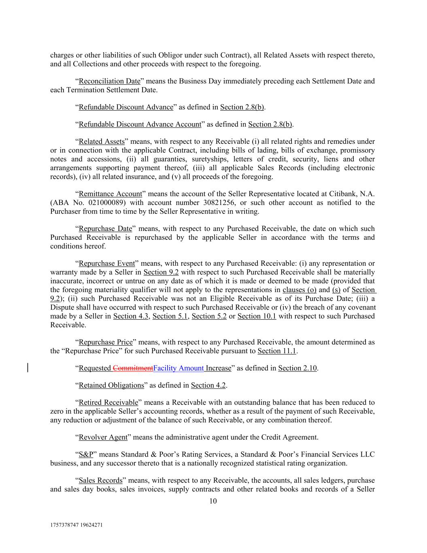
1757378747 19624271 10 charges or other liabilities of such Obligor under such Contract), all Related Assets with respect thereto, and all Collections and other proceeds with respect to the foregoing. “Reconciliation Date” means the Business Day immediately preceding each Settlement Date and each Termination Settlement Date. “Refundable Discount Advance” as defined in Section 2.8(b). “Refundable Discount Advance Account” as defined in Section 2.8(b). “Related Assets” means, with respect to any Receivable (i) all related rights and remedies under or in connection with the applicable Contract, including bills of lading, bills of exchange, promissory notes and accessions, (ii) all guaranties, suretyships, letters of credit, security, liens and other arrangements supporting payment thereof, (iii) all applicable Sales Records (including electronic records), (iv) all related insurance, and (v) all proceeds of the foregoing. “Remittance Account” means the account of the Seller Representative located at Citibank, N.A. (ABA No. 021000089) with account number 30821256, or such other account as notified to the Purchaser from time to time by the Seller Representative in writing. “Repurchase Date” means, with respect to any Purchased Receivable, the date on which such Purchased Receivable is repurchased by the applicable Seller in accordance with the terms and conditions hereof. “Repurchase Event” means, with respect to any Purchased Receivable: (i) any representation or warranty made by a Seller in Section 9.2 with respect to such Purchased Receivable shall be materially inaccurate, incorrect or untrue on any date as of which it is made or deemed to be made (provided that the foregoing materiality qualifier will not apply to the representations in clauses (o) and (s) of Section 9.2); (ii) such Purchased Receivable was not an Eligible Receivable as of its Purchase Date; (iii) a Dispute shall have occurred with respect to such Purchased Receivable or (iv) the breach of any covenant made by a Seller in Section 4.3, Section 5.1, Section 5.2 or Section 10.1 with respect to such Purchased Receivable. “Repurchase Price” means, with respect to any Purchased Receivable, the amount determined as the “Repurchase Price” for such Purchased Receivable pursuant to Section 11.1. “Requested CommitmentFacility Amount Increase” as defined in Section 2.10. “Retained Obligations” as defined in Section 4.2. “Retired Receivable” means a Receivable with an outstanding balance that has been reduced to zero in the applicable Seller’s accounting records, whether as a result of the payment of such Receivable, any reduction or adjustment of the balance of such Receivable, or any combination thereof. “Revolver Agent” means the administrative agent under the Credit Agreement. “S&P” means Standard & Poor’s Rating Services, a Standard & Poor’s Financial Services LLC business, and any successor thereto that is a nationally recognized statistical rating organization. “Sales Records” means, with respect to any Receivable, the accounts, all sales ledgers, purchase and sales day books, sales invoices, supply contracts and other related books and records of a Seller

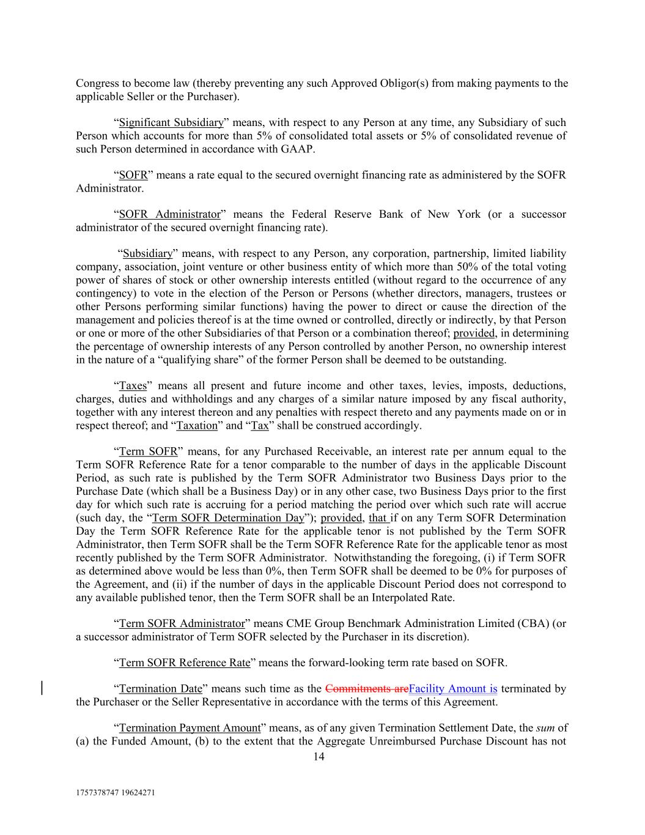
1757378747 19624271 14 Congress to become law (thereby preventing any such Approved Obligor(s) from making payments to the applicable Seller or the Purchaser). “Significant Subsidiary” means, with respect to any Person at any time, any Subsidiary of such Person which accounts for more than 5% of consolidated total assets or 5% of consolidated revenue of such Person determined in accordance with GAAP. “SOFR” means a rate equal to the secured overnight financing rate as administered by the SOFR Administrator. “SOFR Administrator” means the Federal Reserve Bank of New York (or a successor administrator of the secured overnight financing rate). “Subsidiary” means, with respect to any Person, any corporation, partnership, limited liability company, association, joint venture or other business entity of which more than 50% of the total voting power of shares of stock or other ownership interests entitled (without regard to the occurrence of any contingency) to vote in the election of the Person or Persons (whether directors, managers, trustees or other Persons performing similar functions) having the power to direct or cause the direction of the management and policies thereof is at the time owned or controlled, directly or indirectly, by that Person or one or more of the other Subsidiaries of that Person or a combination thereof; provided, in determining the percentage of ownership interests of any Person controlled by another Person, no ownership interest in the nature of a “qualifying share” of the former Person shall be deemed to be outstanding. “Taxes” means all present and future income and other taxes, levies, imposts, deductions, charges, duties and withholdings and any charges of a similar nature imposed by any fiscal authority, together with any interest thereon and any penalties with respect thereto and any payments made on or in respect thereof; and “Taxation” and “Tax” shall be construed accordingly. “Term SOFR” means, for any Purchased Receivable, an interest rate per annum equal to the Term SOFR Reference Rate for a tenor comparable to the number of days in the applicable Discount Period, as such rate is published by the Term SOFR Administrator two Business Days prior to the Purchase Date (which shall be a Business Day) or in any other case, two Business Days prior to the first day for which such rate is accruing for a period matching the period over which such rate will accrue (such day, the “Term SOFR Determination Day”); provided, that if on any Term SOFR Determination Day the Term SOFR Reference Rate for the applicable tenor is not published by the Term SOFR Administrator, then Term SOFR shall be the Term SOFR Reference Rate for the applicable tenor as most recently published by the Term SOFR Administrator. Notwithstanding the foregoing, (i) if Term SOFR as determined above would be less than 0%, then Term SOFR shall be deemed to be 0% for purposes of the Agreement, and (ii) if the number of days in the applicable Discount Period does not correspond to any available published tenor, then the Term SOFR shall be an Interpolated Rate. “Term SOFR Administrator” means CME Group Benchmark Administration Limited (CBA) (or a successor administrator of Term SOFR selected by the Purchaser in its discretion). “Term SOFR Reference Rate” means the forward-looking term rate based on SOFR. “Termination Date” means such time as the Commitments areFacility Amount is terminated by the Purchaser or the Seller Representative in accordance with the terms of this Agreement. “Termination Payment Amount” means, as of any given Termination Settlement Date, the sum of (a) the Funded Amount, (b) to the extent that the Aggregate Unreimbursed Purchase Discount has not

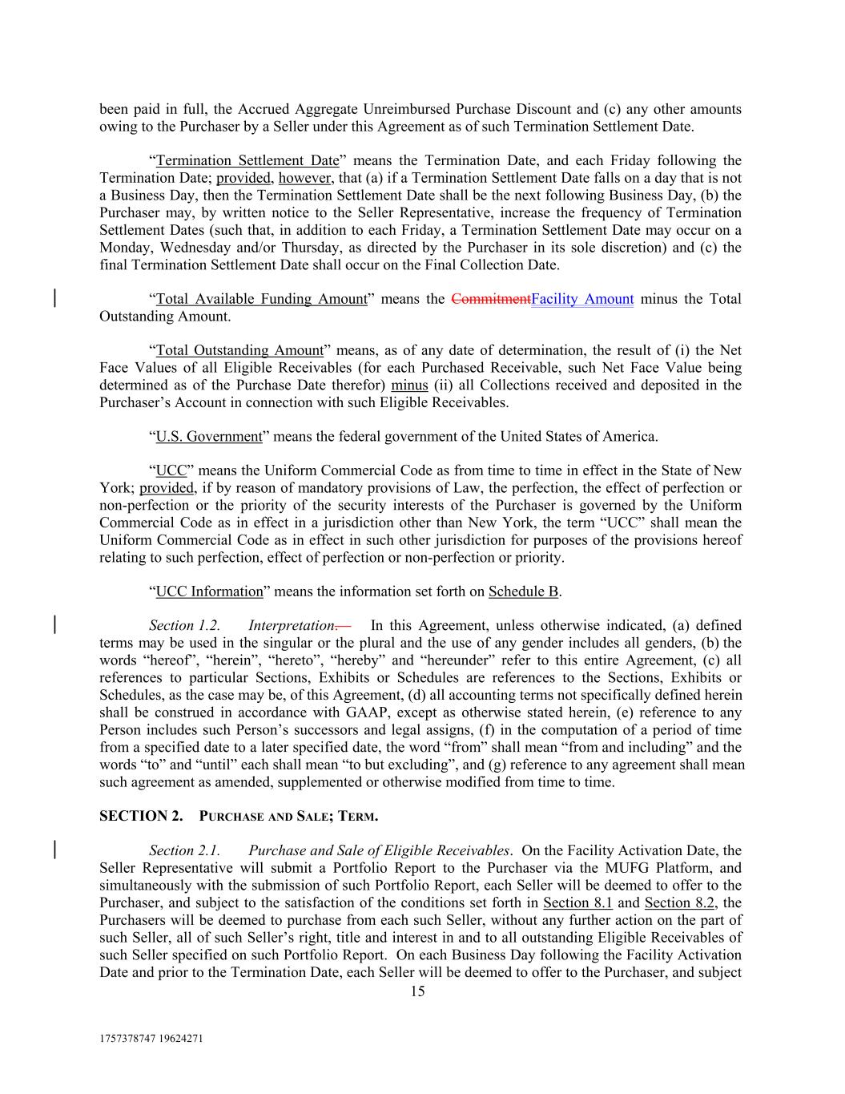
1757378747 19624271 15 been paid in full, the Accrued Aggregate Unreimbursed Purchase Discount and (c) any other amounts owing to the Purchaser by a Seller under this Agreement as of such Termination Settlement Date. “Termination Settlement Date” means the Termination Date, and each Friday following the Termination Date; provided, however, that (a) if a Termination Settlement Date falls on a day that is not a Business Day, then the Termination Settlement Date shall be the next following Business Day, (b) the Purchaser may, by written notice to the Seller Representative, increase the frequency of Termination Settlement Dates (such that, in addition to each Friday, a Termination Settlement Date may occur on a Monday, Wednesday and/or Thursday, as directed by the Purchaser in its sole discretion) and (c) the final Termination Settlement Date shall occur on the Final Collection Date. “Total Available Funding Amount” means the CommitmentFacility Amount minus the Total Outstanding Amount. “Total Outstanding Amount” means, as of any date of determination, the result of (i) the Net Face Values of all Eligible Receivables (for each Purchased Receivable, such Net Face Value being determined as of the Purchase Date therefor) minus (ii) all Collections received and deposited in the Purchaser’s Account in connection with such Eligible Receivables. “U.S. Government” means the federal government of the United States of America. “UCC” means the Uniform Commercial Code as from time to time in effect in the State of New York; provided, if by reason of mandatory provisions of Law, the perfection, the effect of perfection or non-perfection or the priority of the security interests of the Purchaser is governed by the Uniform Commercial Code as in effect in a jurisdiction other than New York, the term “UCC” shall mean the Uniform Commercial Code as in effect in such other jurisdiction for purposes of the provisions hereof relating to such perfection, effect of perfection or non-perfection or priority. “UCC Information” means the information set forth on Schedule B. Section 1.2. Interpretation. In this Agreement, unless otherwise indicated, (a) defined terms may be used in the singular or the plural and the use of any gender includes all genders, (b) the words “hereof”, “herein”, “hereto”, “hereby” and “hereunder” refer to this entire Agreement, (c) all references to particular Sections, Exhibits or Schedules are references to the Sections, Exhibits or Schedules, as the case may be, of this Agreement, (d) all accounting terms not specifically defined herein shall be construed in accordance with GAAP, except as otherwise stated herein, (e) reference to any Person includes such Person’s successors and legal assigns, (f) in the computation of a period of time from a specified date to a later specified date, the word “from” shall mean “from and including” and the words “to” and “until” each shall mean “to but excluding”, and (g) reference to any agreement shall mean such agreement as amended, supplemented or otherwise modified from time to time. SECTION 2. PURCHASE AND SALE; TERM. Section 2.1. Purchase and Sale of Eligible Receivables. On the Facility Activation Date, the Seller Representative will submit a Portfolio Report to the Purchaser via the MUFG Platform, and simultaneously with the submission of such Portfolio Report, each Seller will be deemed to offer to the Purchaser, and subject to the satisfaction of the conditions set forth in Section 8.1 and Section 8.2, the Purchasers will be deemed to purchase from each such Seller, without any further action on the part of such Seller, all of such Seller’s right, title and interest in and to all outstanding Eligible Receivables of such Seller specified on such Portfolio Report. On each Business Day following the Facility Activation Date and prior to the Termination Date, each Seller will be deemed to offer to the Purchaser, and subject

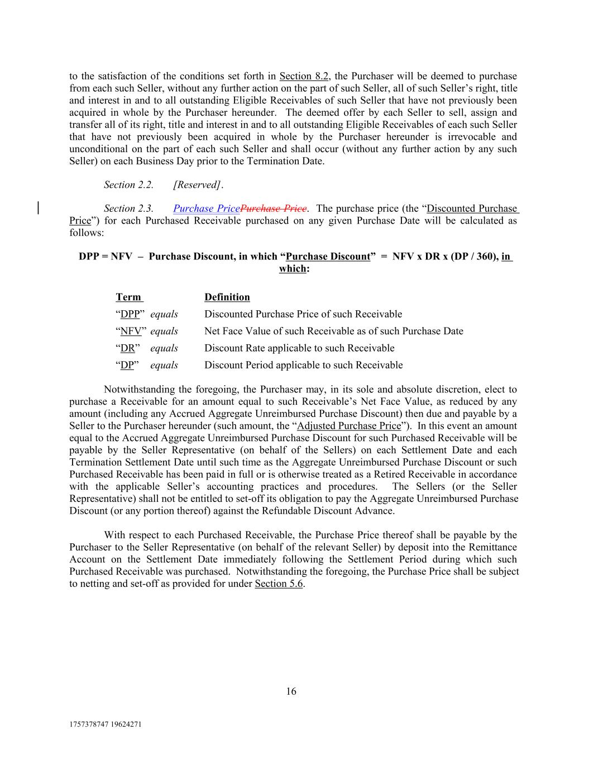
1757378747 19624271 16 Definition Net Face Value of such Receivable as of such Purchase Date to the satisfaction of the conditions set forth in Section 8.2, the Purchaser will be deemed to purchase from each such Seller, without any further action on the part of such Seller, all of such Seller’s right, title and interest in and to all outstanding Eligible Receivables of such Seller that have not previously been acquired in whole by the Purchaser hereunder. The deemed offer by each Seller to sell, assign and transfer all of its right, title and interest in and to all outstanding Eligible Receivables of each such Seller that have not previously been acquired in whole by the Purchaser hereunder is irrevocable and unconditional on the part of each such Seller and shall occur (without any further action by any such Seller) on each Business Day prior to the Termination Date. Section 2.2. [Reserved]. Section 2.3. Purchase PricePurchase Price. The purchase price (the “Discounted Purchase Price”) for each Purchased Receivable purchased on any given Purchase Date will be calculated as follows: DPP = NFV – Purchase Discount, in which “Purchase Discount” = NFV x DR x (DP / 360), in which: “DR” equals Discount Rate applicable to such Receivable “DPP” equals “DP” equals Discounted Purchase Price of such Receivable Discount Period applicable to such Receivable Term Notwithstanding the foregoing, the Purchaser may, in its sole and absolute discretion, elect to purchase a Receivable for an amount equal to such Receivable’s Net Face Value, as reduced by any amount (including any Accrued Aggregate Unreimbursed Purchase Discount) then due and payable by a Seller to the Purchaser hereunder (such amount, the “Adjusted Purchase Price”). In this event an amount equal to the Accrued Aggregate Unreimbursed Purchase Discount for such Purchased Receivable will be payable by the Seller Representative (on behalf of the Sellers) on each Settlement Date and each Termination Settlement Date until such time as the Aggregate Unreimbursed Purchase Discount or such Purchased Receivable has been paid in full or is otherwise treated as a Retired Receivable in accordance with the applicable Seller’s accounting practices and procedures. The Sellers (or the Seller Representative) shall not be entitled to set-off its obligation to pay the Aggregate Unreimbursed Purchase Discount (or any portion thereof) against the Refundable Discount Advance. With respect to each Purchased Receivable, the Purchase Price thereof shall be payable by the Purchaser to the Seller Representative (on behalf of the relevant Seller) by deposit into the Remittance Account on the Settlement Date immediately following the Settlement Period during which such Purchased Receivable was purchased. Notwithstanding the foregoing, the Purchase Price shall be subject to netting and set-off as provided for under Section 5.6. “NFV” equals

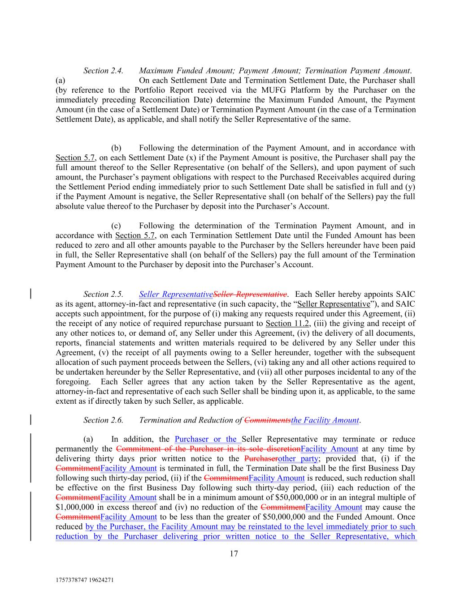
1757378747 19624271 17 Section 2.4. Maximum Funded Amount; Payment Amount; Termination Payment Amount. (a) On each Settlement Date and Termination Settlement Date, the Purchaser shall (by reference to the Portfolio Report received via the MUFG Platform by the Purchaser on the immediately preceding Reconciliation Date) determine the Maximum Funded Amount, the Payment Amount (in the case of a Settlement Date) or Termination Payment Amount (in the case of a Termination Settlement Date), as applicable, and shall notify the Seller Representative of the same. (b) Following the determination of the Payment Amount, and in accordance with Section 5.7, on each Settlement Date (x) if the Payment Amount is positive, the Purchaser shall pay the full amount thereof to the Seller Representative (on behalf of the Sellers), and upon payment of such amount, the Purchaser’s payment obligations with respect to the Purchased Receivables acquired during the Settlement Period ending immediately prior to such Settlement Date shall be satisfied in full and (y) if the Payment Amount is negative, the Seller Representative shall (on behalf of the Sellers) pay the full absolute value thereof to the Purchaser by deposit into the Purchaser’s Account. (c) Following the determination of the Termination Payment Amount, and in accordance with Section 5.7, on each Termination Settlement Date until the Funded Amount has been reduced to zero and all other amounts payable to the Purchaser by the Sellers hereunder have been paid in full, the Seller Representative shall (on behalf of the Sellers) pay the full amount of the Termination Payment Amount to the Purchaser by deposit into the Purchaser’s Account. Section 2.5. Seller RepresentativeSeller Representative. Each Seller hereby appoints SAIC as its agent, attorney-in-fact and representative (in such capacity, the “Seller Representative”), and SAIC accepts such appointment, for the purpose of (i) making any requests required under this Agreement, (ii) the receipt of any notice of required repurchase pursuant to Section 11.2, (iii) the giving and receipt of any other notices to, or demand of, any Seller under this Agreement, (iv) the delivery of all documents, reports, financial statements and written materials required to be delivered by any Seller under this Agreement, (v) the receipt of all payments owing to a Seller hereunder, together with the subsequent allocation of such payment proceeds between the Sellers, (vi) taking any and all other actions required to be undertaken hereunder by the Seller Representative, and (vii) all other purposes incidental to any of the foregoing. Each Seller agrees that any action taken by the Seller Representative as the agent, attorney-in-fact and representative of each such Seller shall be binding upon it, as applicable, to the same extent as if directly taken by such Seller, as applicable. Section 2.6. Termination and Reduction of Commitmentsthe Facility Amount. (a) In addition, the Purchaser or the Seller Representative may terminate or reduce permanently the Commitment of the Purchaser in its sole discretionFacility Amount at any time by delivering thirty days prior written notice to the Purchaserother party; provided that, (i) if the CommitmentFacility Amount is terminated in full, the Termination Date shall be the first Business Day following such thirty-day period, (ii) if the CommitmentFacility Amount is reduced, such reduction shall be effective on the first Business Day following such thirty-day period, (iii) each reduction of the CommitmentFacility Amount shall be in a minimum amount of $50,000,000 or in an integral multiple of $1,000,000 in excess thereof and (iv) no reduction of the CommitmentFacility Amount may cause the CommitmentFacility Amount to be less than the greater of $50,000,000 and the Funded Amount. Once reduced by the Purchaser, the Facility Amount may be reinstated to the level immediately prior to such reduction by the Purchaser delivering prior written notice to the Seller Representative, which

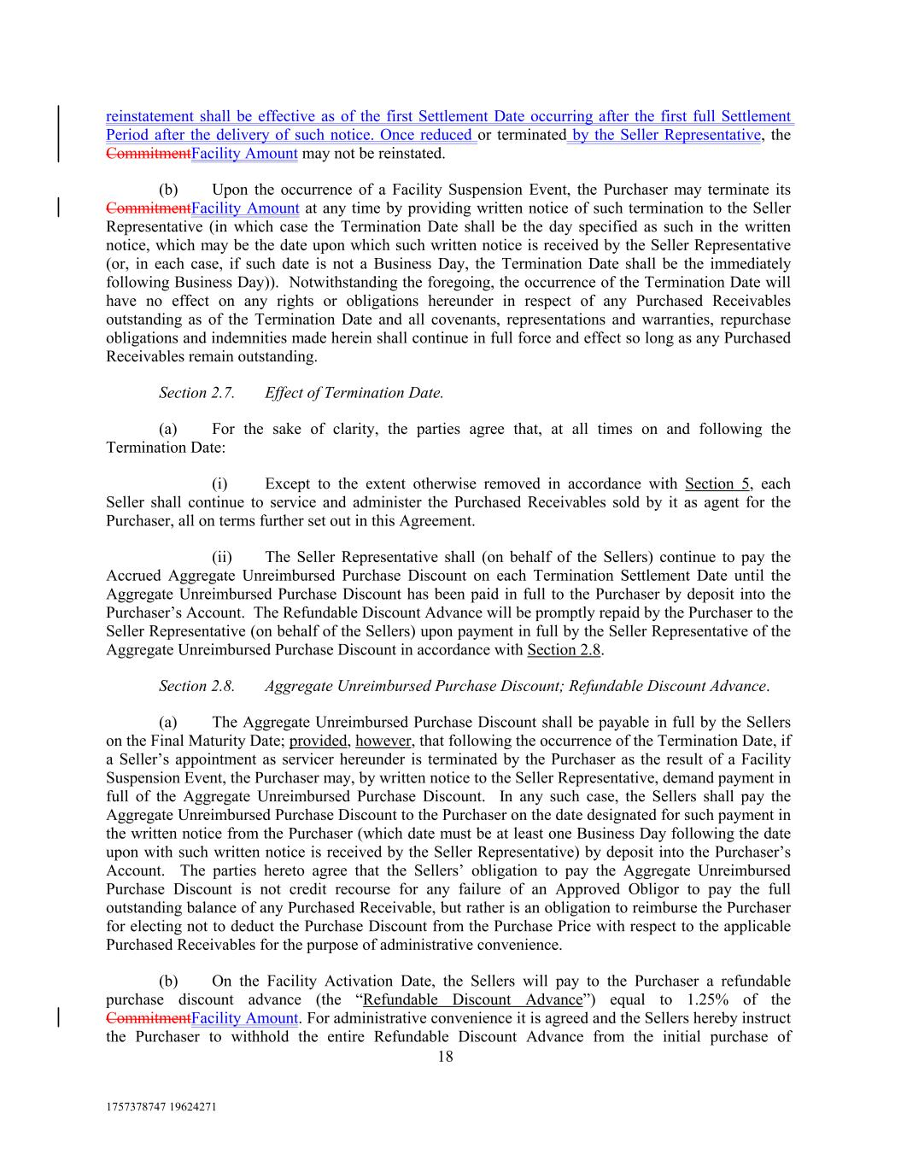
1757378747 19624271 18 reinstatement shall be effective as of the first Settlement Date occurring after the first full Settlement Period after the delivery of such notice. Once reduced or terminated by the Seller Representative, the CommitmentFacility Amount may not be reinstated. (b) Upon the occurrence of a Facility Suspension Event, the Purchaser may terminate its CommitmentFacility Amount at any time by providing written notice of such termination to the Seller Representative (in which case the Termination Date shall be the day specified as such in the written notice, which may be the date upon which such written notice is received by the Seller Representative (or, in each case, if such date is not a Business Day, the Termination Date shall be the immediately following Business Day)). Notwithstanding the foregoing, the occurrence of the Termination Date will have no effect on any rights or obligations hereunder in respect of any Purchased Receivables outstanding as of the Termination Date and all covenants, representations and warranties, repurchase obligations and indemnities made herein shall continue in full force and effect so long as any Purchased Receivables remain outstanding. Section 2.7. Effect of Termination Date. (a) For the sake of clarity, the parties agree that, at all times on and following the Termination Date: (i) Except to the extent otherwise removed in accordance with Section 5, each Seller shall continue to service and administer the Purchased Receivables sold by it as agent for the Purchaser, all on terms further set out in this Agreement. (ii) The Seller Representative shall (on behalf of the Sellers) continue to pay the Accrued Aggregate Unreimbursed Purchase Discount on each Termination Settlement Date until the Aggregate Unreimbursed Purchase Discount has been paid in full to the Purchaser by deposit into the Purchaser’s Account. The Refundable Discount Advance will be promptly repaid by the Purchaser to the Seller Representative (on behalf of the Sellers) upon payment in full by the Seller Representative of the Aggregate Unreimbursed Purchase Discount in accordance with Section 2.8. Section 2.8. Aggregate Unreimbursed Purchase Discount; Refundable Discount Advance. (a) The Aggregate Unreimbursed Purchase Discount shall be payable in full by the Sellers on the Final Maturity Date; provided, however, that following the occurrence of the Termination Date, if a Seller’s appointment as servicer hereunder is terminated by the Purchaser as the result of a Facility Suspension Event, the Purchaser may, by written notice to the Seller Representative, demand payment in full of the Aggregate Unreimbursed Purchase Discount. In any such case, the Sellers shall pay the Aggregate Unreimbursed Purchase Discount to the Purchaser on the date designated for such payment in the written notice from the Purchaser (which date must be at least one Business Day following the date upon with such written notice is received by the Seller Representative) by deposit into the Purchaser’s Account. The parties hereto agree that the Sellers’ obligation to pay the Aggregate Unreimbursed Purchase Discount is not credit recourse for any failure of an Approved Obligor to pay the full outstanding balance of any Purchased Receivable, but rather is an obligation to reimburse the Purchaser for electing not to deduct the Purchase Discount from the Purchase Price with respect to the applicable Purchased Receivables for the purpose of administrative convenience. (b) On the Facility Activation Date, the Sellers will pay to the Purchaser a refundable purchase discount advance (the “Refundable Discount Advance”) equal to 1.25% of the CommitmentFacility Amount. For administrative convenience it is agreed and the Sellers hereby instruct the Purchaser to withhold the entire Refundable Discount Advance from the initial purchase of

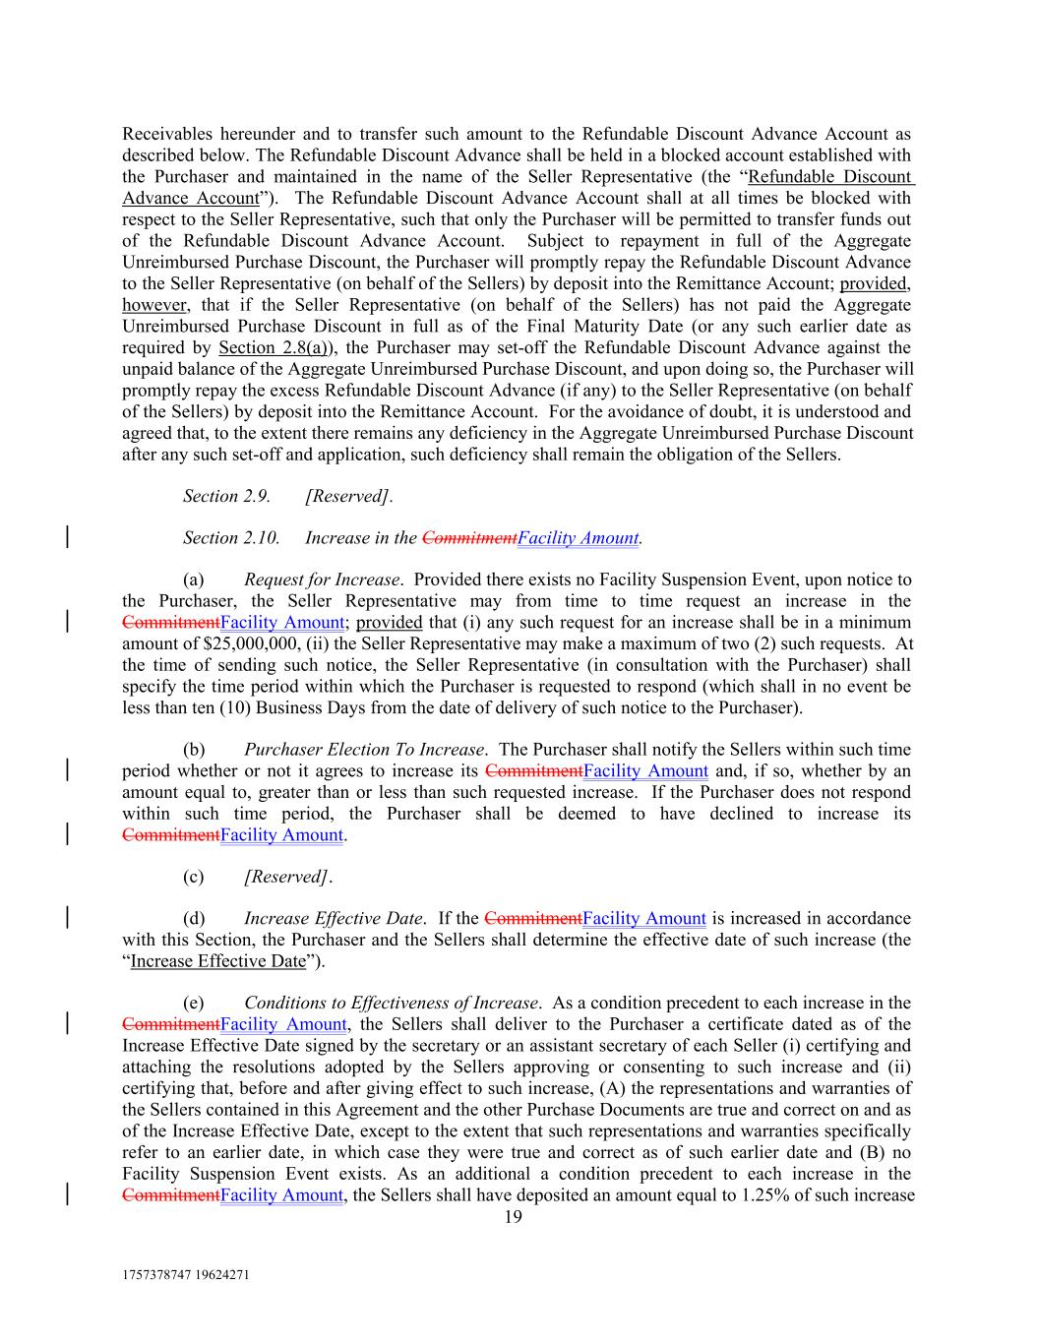
1757378747 19624271 19 Receivables hereunder and to transfer such amount to the Refundable Discount Advance Account as described below. The Refundable Discount Advance shall be held in a blocked account established with the Purchaser and maintained in the name of the Seller Representative (the “Refundable Discount Advance Account”). The Refundable Discount Advance Account shall at all times be blocked with respect to the Seller Representative, such that only the Purchaser will be permitted to transfer funds out of the Refundable Discount Advance Account. Subject to repayment in full of the Aggregate Unreimbursed Purchase Discount, the Purchaser will promptly repay the Refundable Discount Advance to the Seller Representative (on behalf of the Sellers) by deposit into the Remittance Account; provided, however, that if the Seller Representative (on behalf of the Sellers) has not paid the Aggregate Unreimbursed Purchase Discount in full as of the Final Maturity Date (or any such earlier date as required by Section 2.8(a)), the Purchaser may set-off the Refundable Discount Advance against the unpaid balance of the Aggregate Unreimbursed Purchase Discount, and upon doing so, the Purchaser will promptly repay the excess Refundable Discount Advance (if any) to the Seller Representative (on behalf of the Sellers) by deposit into the Remittance Account. For the avoidance of doubt, it is understood and agreed that, to the extent there remains any deficiency in the Aggregate Unreimbursed Purchase Discount after any such set-off and application, such deficiency shall remain the obligation of the Sellers. Section 2.9. [Reserved]. Section 2.10. Increase in the CommitmentFacility Amount. (a) Request for Increase. Provided there exists no Facility Suspension Event, upon notice to the Purchaser, the Seller Representative may from time to time request an increase in the CommitmentFacility Amount; provided that (i) any such request for an increase shall be in a minimum amount of $25,000,000, (ii) the Seller Representative may make a maximum of two (2) such requests. At the time of sending such notice, the Seller Representative (in consultation with the Purchaser) shall specify the time period within which the Purchaser is requested to respond (which shall in no event be less than ten (10) Business Days from the date of delivery of such notice to the Purchaser). (b) Purchaser Election To Increase. The Purchaser shall notify the Sellers within such time period whether or not it agrees to increase its CommitmentFacility Amount and, if so, whether by an amount equal to, greater than or less than such requested increase. If the Purchaser does not respond within such time period, the Purchaser shall be deemed to have declined to increase its CommitmentFacility Amount. (c) [Reserved]. (d) Increase Effective Date. If the CommitmentFacility Amount is increased in accordance with this Section, the Purchaser and the Sellers shall determine the effective date of such increase (the “Increase Effective Date”). (e) Conditions to Effectiveness of Increase. As a condition precedent to each increase in the CommitmentFacility Amount, the Sellers shall deliver to the Purchaser a certificate dated as of the Increase Effective Date signed by the secretary or an assistant secretary of each Seller (i) certifying and attaching the resolutions adopted by the Sellers approving or consenting to such increase and (ii) certifying that, before and after giving effect to such increase, (A) the representations and warranties of the Sellers contained in this Agreement and the other Purchase Documents are true and correct on and as of the Increase Effective Date, except to the extent that such representations and warranties specifically refer to an earlier date, in which case they were true and correct as of such earlier date and (B) no Facility Suspension Event exists. As an additional a condition precedent to each increase in the CommitmentFacility Amount, the Sellers shall have deposited an amount equal to 1.25% of such increase

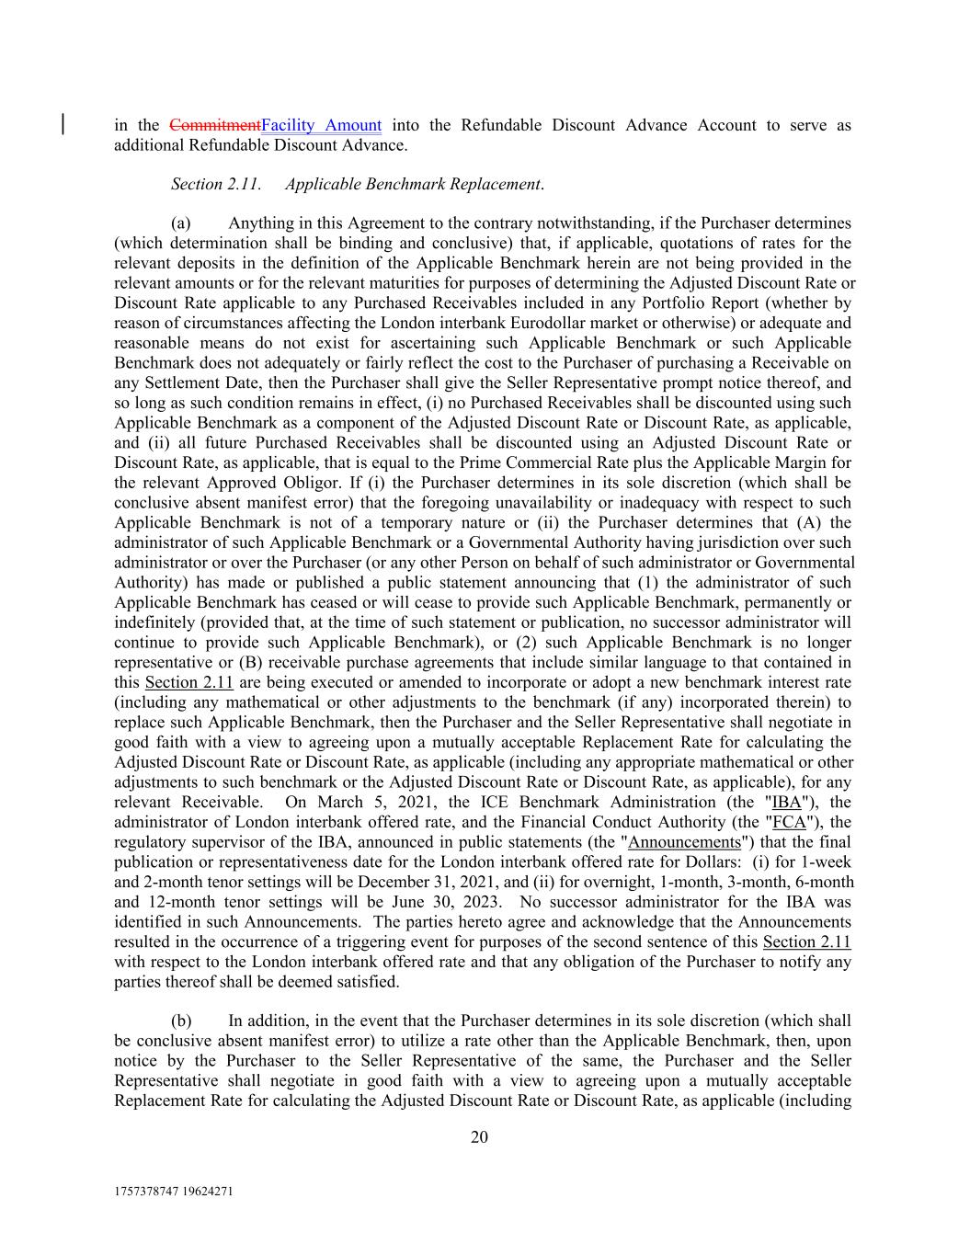
1757378747 19624271 20 in the CommitmentFacility Amount into the Refundable Discount Advance Account to serve as additional Refundable Discount Advance. Section 2.11. Applicable Benchmark Replacement. (a) Anything in this Agreement to the contrary notwithstanding, if the Purchaser determines (which determination shall be binding and conclusive) that, if applicable, quotations of rates for the relevant deposits in the definition of the Applicable Benchmark herein are not being provided in the relevant amounts or for the relevant maturities for purposes of determining the Adjusted Discount Rate or Discount Rate applicable to any Purchased Receivables included in any Portfolio Report (whether by reason of circumstances affecting the London interbank Eurodollar market or otherwise) or adequate and reasonable means do not exist for ascertaining such Applicable Benchmark or such Applicable Benchmark does not adequately or fairly reflect the cost to the Purchaser of purchasing a Receivable on any Settlement Date, then the Purchaser shall give the Seller Representative prompt notice thereof, and so long as such condition remains in effect, (i) no Purchased Receivables shall be discounted using such Applicable Benchmark as a component of the Adjusted Discount Rate or Discount Rate, as applicable, and (ii) all future Purchased Receivables shall be discounted using an Adjusted Discount Rate or Discount Rate, as applicable, that is equal to the Prime Commercial Rate plus the Applicable Margin for the relevant Approved Obligor. If (i) the Purchaser determines in its sole discretion (which shall be conclusive absent manifest error) that the foregoing unavailability or inadequacy with respect to such Applicable Benchmark is not of a temporary nature or (ii) the Purchaser determines that (A) the administrator of such Applicable Benchmark or a Governmental Authority having jurisdiction over such administrator or over the Purchaser (or any other Person on behalf of such administrator or Governmental Authority) has made or published a public statement announcing that (1) the administrator of such Applicable Benchmark has ceased or will cease to provide such Applicable Benchmark, permanently or indefinitely (provided that, at the time of such statement or publication, no successor administrator will continue to provide such Applicable Benchmark), or (2) such Applicable Benchmark is no longer representative or (B) receivable purchase agreements that include similar language to that contained in this Section 2.11 are being executed or amended to incorporate or adopt a new benchmark interest rate (including any mathematical or other adjustments to the benchmark (if any) incorporated therein) to replace such Applicable Benchmark, then the Purchaser and the Seller Representative shall negotiate in good faith with a view to agreeing upon a mutually acceptable Replacement Rate for calculating the Adjusted Discount Rate or Discount Rate, as applicable (including any appropriate mathematical or other adjustments to such benchmark or the Adjusted Discount Rate or Discount Rate, as applicable), for any relevant Receivable. On March 5, 2021, the ICE Benchmark Administration (the "IBA"), the administrator of London interbank offered rate, and the Financial Conduct Authority (the "FCA"), the regulatory supervisor of the IBA, announced in public statements (the "Announcements") that the final publication or representativeness date for the London interbank offered rate for Dollars: (i) for 1-week and 2-month tenor settings will be December 31, 2021, and (ii) for overnight, 1-month, 3-month, 6-month and 12-month tenor settings will be June 30, 2023. No successor administrator for the IBA was identified in such Announcements. The parties hereto agree and acknowledge that the Announcements resulted in the occurrence of a triggering event for purposes of the second sentence of this Section 2.11 with respect to the London interbank offered rate and that any obligation of the Purchaser to notify any parties thereof shall be deemed satisfied. (b) In addition, in the event that the Purchaser determines in its sole discretion (which shall be conclusive absent manifest error) to utilize a rate other than the Applicable Benchmark, then, upon notice by the Purchaser to the Seller Representative of the same, the Purchaser and the Seller Representative shall negotiate in good faith with a view to agreeing upon a mutually acceptable Replacement Rate for calculating the Adjusted Discount Rate or Discount Rate, as applicable (including

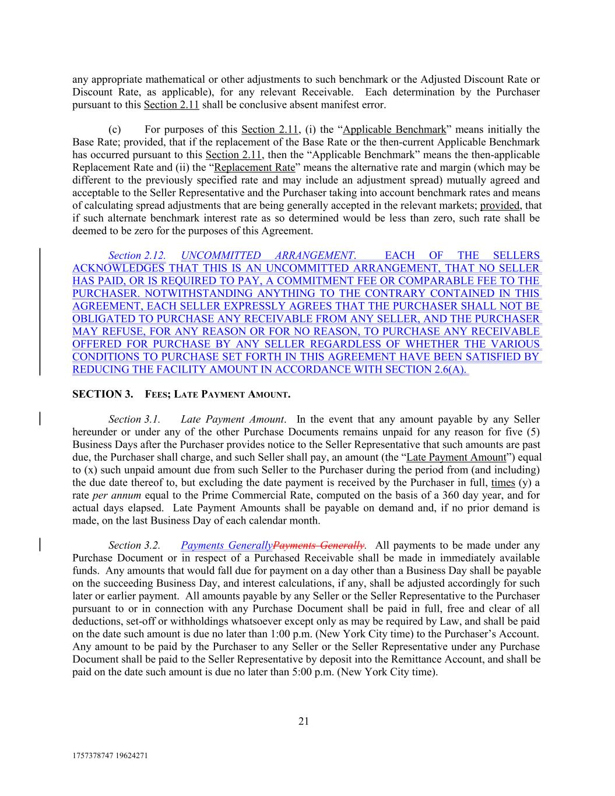
1757378747 19624271 21 any appropriate mathematical or other adjustments to such benchmark or the Adjusted Discount Rate or Discount Rate, as applicable), for any relevant Receivable. Each determination by the Purchaser pursuant to this Section 2.11 shall be conclusive absent manifest error. (c) For purposes of this Section 2.11, (i) the “Applicable Benchmark” means initially the Base Rate; provided, that if the replacement of the Base Rate or the then-current Applicable Benchmark has occurred pursuant to this Section 2.11, then the “Applicable Benchmark” means the then-applicable Replacement Rate and (ii) the “Replacement Rate” means the alternative rate and margin (which may be different to the previously specified rate and may include an adjustment spread) mutually agreed and acceptable to the Seller Representative and the Purchaser taking into account benchmark rates and means of calculating spread adjustments that are being generally accepted in the relevant markets; provided, that if such alternate benchmark interest rate as so determined would be less than zero, such rate shall be deemed to be zero for the purposes of this Agreement. Section 2.12. UNCOMMITTED ARRANGEMENT. EACH OF THE SELLERS ACKNOWLEDGES THAT THIS IS AN UNCOMMITTED ARRANGEMENT, THAT NO SELLER HAS PAID, OR IS REQUIRED TO PAY, A COMMITMENT FEE OR COMPARABLE FEE TO THE PURCHASER. NOTWITHSTANDING ANYTHING TO THE CONTRARY CONTAINED IN THIS AGREEMENT, EACH SELLER EXPRESSLY AGREES THAT THE PURCHASER SHALL NOT BE OBLIGATED TO PURCHASE ANY RECEIVABLE FROM ANY SELLER, AND THE PURCHASER MAY REFUSE, FOR ANY REASON OR FOR NO REASON, TO PURCHASE ANY RECEIVABLE OFFERED FOR PURCHASE BY ANY SELLER REGARDLESS OF WHETHER THE VARIOUS CONDITIONS TO PURCHASE SET FORTH IN THIS AGREEMENT HAVE BEEN SATISFIED BY REDUCING THE FACILITY AMOUNT IN ACCORDANCE WITH SECTION 2.6(A). SECTION 3. FEES; LATE PAYMENT AMOUNT. Section 3.1. Late Payment Amount. In the event that any amount payable by any Seller hereunder or under any of the other Purchase Documents remains unpaid for any reason for five (5) Business Days after the Purchaser provides notice to the Seller Representative that such amounts are past due, the Purchaser shall charge, and such Seller shall pay, an amount (the “Late Payment Amount”) equal to (x) such unpaid amount due from such Seller to the Purchaser during the period from (and including) the due date thereof to, but excluding the date payment is received by the Purchaser in full, times (y) a rate per annum equal to the Prime Commercial Rate, computed on the basis of a 360 day year, and for actual days elapsed. Late Payment Amounts shall be payable on demand and, if no prior demand is made, on the last Business Day of each calendar month. Section 3.2. Payments GenerallyPayments Generally. All payments to be made under any Purchase Document or in respect of a Purchased Receivable shall be made in immediately available funds. Any amounts that would fall due for payment on a day other than a Business Day shall be payable on the succeeding Business Day, and interest calculations, if any, shall be adjusted accordingly for such later or earlier payment. All amounts payable by any Seller or the Seller Representative to the Purchaser pursuant to or in connection with any Purchase Document shall be paid in full, free and clear of all deductions, set-off or withholdings whatsoever except only as may be required by Law, and shall be paid on the date such amount is due no later than 1:00 p.m. (New York City time) to the Purchaser’s Account. Any amount to be paid by the Purchaser to any Seller or the Seller Representative under any Purchase Document shall be paid to the Seller Representative by deposit into the Remittance Account, and shall be paid on the date such amount is due no later than 5:00 p.m. (New York City time).

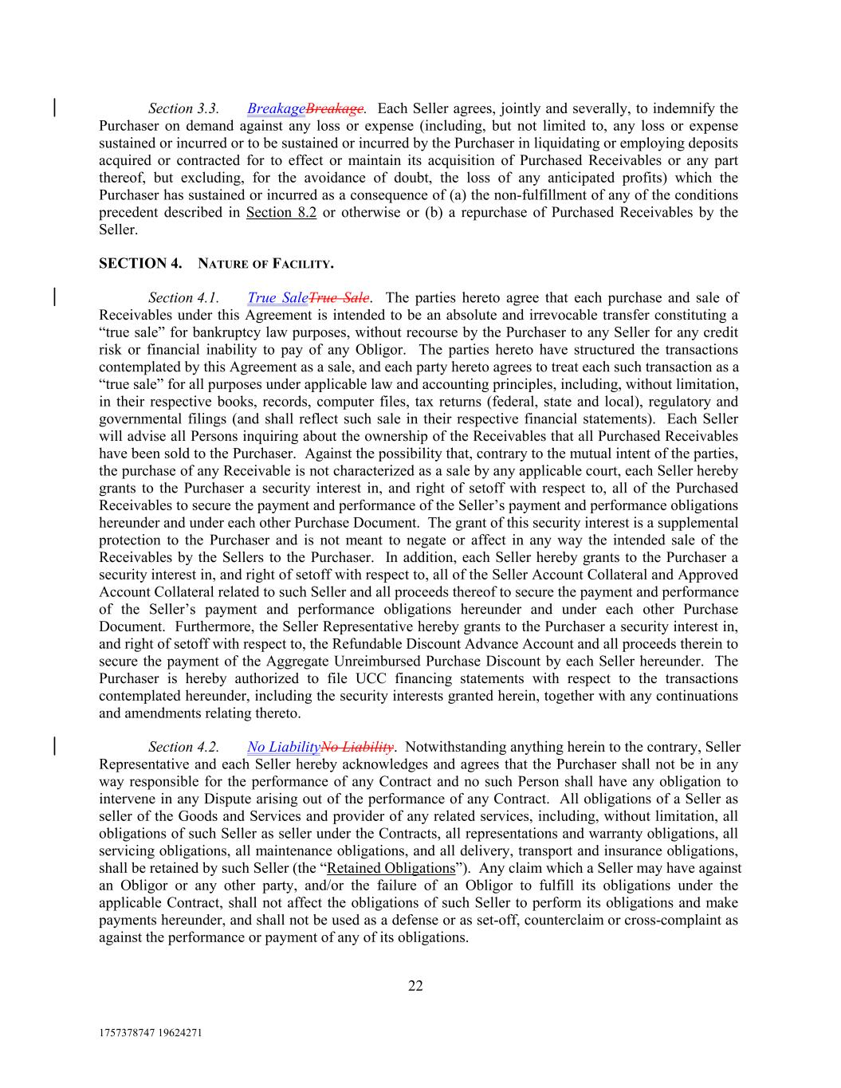
1757378747 19624271 22 Section 3.3. BreakageBreakage. Each Seller agrees, jointly and severally, to indemnify the Purchaser on demand against any loss or expense (including, but not limited to, any loss or expense sustained or incurred or to be sustained or incurred by the Purchaser in liquidating or employing deposits acquired or contracted for to effect or maintain its acquisition of Purchased Receivables or any part thereof, but excluding, for the avoidance of doubt, the loss of any anticipated profits) which the Purchaser has sustained or incurred as a consequence of (a) the non-fulfillment of any of the conditions precedent described in Section 8.2 or otherwise or (b) a repurchase of Purchased Receivables by the Seller. SECTION 4. NATURE OF FACILITY. Section 4.1. True SaleTrue Sale. The parties hereto agree that each purchase and sale of Receivables under this Agreement is intended to be an absolute and irrevocable transfer constituting a “true sale” for bankruptcy law purposes, without recourse by the Purchaser to any Seller for any credit risk or financial inability to pay of any Obligor. The parties hereto have structured the transactions contemplated by this Agreement as a sale, and each party hereto agrees to treat each such transaction as a “true sale” for all purposes under applicable law and accounting principles, including, without limitation, in their respective books, records, computer files, tax returns (federal, state and local), regulatory and governmental filings (and shall reflect such sale in their respective financial statements). Each Seller will advise all Persons inquiring about the ownership of the Receivables that all Purchased Receivables have been sold to the Purchaser. Against the possibility that, contrary to the mutual intent of the parties, the purchase of any Receivable is not characterized as a sale by any applicable court, each Seller hereby grants to the Purchaser a security interest in, and right of setoff with respect to, all of the Purchased Receivables to secure the payment and performance of the Seller’s payment and performance obligations hereunder and under each other Purchase Document. The grant of this security interest is a supplemental protection to the Purchaser and is not meant to negate or affect in any way the intended sale of the Receivables by the Sellers to the Purchaser. In addition, each Seller hereby grants to the Purchaser a security interest in, and right of setoff with respect to, all of the Seller Account Collateral and Approved Account Collateral related to such Seller and all proceeds thereof to secure the payment and performance of the Seller’s payment and performance obligations hereunder and under each other Purchase Document. Furthermore, the Seller Representative hereby grants to the Purchaser a security interest in, and right of setoff with respect to, the Refundable Discount Advance Account and all proceeds therein to secure the payment of the Aggregate Unreimbursed Purchase Discount by each Seller hereunder. The Purchaser is hereby authorized to file UCC financing statements with respect to the transactions contemplated hereunder, including the security interests granted herein, together with any continuations and amendments relating thereto. Section 4.2. No LiabilityNo Liability. Notwithstanding anything herein to the contrary, Seller Representative and each Seller hereby acknowledges and agrees that the Purchaser shall not be in any way responsible for the performance of any Contract and no such Person shall have any obligation to intervene in any Dispute arising out of the performance of any Contract. All obligations of a Seller as seller of the Goods and Services and provider of any related services, including, without limitation, all obligations of such Seller as seller under the Contracts, all representations and warranty obligations, all servicing obligations, all maintenance obligations, and all delivery, transport and insurance obligations, shall be retained by such Seller (the “Retained Obligations”). Any claim which a Seller may have against an Obligor or any other party, and/or the failure of an Obligor to fulfill its obligations under the applicable Contract, shall not affect the obligations of such Seller to perform its obligations and make payments hereunder, and shall not be used as a defense or as set-off, counterclaim or cross-complaint as against the performance or payment of any of its obligations.

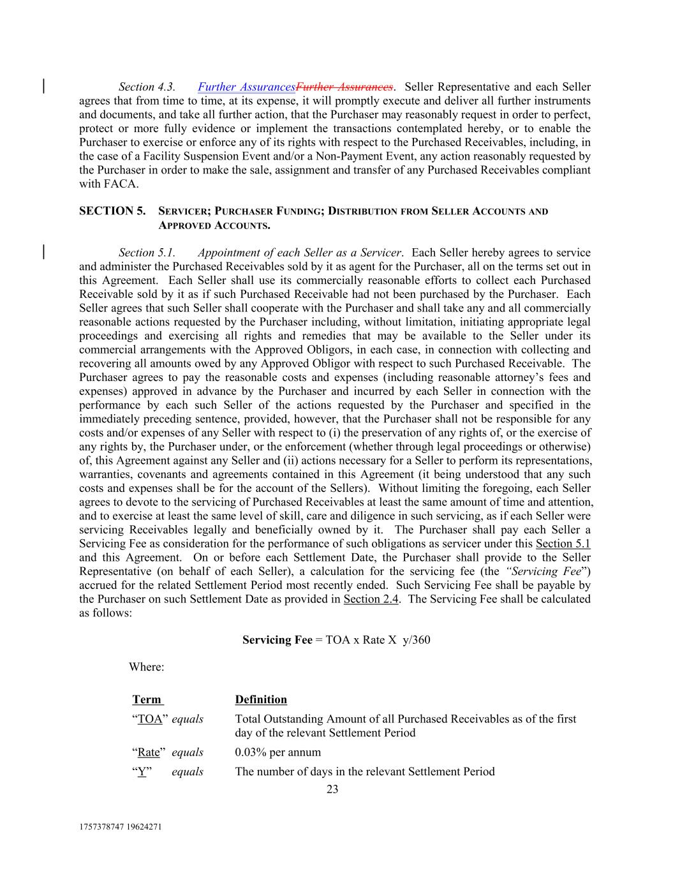
1757378747 19624271 23 “Rate” equals Definition 0.03% per annum Section 4.3. Further AssurancesFurther Assurances. Seller Representative and each Seller agrees that from time to time, at its expense, it will promptly execute and deliver all further instruments and documents, and take all further action, that the Purchaser may reasonably request in order to perfect, protect or more fully evidence or implement the transactions contemplated hereby, or to enable the Purchaser to exercise or enforce any of its rights with respect to the Purchased Receivables, including, in the case of a Facility Suspension Event and/or a Non-Payment Event, any action reasonably requested by the Purchaser in order to make the sale, assignment and transfer of any Purchased Receivables compliant with FACA. SECTION 5. SERVICER; PURCHASER FUNDING; DISTRIBUTION FROM SELLER ACCOUNTS AND APPROVED ACCOUNTS. Section 5.1. Appointment of each Seller as a Servicer. Each Seller hereby agrees to service and administer the Purchased Receivables sold by it as agent for the Purchaser, all on the terms set out in this Agreement. Each Seller shall use its commercially reasonable efforts to collect each Purchased Receivable sold by it as if such Purchased Receivable had not been purchased by the Purchaser. Each Seller agrees that such Seller shall cooperate with the Purchaser and shall take any and all commercially reasonable actions requested by the Purchaser including, without limitation, initiating appropriate legal proceedings and exercising all rights and remedies that may be available to the Seller under its commercial arrangements with the Approved Obligors, in each case, in connection with collecting and recovering all amounts owed by any Approved Obligor with respect to such Purchased Receivable. The Purchaser agrees to pay the reasonable costs and expenses (including reasonable attorney’s fees and expenses) approved in advance by the Purchaser and incurred by each Seller in connection with the performance by each such Seller of the actions requested by the Purchaser and specified in the immediately preceding sentence, provided, however, that the Purchaser shall not be responsible for any costs and/or expenses of any Seller with respect to (i) the preservation of any rights of, or the exercise of any rights by, the Purchaser under, or the enforcement (whether through legal proceedings or otherwise) of, this Agreement against any Seller and (ii) actions necessary for a Seller to perform its representations, warranties, covenants and agreements contained in this Agreement (it being understood that any such costs and expenses shall be for the account of the Sellers). Without limiting the foregoing, each Seller agrees to devote to the servicing of Purchased Receivables at least the same amount of time and attention, and to exercise at least the same level of skill, care and diligence in such servicing, as if each Seller were servicing Receivables legally and beneficially owned by it. The Purchaser shall pay each Seller a Servicing Fee as consideration for the performance of such obligations as servicer under this Section 5.1 and this Agreement. On or before each Settlement Date, the Purchaser shall provide to the Seller Representative (on behalf of each Seller), a calculation for the servicing fee (the “Servicing Fee”) accrued for the related Settlement Period most recently ended. Such Servicing Fee shall be payable by the Purchaser on such Settlement Date as provided in Section 2.4. The Servicing Fee shall be calculated as follows: Servicing Fee = TOA x Rate X y/360 Where: “Y” equals The number of days in the relevant Settlement Period “TOA” equals Total Outstanding Amount of all Purchased Receivables as of the first day of the relevant Settlement Period Term

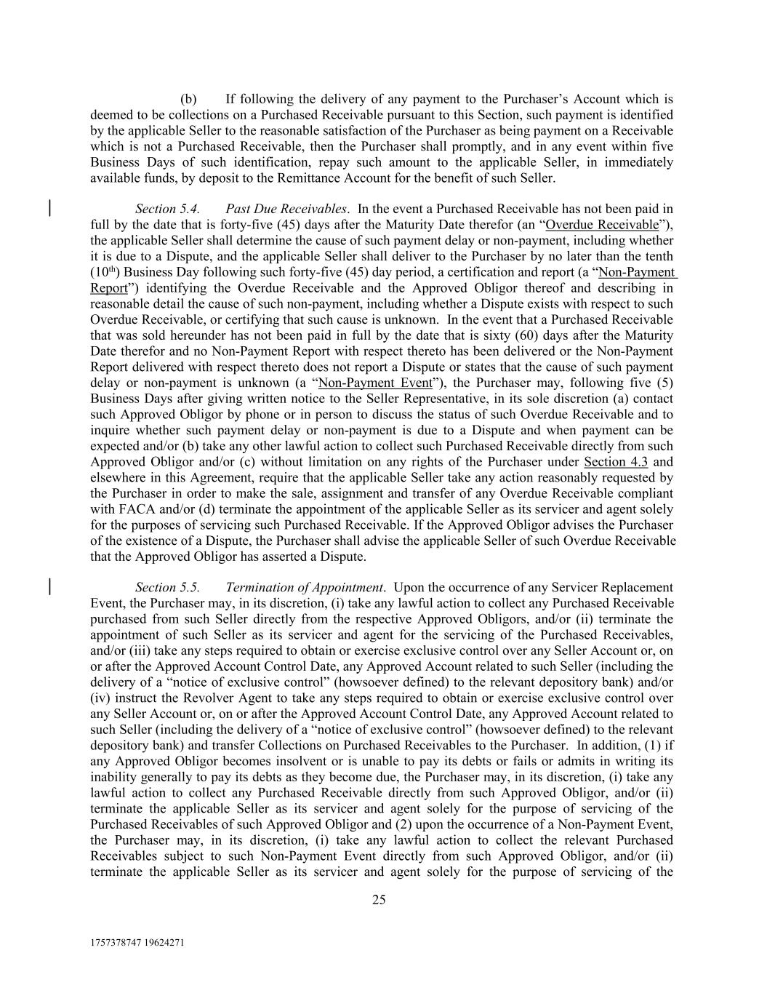
1757378747 19624271 25 (b) If following the delivery of any payment to the Purchaser’s Account which is deemed to be collections on a Purchased Receivable pursuant to this Section, such payment is identified by the applicable Seller to the reasonable satisfaction of the Purchaser as being payment on a Receivable which is not a Purchased Receivable, then the Purchaser shall promptly, and in any event within five Business Days of such identification, repay such amount to the applicable Seller, in immediately available funds, by deposit to the Remittance Account for the benefit of such Seller. Section 5.4. Past Due Receivables. In the event a Purchased Receivable has not been paid in full by the date that is forty-five (45) days after the Maturity Date therefor (an “Overdue Receivable”), the applicable Seller shall determine the cause of such payment delay or non-payment, including whether it is due to a Dispute, and the applicable Seller shall deliver to the Purchaser by no later than the tenth (10th) Business Day following such forty-five (45) day period, a certification and report (a “Non-Payment Report”) identifying the Overdue Receivable and the Approved Obligor thereof and describing in reasonable detail the cause of such non-payment, including whether a Dispute exists with respect to such Overdue Receivable, or certifying that such cause is unknown. In the event that a Purchased Receivable that was sold hereunder has not been paid in full by the date that is sixty (60) days after the Maturity Date therefor and no Non-Payment Report with respect thereto has been delivered or the Non-Payment Report delivered with respect thereto does not report a Dispute or states that the cause of such payment delay or non-payment is unknown (a “Non-Payment Event”), the Purchaser may, following five (5) Business Days after giving written notice to the Seller Representative, in its sole discretion (a) contact such Approved Obligor by phone or in person to discuss the status of such Overdue Receivable and to inquire whether such payment delay or non-payment is due to a Dispute and when payment can be expected and/or (b) take any other lawful action to collect such Purchased Receivable directly from such Approved Obligor and/or (c) without limitation on any rights of the Purchaser under Section 4.3 and elsewhere in this Agreement, require that the applicable Seller take any action reasonably requested by the Purchaser in order to make the sale, assignment and transfer of any Overdue Receivable compliant with FACA and/or (d) terminate the appointment of the applicable Seller as its servicer and agent solely for the purposes of servicing such Purchased Receivable. If the Approved Obligor advises the Purchaser of the existence of a Dispute, the Purchaser shall advise the applicable Seller of such Overdue Receivable that the Approved Obligor has asserted a Dispute. Section 5.5. Termination of Appointment. Upon the occurrence of any Servicer Replacement Event, the Purchaser may, in its discretion, (i) take any lawful action to collect any Purchased Receivable purchased from such Seller directly from the respective Approved Obligors, and/or (ii) terminate the appointment of such Seller as its servicer and agent for the servicing of the Purchased Receivables, and/or (iii) take any steps required to obtain or exercise exclusive control over any Seller Account or, on or after the Approved Account Control Date, any Approved Account related to such Seller (including the delivery of a “notice of exclusive control” (howsoever defined) to the relevant depository bank) and/or (iv) instruct the Revolver Agent to take any steps required to obtain or exercise exclusive control over any Seller Account or, on or after the Approved Account Control Date, any Approved Account related to such Seller (including the delivery of a “notice of exclusive control” (howsoever defined) to the relevant depository bank) and transfer Collections on Purchased Receivables to the Purchaser. In addition, (1) if any Approved Obligor becomes insolvent or is unable to pay its debts or fails or admits in writing its inability generally to pay its debts as they become due, the Purchaser may, in its discretion, (i) take any lawful action to collect any Purchased Receivable directly from such Approved Obligor, and/or (ii) terminate the applicable Seller as its servicer and agent solely for the purpose of servicing of the Purchased Receivables of such Approved Obligor and (2) upon the occurrence of a Non-Payment Event, the Purchaser may, in its discretion, (i) take any lawful action to collect the relevant Purchased Receivables subject to such Non-Payment Event directly from such Approved Obligor, and/or (ii) terminate the applicable Seller as its servicer and agent solely for the purpose of servicing of the

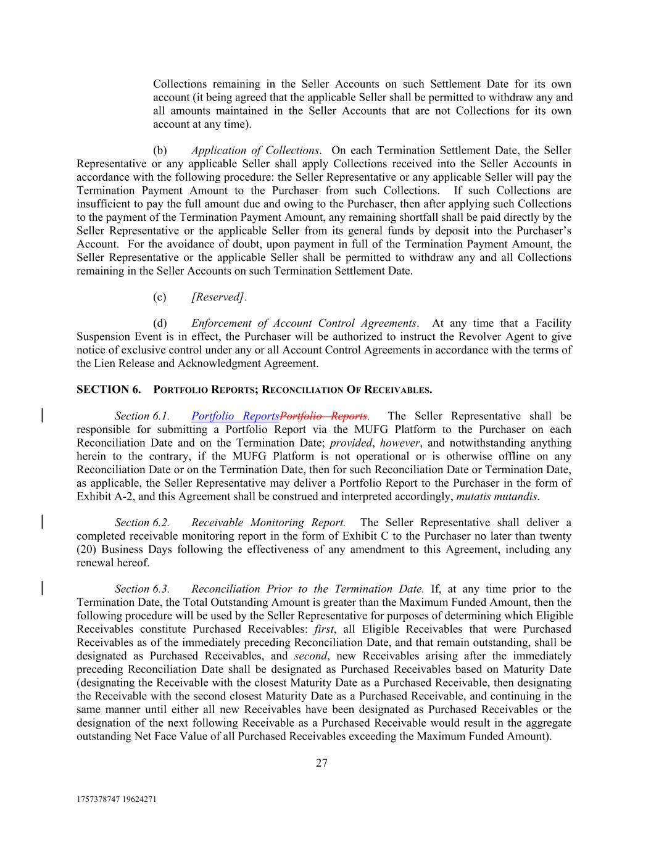
1757378747 19624271 27 Collections remaining in the Seller Accounts on such Settlement Date for its own account (it being agreed that the applicable Seller shall be permitted to withdraw any and all amounts maintained in the Seller Accounts that are not Collections for its own account at any time). (b) Application of Collections. On each Termination Settlement Date, the Seller Representative or any applicable Seller shall apply Collections received into the Seller Accounts in accordance with the following procedure: the Seller Representative or any applicable Seller will pay the Termination Payment Amount to the Purchaser from such Collections. If such Collections are insufficient to pay the full amount due and owing to the Purchaser, then after applying such Collections to the payment of the Termination Payment Amount, any remaining shortfall shall be paid directly by the Seller Representative or the applicable Seller from its general funds by deposit into the Purchaser’s Account. For the avoidance of doubt, upon payment in full of the Termination Payment Amount, the Seller Representative or the applicable Seller shall be permitted to withdraw any and all Collections remaining in the Seller Accounts on such Termination Settlement Date. (c) [Reserved]. (d) Enforcement of Account Control Agreements. At any time that a Facility Suspension Event is in effect, the Purchaser will be authorized to instruct the Revolver Agent to give notice of exclusive control under any or all Account Control Agreements in accordance with the terms of the Lien Release and Acknowledgment Agreement. SECTION 6. PORTFOLIO REPORTS; RECONCILIATION OF RECEIVABLES. Section 6.1. Portfolio ReportsPortfolio Reports. The Seller Representative shall be responsible for submitting a Portfolio Report via the MUFG Platform to the Purchaser on each Reconciliation Date and on the Termination Date; provided, however, and notwithstanding anything herein to the contrary, if the MUFG Platform is not operational or is otherwise offline on any Reconciliation Date or on the Termination Date, then for such Reconciliation Date or Termination Date, as applicable, the Seller Representative may deliver a Portfolio Report to the Purchaser in the form of Exhibit A-2, and this Agreement shall be construed and interpreted accordingly, mutatis mutandis. Section 6.2. Receivable Monitoring Report. The Seller Representative shall deliver a completed receivable monitoring report in the form of Exhibit C to the Purchaser no later than twenty (20) Business Days following the effectiveness of any amendment to this Agreement, including any renewal hereof. Section 6.3. Reconciliation Prior to the Termination Date. If, at any time prior to the Termination Date, the Total Outstanding Amount is greater than the Maximum Funded Amount, then the following procedure will be used by the Seller Representative for purposes of determining which Eligible Receivables constitute Purchased Receivables: first, all Eligible Receivables that were Purchased Receivables as of the immediately preceding Reconciliation Date, and that remain outstanding, shall be designated as Purchased Receivables, and second, new Receivables arising after the immediately preceding Reconciliation Date shall be designated as Purchased Receivables based on Maturity Date (designating the Receivable with the closest Maturity Date as a Purchased Receivable, then designating the Receivable with the second closest Maturity Date as a Purchased Receivable, and continuing in the same manner until either all new Receivables have been designated as Purchased Receivables or the designation of the next following Receivable as a Purchased Receivable would result in the aggregate outstanding Net Face Value of all Purchased Receivables exceeding the Maximum Funded Amount).

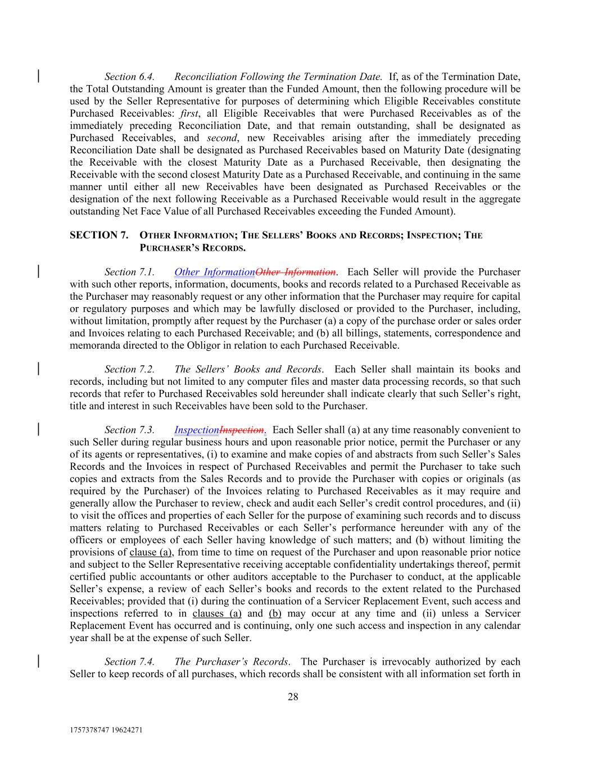
1757378747 19624271 28 Section 6.4. Reconciliation Following the Termination Date. If, as of the Termination Date, the Total Outstanding Amount is greater than the Funded Amount, then the following procedure will be used by the Seller Representative for purposes of determining which Eligible Receivables constitute Purchased Receivables: first, all Eligible Receivables that were Purchased Receivables as of the immediately preceding Reconciliation Date, and that remain outstanding, shall be designated as Purchased Receivables, and second, new Receivables arising after the immediately preceding Reconciliation Date shall be designated as Purchased Receivables based on Maturity Date (designating the Receivable with the closest Maturity Date as a Purchased Receivable, then designating the Receivable with the second closest Maturity Date as a Purchased Receivable, and continuing in the same manner until either all new Receivables have been designated as Purchased Receivables or the designation of the next following Receivable as a Purchased Receivable would result in the aggregate outstanding Net Face Value of all Purchased Receivables exceeding the Funded Amount). SECTION 7. OTHER INFORMATION; THE SELLERS’ BOOKS AND RECORDS; INSPECTION; THE PURCHASER’S RECORDS. Section 7.1. Other InformationOther Information. Each Seller will provide the Purchaser with such other reports, information, documents, books and records related to a Purchased Receivable as the Purchaser may reasonably request or any other information that the Purchaser may require for capital or regulatory purposes and which may be lawfully disclosed or provided to the Purchaser, including, without limitation, promptly after request by the Purchaser (a) a copy of the purchase order or sales order and Invoices relating to each Purchased Receivable; and (b) all billings, statements, correspondence and memoranda directed to the Obligor in relation to each Purchased Receivable. Section 7.2. The Sellers’ Books and Records. Each Seller shall maintain its books and records, including but not limited to any computer files and master data processing records, so that such records that refer to Purchased Receivables sold hereunder shall indicate clearly that such Seller’s right, title and interest in such Receivables have been sold to the Purchaser. Section 7.3. InspectionInspection. Each Seller shall (a) at any time reasonably convenient to such Seller during regular business hours and upon reasonable prior notice, permit the Purchaser or any of its agents or representatives, (i) to examine and make copies of and abstracts from such Seller’s Sales Records and the Invoices in respect of Purchased Receivables and permit the Purchaser to take such copies and extracts from the Sales Records and to provide the Purchaser with copies or originals (as required by the Purchaser) of the Invoices relating to Purchased Receivables as it may require and generally allow the Purchaser to review, check and audit each Seller’s credit control procedures, and (ii) to visit the offices and properties of each Seller for the purpose of examining such records and to discuss matters relating to Purchased Receivables or each Seller’s performance hereunder with any of the officers or employees of each Seller having knowledge of such matters; and (b) without limiting the provisions of clause (a), from time to time on request of the Purchaser and upon reasonable prior notice and subject to the Seller Representative receiving acceptable confidentiality undertakings thereof, permit certified public accountants or other auditors acceptable to the Purchaser to conduct, at the applicable Seller’s expense, a review of each Seller’s books and records to the extent related to the Purchased Receivables; provided that (i) during the continuation of a Servicer Replacement Event, such access and inspections referred to in clauses (a) and (b) may occur at any time and (ii) unless a Servicer Replacement Event has occurred and is continuing, only one such access and inspection in any calendar year shall be at the expense of such Seller. Section 7.4. The Purchaser’s Records. The Purchaser is irrevocably authorized by each Seller to keep records of all purchases, which records shall be consistent with all information set forth in

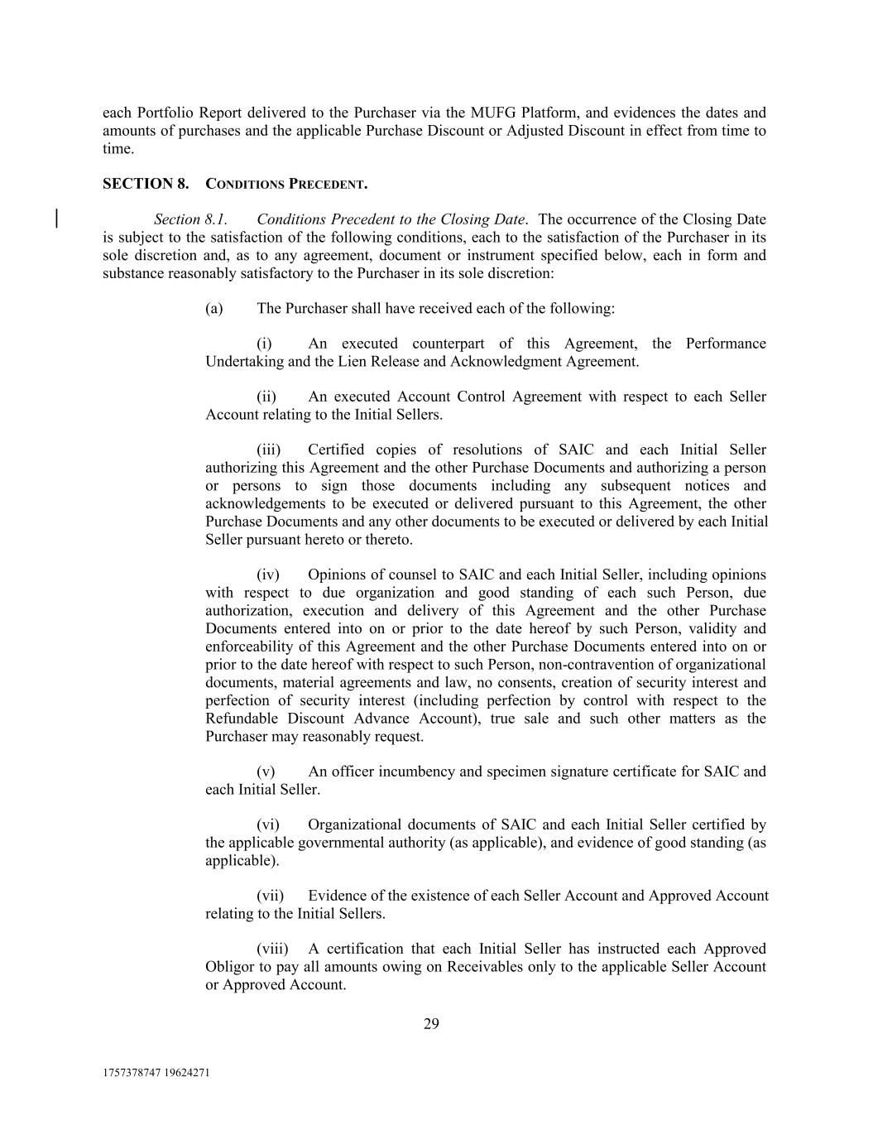
1757378747 19624271 29 each Portfolio Report delivered to the Purchaser via the MUFG Platform, and evidences the dates and amounts of purchases and the applicable Purchase Discount or Adjusted Discount in effect from time to time. SECTION 8. CONDITIONS PRECEDENT. Section 8.1. Conditions Precedent to the Closing Date. The occurrence of the Closing Date is subject to the satisfaction of the following conditions, each to the satisfaction of the Purchaser in its sole discretion and, as to any agreement, document or instrument specified below, each in form and substance reasonably satisfactory to the Purchaser in its sole discretion: (a) The Purchaser shall have received each of the following: (i) An executed counterpart of this Agreement, the Performance Undertaking and the Lien Release and Acknowledgment Agreement. (ii) An executed Account Control Agreement with respect to each Seller Account relating to the Initial Sellers. (iii) Certified copies of resolutions of SAIC and each Initial Seller authorizing this Agreement and the other Purchase Documents and authorizing a person or persons to sign those documents including any subsequent notices and acknowledgements to be executed or delivered pursuant to this Agreement, the other Purchase Documents and any other documents to be executed or delivered by each Initial Seller pursuant hereto or thereto. (iv) Opinions of counsel to SAIC and each Initial Seller, including opinions with respect to due organization and good standing of each such Person, due authorization, execution and delivery of this Agreement and the other Purchase Documents entered into on or prior to the date hereof by such Person, validity and enforceability of this Agreement and the other Purchase Documents entered into on or prior to the date hereof with respect to such Person, non-contravention of organizational documents, material agreements and law, no consents, creation of security interest and perfection of security interest (including perfection by control with respect to the Refundable Discount Advance Account), true sale and such other matters as the Purchaser may reasonably request. (v) An officer incumbency and specimen signature certificate for SAIC and each Initial Seller. (vi) Organizational documents of SAIC and each Initial Seller certified by the applicable governmental authority (as applicable), and evidence of good standing (as applicable). (vii) Evidence of the existence of each Seller Account and Approved Account relating to the Initial Sellers. (viii) A certification that each Initial Seller has instructed each Approved Obligor to pay all amounts owing on Receivables only to the applicable Seller Account or Approved Account.

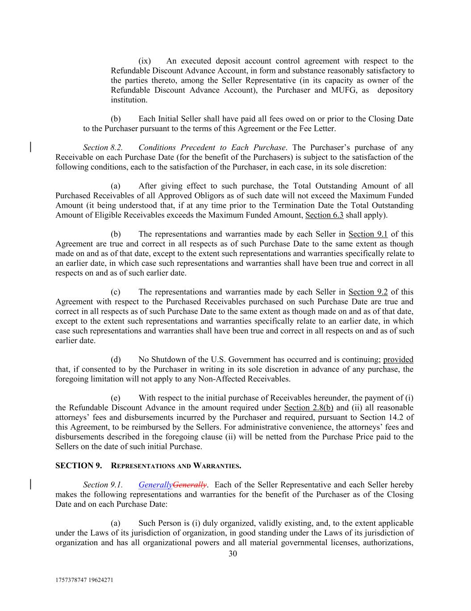
1757378747 19624271 30 (ix) An executed deposit account control agreement with respect to the Refundable Discount Advance Account, in form and substance reasonably satisfactory to the parties thereto, among the Seller Representative (in its capacity as owner of the Refundable Discount Advance Account), the Purchaser and MUFG, as depository institution. (b) Each Initial Seller shall have paid all fees owed on or prior to the Closing Date to the Purchaser pursuant to the terms of this Agreement or the Fee Letter. Section 8.2. Conditions Precedent to Each Purchase. The Purchaser’s purchase of any Receivable on each Purchase Date (for the benefit of the Purchasers) is subject to the satisfaction of the following conditions, each to the satisfaction of the Purchaser, in each case, in its sole discretion: (a) After giving effect to such purchase, the Total Outstanding Amount of all Purchased Receivables of all Approved Obligors as of such date will not exceed the Maximum Funded Amount (it being understood that, if at any time prior to the Termination Date the Total Outstanding Amount of Eligible Receivables exceeds the Maximum Funded Amount, Section 6.3 shall apply). (b) The representations and warranties made by each Seller in Section 9.1 of this Agreement are true and correct in all respects as of such Purchase Date to the same extent as though made on and as of that date, except to the extent such representations and warranties specifically relate to an earlier date, in which case such representations and warranties shall have been true and correct in all respects on and as of such earlier date. (c) The representations and warranties made by each Seller in Section 9.2 of this Agreement with respect to the Purchased Receivables purchased on such Purchase Date are true and correct in all respects as of such Purchase Date to the same extent as though made on and as of that date, except to the extent such representations and warranties specifically relate to an earlier date, in which case such representations and warranties shall have been true and correct in all respects on and as of such earlier date. (d) No Shutdown of the U.S. Government has occurred and is continuing; provided that, if consented to by the Purchaser in writing in its sole discretion in advance of any purchase, the foregoing limitation will not apply to any Non-Affected Receivables. (e) With respect to the initial purchase of Receivables hereunder, the payment of (i) the Refundable Discount Advance in the amount required under Section 2.8(b) and (ii) all reasonable attorneys’ fees and disbursements incurred by the Purchaser and required, pursuant to Section 14.2 of this Agreement, to be reimbursed by the Sellers. For administrative convenience, the attorneys’ fees and disbursements described in the foregoing clause (ii) will be netted from the Purchase Price paid to the Sellers on the date of such initial Purchase. SECTION 9. REPRESENTATIONS AND WARRANTIES. Section 9.1. GenerallyGenerally. Each of the Seller Representative and each Seller hereby makes the following representations and warranties for the benefit of the Purchaser as of the Closing Date and on each Purchase Date: (a) Such Person is (i) duly organized, validly existing, and, to the extent applicable under the Laws of its jurisdiction of organization, in good standing under the Laws of its jurisdiction of organization and has all organizational powers and all material governmental licenses, authorizations,

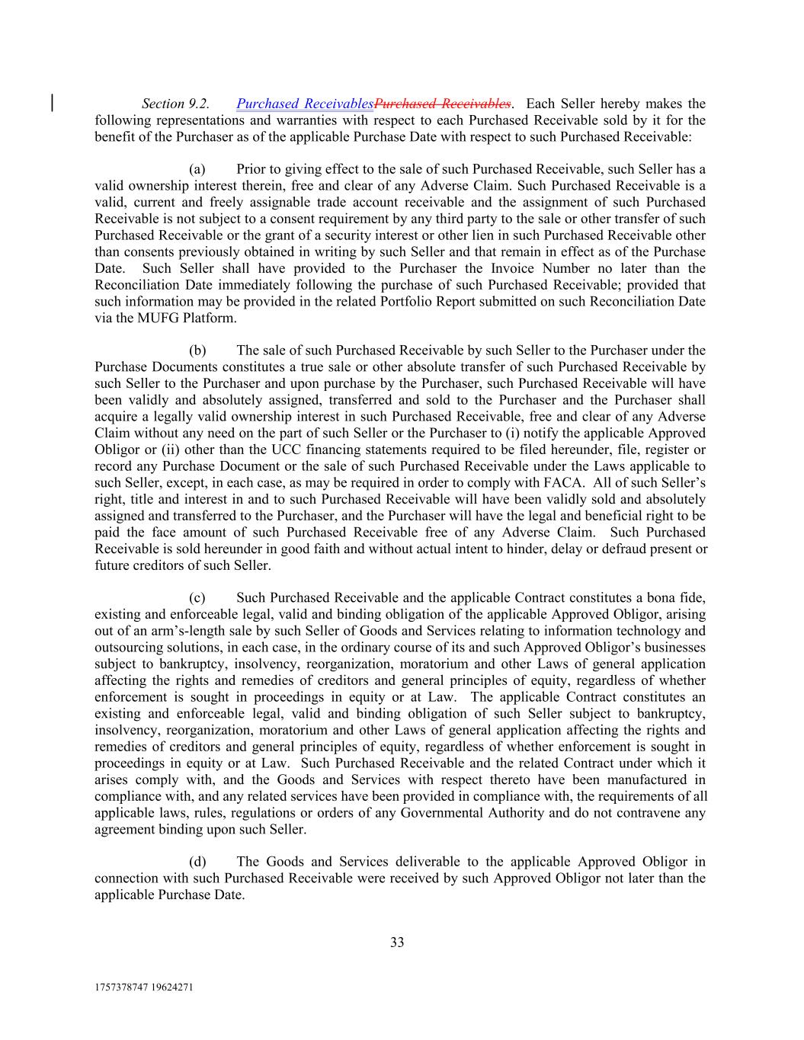
1757378747 19624271 33 Section 9.2. Purchased ReceivablesPurchased Receivables. Each Seller hereby makes the following representations and warranties with respect to each Purchased Receivable sold by it for the benefit of the Purchaser as of the applicable Purchase Date with respect to such Purchased Receivable: (a) Prior to giving effect to the sale of such Purchased Receivable, such Seller has a valid ownership interest therein, free and clear of any Adverse Claim. Such Purchased Receivable is a valid, current and freely assignable trade account receivable and the assignment of such Purchased Receivable is not subject to a consent requirement by any third party to the sale or other transfer of such Purchased Receivable or the grant of a security interest or other lien in such Purchased Receivable other than consents previously obtained in writing by such Seller and that remain in effect as of the Purchase Date. Such Seller shall have provided to the Purchaser the Invoice Number no later than the Reconciliation Date immediately following the purchase of such Purchased Receivable; provided that such information may be provided in the related Portfolio Report submitted on such Reconciliation Date via the MUFG Platform. (b) The sale of such Purchased Receivable by such Seller to the Purchaser under the Purchase Documents constitutes a true sale or other absolute transfer of such Purchased Receivable by such Seller to the Purchaser and upon purchase by the Purchaser, such Purchased Receivable will have been validly and absolutely assigned, transferred and sold to the Purchaser and the Purchaser shall acquire a legally valid ownership interest in such Purchased Receivable, free and clear of any Adverse Claim without any need on the part of such Seller or the Purchaser to (i) notify the applicable Approved Obligor or (ii) other than the UCC financing statements required to be filed hereunder, file, register or record any Purchase Document or the sale of such Purchased Receivable under the Laws applicable to such Seller, except, in each case, as may be required in order to comply with FACA. All of such Seller’s right, title and interest in and to such Purchased Receivable will have been validly sold and absolutely assigned and transferred to the Purchaser, and the Purchaser will have the legal and beneficial right to be paid the face amount of such Purchased Receivable free of any Adverse Claim. Such Purchased Receivable is sold hereunder in good faith and without actual intent to hinder, delay or defraud present or future creditors of such Seller. (c) Such Purchased Receivable and the applicable Contract constitutes a bona fide, existing and enforceable legal, valid and binding obligation of the applicable Approved Obligor, arising out of an arm’s-length sale by such Seller of Goods and Services relating to information technology and outsourcing solutions, in each case, in the ordinary course of its and such Approved Obligor’s businesses subject to bankruptcy, insolvency, reorganization, moratorium and other Laws of general application affecting the rights and remedies of creditors and general principles of equity, regardless of whether enforcement is sought in proceedings in equity or at Law. The applicable Contract constitutes an existing and enforceable legal, valid and binding obligation of such Seller subject to bankruptcy, insolvency, reorganization, moratorium and other Laws of general application affecting the rights and remedies of creditors and general principles of equity, regardless of whether enforcement is sought in proceedings in equity or at Law. Such Purchased Receivable and the related Contract under which it arises comply with, and the Goods and Services with respect thereto have been manufactured in compliance with, and any related services have been provided in compliance with, the requirements of all applicable laws, rules, regulations or orders of any Governmental Authority and do not contravene any agreement binding upon such Seller. (d) The Goods and Services deliverable to the applicable Approved Obligor in connection with such Purchased Receivable were received by such Approved Obligor not later than the applicable Purchase Date.

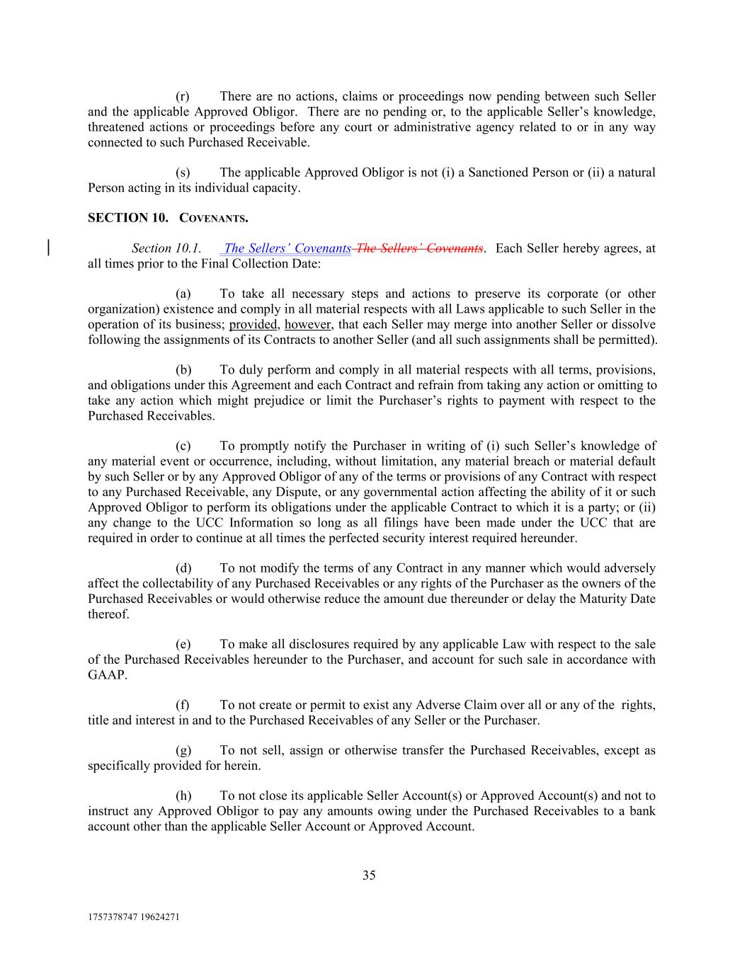
1757378747 19624271 35 (r) There are no actions, claims or proceedings now pending between such Seller and the applicable Approved Obligor. There are no pending or, to the applicable Seller’s knowledge, threatened actions or proceedings before any court or administrative agency related to or in any way connected to such Purchased Receivable. (s) The applicable Approved Obligor is not (i) a Sanctioned Person or (ii) a natural Person acting in its individual capacity. SECTION 10. COVENANTS. Section 10.1. The Sellers’ Covenants The Sellers’ Covenants. Each Seller hereby agrees, at all times prior to the Final Collection Date: (a) To take all necessary steps and actions to preserve its corporate (or other organization) existence and comply in all material respects with all Laws applicable to such Seller in the operation of its business; provided, however, that each Seller may merge into another Seller or dissolve following the assignments of its Contracts to another Seller (and all such assignments shall be permitted). (b) To duly perform and comply in all material respects with all terms, provisions, and obligations under this Agreement and each Contract and refrain from taking any action or omitting to take any action which might prejudice or limit the Purchaser’s rights to payment with respect to the Purchased Receivables. (c) To promptly notify the Purchaser in writing of (i) such Seller’s knowledge of any material event or occurrence, including, without limitation, any material breach or material default by such Seller or by any Approved Obligor of any of the terms or provisions of any Contract with respect to any Purchased Receivable, any Dispute, or any governmental action affecting the ability of it or such Approved Obligor to perform its obligations under the applicable Contract to which it is a party; or (ii) any change to the UCC Information so long as all filings have been made under the UCC that are required in order to continue at all times the perfected security interest required hereunder. (d) To not modify the terms of any Contract in any manner which would adversely affect the collectability of any Purchased Receivables or any rights of the Purchaser as the owners of the Purchased Receivables or would otherwise reduce the amount due thereunder or delay the Maturity Date thereof. (e) To make all disclosures required by any applicable Law with respect to the sale of the Purchased Receivables hereunder to the Purchaser, and account for such sale in accordance with GAAP. (f) To not create or permit to exist any Adverse Claim over all or any of the rights, title and interest in and to the Purchased Receivables of any Seller or the Purchaser. (g) To not sell, assign or otherwise transfer the Purchased Receivables, except as specifically provided for herein. (h) To not close its applicable Seller Account(s) or Approved Account(s) and not to instruct any Approved Obligor to pay any amounts owing under the Purchased Receivables to a bank account other than the applicable Seller Account or Approved Account.

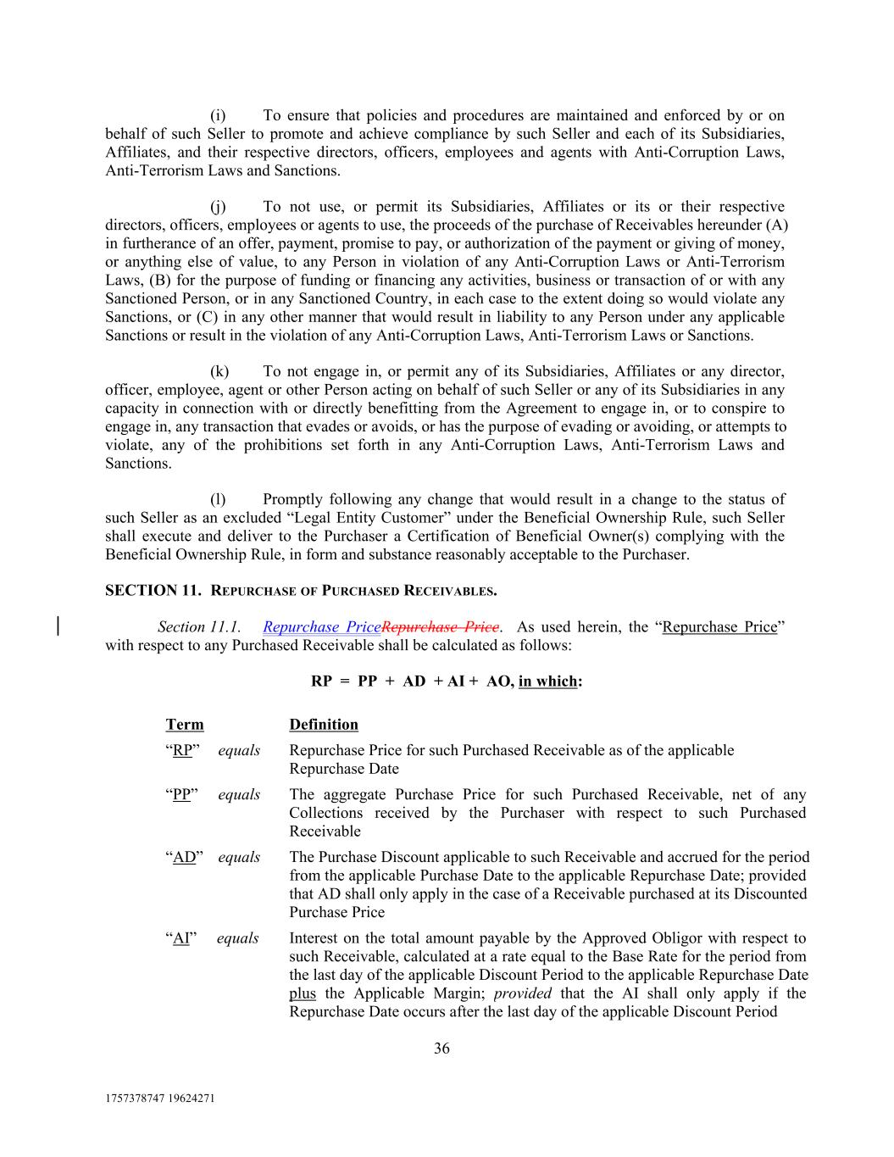
1757378747 19624271 36 Definition The aggregate Purchase Price for such Purchased Receivable, net of any Collections received by the Purchaser with respect to such Purchased Receivable (i) To ensure that policies and procedures are maintained and enforced by or on behalf of such Seller to promote and achieve compliance by such Seller and each of its Subsidiaries, Affiliates, and their respective directors, officers, employees and agents with Anti-Corruption Laws, Anti-Terrorism Laws and Sanctions. (j) To not use, or permit its Subsidiaries, Affiliates or its or their respective directors, officers, employees or agents to use, the proceeds of the purchase of Receivables hereunder (A) in furtherance of an offer, payment, promise to pay, or authorization of the payment or giving of money, or anything else of value, to any Person in violation of any Anti-Corruption Laws or Anti-Terrorism Laws, (B) for the purpose of funding or financing any activities, business or transaction of or with any Sanctioned Person, or in any Sanctioned Country, in each case to the extent doing so would violate any Sanctions, or (C) in any other manner that would result in liability to any Person under any applicable Sanctions or result in the violation of any Anti-Corruption Laws, Anti-Terrorism Laws or Sanctions. (k) To not engage in, or permit any of its Subsidiaries, Affiliates or any director, officer, employee, agent or other Person acting on behalf of such Seller or any of its Subsidiaries in any capacity in connection with or directly benefitting from the Agreement to engage in, or to conspire to engage in, any transaction that evades or avoids, or has the purpose of evading or avoiding, or attempts to violate, any of the prohibitions set forth in any Anti-Corruption Laws, Anti-Terrorism Laws and Sanctions. (l) Promptly following any change that would result in a change to the status of such Seller as an excluded “Legal Entity Customer” under the Beneficial Ownership Rule, such Seller shall execute and deliver to the Purchaser a Certification of Beneficial Owner(s) complying with the Beneficial Ownership Rule, in form and substance reasonably acceptable to the Purchaser. SECTION 11. REPURCHASE OF PURCHASED RECEIVABLES. Section 11.1. Repurchase PriceRepurchase Price. As used herein, the “Repurchase Price” with respect to any Purchased Receivable shall be calculated as follows: RP = PP + AD + AI + AO, in which: “AD” equals The Purchase Discount applicable to such Receivable and accrued for the period from the applicable Purchase Date to the applicable Repurchase Date; provided that AD shall only apply in the case of a Receivable purchased at its Discounted Purchase Price “RP” equals “AI” equals Repurchase Price for such Purchased Receivable as of the applicable Repurchase Date Interest on the total amount payable by the Approved Obligor with respect to such Receivable, calculated at a rate equal to the Base Rate for the period from the last day of the applicable Discount Period to the applicable Repurchase Date plus the Applicable Margin; provided that the AI shall only apply if the Repurchase Date occurs after the last day of the applicable Discount Period Term “PP” equals

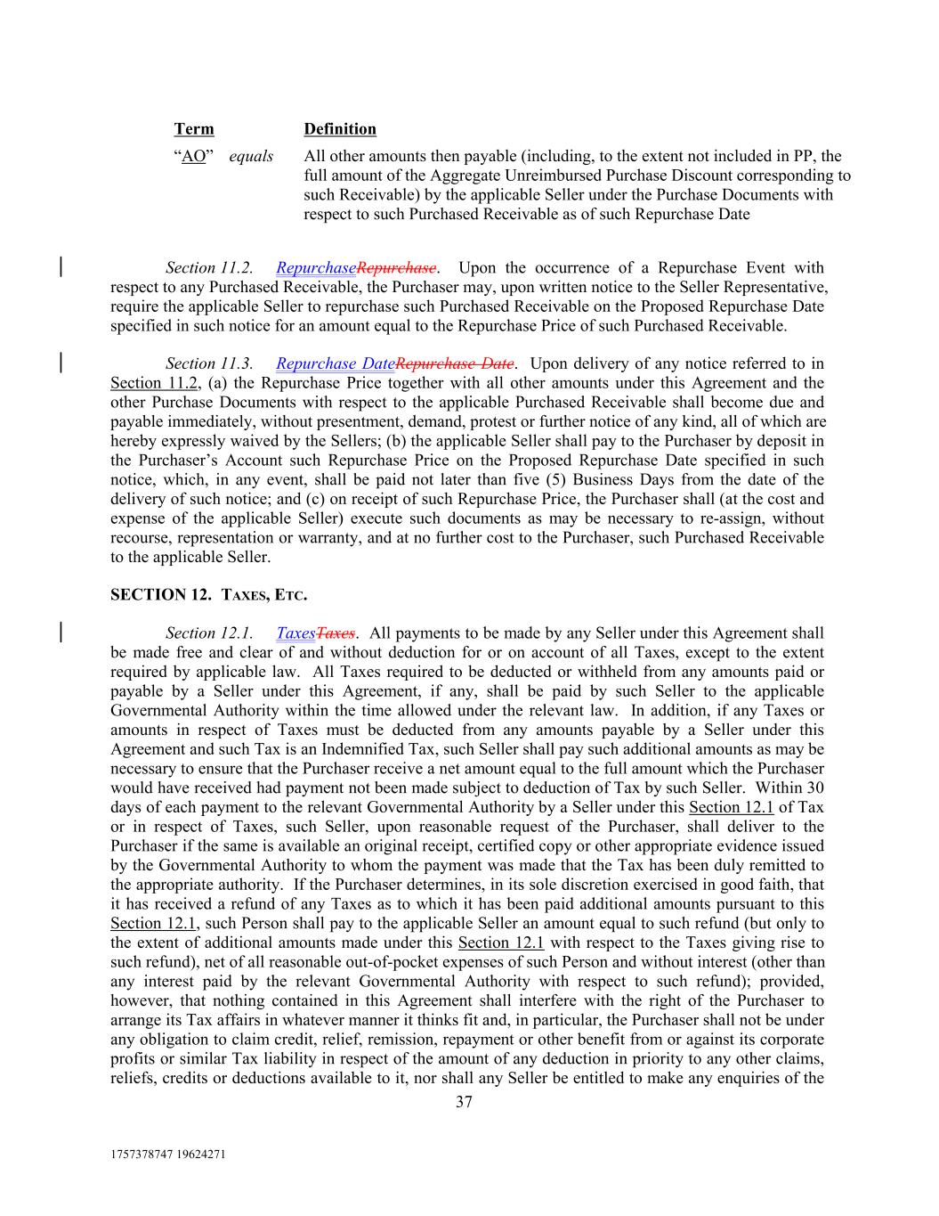
1757378747 19624271 37 “AO” equals Term All other amounts then payable (including, to the extent not included in PP, the full amount of the Aggregate Unreimbursed Purchase Discount corresponding to such Receivable) by the applicable Seller under the Purchase Documents with respect to such Purchased Receivable as of such Repurchase Date Section 11.2. RepurchaseRepurchase. Upon the occurrence of a Repurchase Event with respect to any Purchased Receivable, the Purchaser may, upon written notice to the Seller Representative, require the applicable Seller to repurchase such Purchased Receivable on the Proposed Repurchase Date specified in such notice for an amount equal to the Repurchase Price of such Purchased Receivable. Section 11.3. Repurchase DateRepurchase Date. Upon delivery of any notice referred to in Section 11.2, (a) the Repurchase Price together with all other amounts under this Agreement and the other Purchase Documents with respect to the applicable Purchased Receivable shall become due and payable immediately, without presentment, demand, protest or further notice of any kind, all of which are hereby expressly waived by the Sellers; (b) the applicable Seller shall pay to the Purchaser by deposit in the Purchaser’s Account such Repurchase Price on the Proposed Repurchase Date specified in such notice, which, in any event, shall be paid not later than five (5) Business Days from the date of the delivery of such notice; and (c) on receipt of such Repurchase Price, the Purchaser shall (at the cost and expense of the applicable Seller) execute such documents as may be necessary to re-assign, without recourse, representation or warranty, and at no further cost to the Purchaser, such Purchased Receivable to the applicable Seller. SECTION 12. TAXES, ETC. Section 12.1. TaxesTaxes. All payments to be made by any Seller under this Agreement shall be made free and clear of and without deduction for or on account of all Taxes, except to the extent required by applicable law. All Taxes required to be deducted or withheld from any amounts paid or payable by a Seller under this Agreement, if any, shall be paid by such Seller to the applicable Governmental Authority within the time allowed under the relevant law. In addition, if any Taxes or amounts in respect of Taxes must be deducted from any amounts payable by a Seller under this Agreement and such Tax is an Indemnified Tax, such Seller shall pay such additional amounts as may be necessary to ensure that the Purchaser receive a net amount equal to the full amount which the Purchaser would have received had payment not been made subject to deduction of Tax by such Seller. Within 30 days of each payment to the relevant Governmental Authority by a Seller under this Section 12.1 of Tax or in respect of Taxes, such Seller, upon reasonable request of the Purchaser, shall deliver to the Purchaser if the same is available an original receipt, certified copy or other appropriate evidence issued by the Governmental Authority to whom the payment was made that the Tax has been duly remitted to the appropriate authority. If the Purchaser determines, in its sole discretion exercised in good faith, that it has received a refund of any Taxes as to which it has been paid additional amounts pursuant to this Section 12.1, such Person shall pay to the applicable Seller an amount equal to such refund (but only to the extent of additional amounts made under this Section 12.1 with respect to the Taxes giving rise to such refund), net of all reasonable out-of-pocket expenses of such Person and without interest (other than any interest paid by the relevant Governmental Authority with respect to such refund); provided, however, that nothing contained in this Agreement shall interfere with the right of the Purchaser to arrange its Tax affairs in whatever manner it thinks fit and, in particular, the Purchaser shall not be under any obligation to claim credit, relief, remission, repayment or other benefit from or against its corporate profits or similar Tax liability in respect of the amount of any deduction in priority to any other claims, reliefs, credits or deductions available to it, nor shall any Seller be entitled to make any enquiries of the Definition

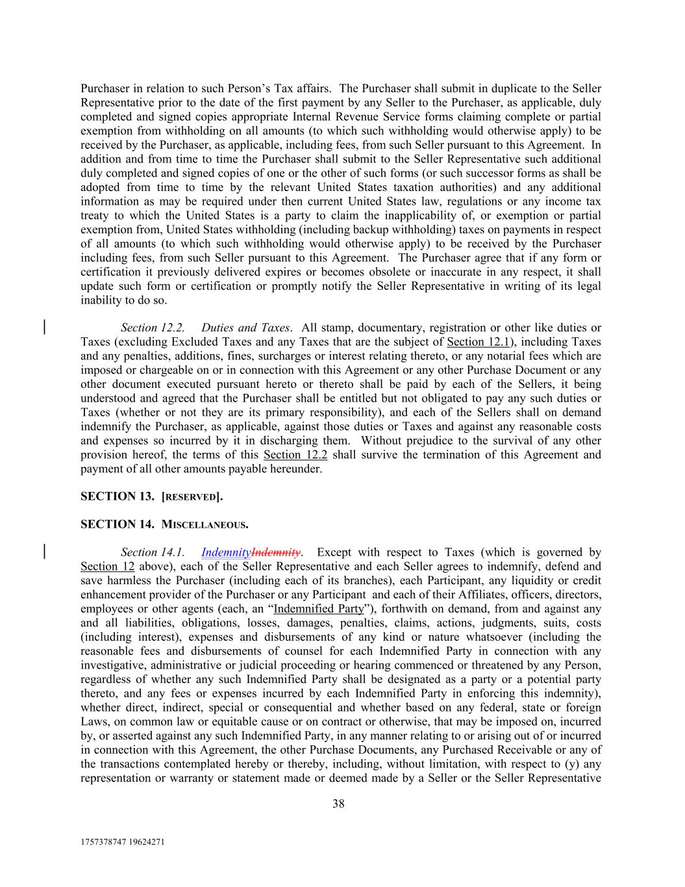
1757378747 19624271 38 Purchaser in relation to such Person’s Tax affairs. The Purchaser shall submit in duplicate to the Seller Representative prior to the date of the first payment by any Seller to the Purchaser, as applicable, duly completed and signed copies appropriate Internal Revenue Service forms claiming complete or partial exemption from withholding on all amounts (to which such withholding would otherwise apply) to be received by the Purchaser, as applicable, including fees, from such Seller pursuant to this Agreement. In addition and from time to time the Purchaser shall submit to the Seller Representative such additional duly completed and signed copies of one or the other of such forms (or such successor forms as shall be adopted from time to time by the relevant United States taxation authorities) and any additional information as may be required under then current United States law, regulations or any income tax treaty to which the United States is a party to claim the inapplicability of, or exemption or partial exemption from, United States withholding (including backup withholding) taxes on payments in respect of all amounts (to which such withholding would otherwise apply) to be received by the Purchaser including fees, from such Seller pursuant to this Agreement. The Purchaser agree that if any form or certification it previously delivered expires or becomes obsolete or inaccurate in any respect, it shall update such form or certification or promptly notify the Seller Representative in writing of its legal inability to do so. Section 12.2. Duties and Taxes. All stamp, documentary, registration or other like duties or Taxes (excluding Excluded Taxes and any Taxes that are the subject of Section 12.1), including Taxes and any penalties, additions, fines, surcharges or interest relating thereto, or any notarial fees which are imposed or chargeable on or in connection with this Agreement or any other Purchase Document or any other document executed pursuant hereto or thereto shall be paid by each of the Sellers, it being understood and agreed that the Purchaser shall be entitled but not obligated to pay any such duties or Taxes (whether or not they are its primary responsibility), and each of the Sellers shall on demand indemnify the Purchaser, as applicable, against those duties or Taxes and against any reasonable costs and expenses so incurred by it in discharging them. Without prejudice to the survival of any other provision hereof, the terms of this Section 12.2 shall survive the termination of this Agreement and payment of all other amounts payable hereunder. SECTION 13. [RESERVED]. SECTION 14. MISCELLANEOUS. Section 14.1. IndemnityIndemnity. Except with respect to Taxes (which is governed by Section 12 above), each of the Seller Representative and each Seller agrees to indemnify, defend and save harmless the Purchaser (including each of its branches), each Participant, any liquidity or credit enhancement provider of the Purchaser or any Participant and each of their Affiliates, officers, directors, employees or other agents (each, an “Indemnified Party”), forthwith on demand, from and against any and all liabilities, obligations, losses, damages, penalties, claims, actions, judgments, suits, costs (including interest), expenses and disbursements of any kind or nature whatsoever (including the reasonable fees and disbursements of counsel for each Indemnified Party in connection with any investigative, administrative or judicial proceeding or hearing commenced or threatened by any Person, regardless of whether any such Indemnified Party shall be designated as a party or a potential party thereto, and any fees or expenses incurred by each Indemnified Party in enforcing this indemnity), whether direct, indirect, special or consequential and whether based on any federal, state or foreign Laws, on common law or equitable cause or on contract or otherwise, that may be imposed on, incurred by, or asserted against any such Indemnified Party, in any manner relating to or arising out of or incurred in connection with this Agreement, the other Purchase Documents, any Purchased Receivable or any of the transactions contemplated hereby or thereby, including, without limitation, with respect to (y) any representation or warranty or statement made or deemed made by a Seller or the Seller Representative

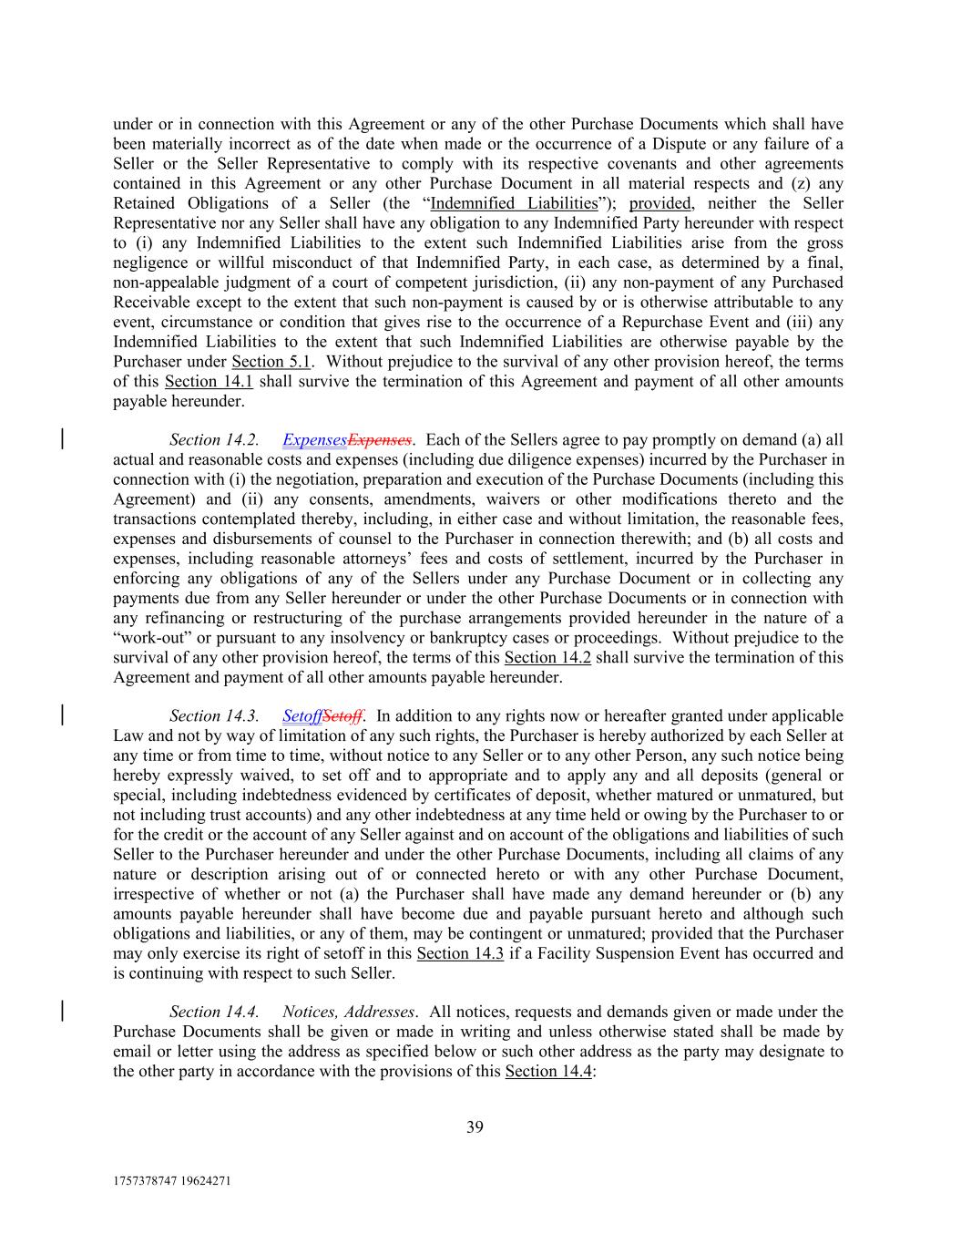
1757378747 19624271 39 under or in connection with this Agreement or any of the other Purchase Documents which shall have been materially incorrect as of the date when made or the occurrence of a Dispute or any failure of a Seller or the Seller Representative to comply with its respective covenants and other agreements contained in this Agreement or any other Purchase Document in all material respects and (z) any Retained Obligations of a Seller (the “Indemnified Liabilities”); provided, neither the Seller Representative nor any Seller shall have any obligation to any Indemnified Party hereunder with respect to (i) any Indemnified Liabilities to the extent such Indemnified Liabilities arise from the gross negligence or willful misconduct of that Indemnified Party, in each case, as determined by a final, non-appealable judgment of a court of competent jurisdiction, (ii) any non-payment of any Purchased Receivable except to the extent that such non-payment is caused by or is otherwise attributable to any event, circumstance or condition that gives rise to the occurrence of a Repurchase Event and (iii) any Indemnified Liabilities to the extent that such Indemnified Liabilities are otherwise payable by the Purchaser under Section 5.1. Without prejudice to the survival of any other provision hereof, the terms of this Section 14.1 shall survive the termination of this Agreement and payment of all other amounts payable hereunder. Section 14.2. ExpensesExpenses. Each of the Sellers agree to pay promptly on demand (a) all actual and reasonable costs and expenses (including due diligence expenses) incurred by the Purchaser in connection with (i) the negotiation, preparation and execution of the Purchase Documents (including this Agreement) and (ii) any consents, amendments, waivers or other modifications thereto and the transactions contemplated thereby, including, in either case and without limitation, the reasonable fees, expenses and disbursements of counsel to the Purchaser in connection therewith; and (b) all costs and expenses, including reasonable attorneys’ fees and costs of settlement, incurred by the Purchaser in enforcing any obligations of any of the Sellers under any Purchase Document or in collecting any payments due from any Seller hereunder or under the other Purchase Documents or in connection with any refinancing or restructuring of the purchase arrangements provided hereunder in the nature of a “work-out” or pursuant to any insolvency or bankruptcy cases or proceedings. Without prejudice to the survival of any other provision hereof, the terms of this Section 14.2 shall survive the termination of this Agreement and payment of all other amounts payable hereunder. Section 14.3. SetoffSetoff. In addition to any rights now or hereafter granted under applicable Law and not by way of limitation of any such rights, the Purchaser is hereby authorized by each Seller at any time or from time to time, without notice to any Seller or to any other Person, any such notice being hereby expressly waived, to set off and to appropriate and to apply any and all deposits (general or special, including indebtedness evidenced by certificates of deposit, whether matured or unmatured, but not including trust accounts) and any other indebtedness at any time held or owing by the Purchaser to or for the credit or the account of any Seller against and on account of the obligations and liabilities of such Seller to the Purchaser hereunder and under the other Purchase Documents, including all claims of any nature or description arising out of or connected hereto or with any other Purchase Document, irrespective of whether or not (a) the Purchaser shall have made any demand hereunder or (b) any amounts payable hereunder shall have become due and payable pursuant hereto and although such obligations and liabilities, or any of them, may be contingent or unmatured; provided that the Purchaser may only exercise its right of setoff in this Section 14.3 if a Facility Suspension Event has occurred and is continuing with respect to such Seller. Section 14.4. Notices, Addresses. All notices, requests and demands given or made under the Purchase Documents shall be given or made in writing and unless otherwise stated shall be made by email or letter using the address as specified below or such other address as the party may designate to the other party in accordance with the provisions of this Section 14.4:

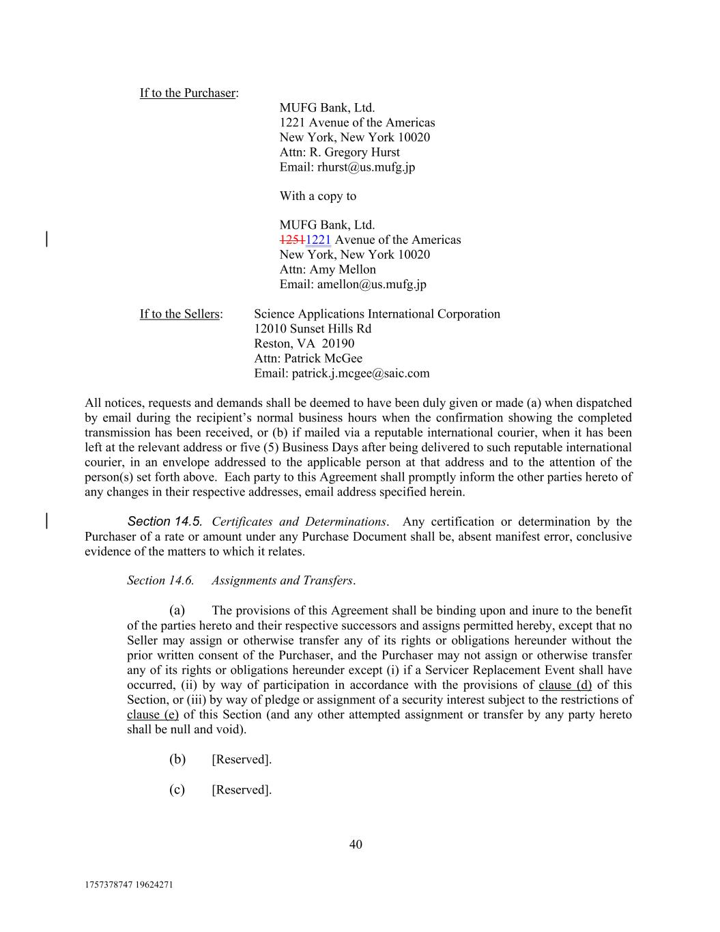
1757378747 19624271 40 If to the Sellers: If to the Purchaser: Science Applications International Corporation 12010 Sunset Hills Rd Reston, VA 20190 Attn: Patrick McGee Email: patrick.j.mcgee@saic.com All notices, requests and demands shall be deemed to have been duly given or made (a) when dispatched by email during the recipient’s normal business hours when the confirmation showing the completed transmission has been received, or (b) if mailed via a reputable international courier, when it has been left at the relevant address or five (5) Business Days after being delivered to such reputable international courier, in an envelope addressed to the applicable person at that address and to the attention of the person(s) set forth above. Each party to this Agreement shall promptly inform the other parties hereto of any changes in their respective addresses, email address specified herein. Section 14.5. Certificates and Determinations. Any certification or determination by the Purchaser of a rate or amount under any Purchase Document shall be, absent manifest error, conclusive evidence of the matters to which it relates. Section 14.6. Assignments and Transfers. (a) The provisions of this Agreement shall be binding upon and inure to the benefit of the parties hereto and their respective successors and assigns permitted hereby, except that no Seller may assign or otherwise transfer any of its rights or obligations hereunder without the prior written consent of the Purchaser, and the Purchaser may not assign or otherwise transfer any of its rights or obligations hereunder except (i) if a Servicer Replacement Event shall have occurred, (ii) by way of participation in accordance with the provisions of clause (d) of this Section, or (iii) by way of pledge or assignment of a security interest subject to the restrictions of clause (e) of this Section (and any other attempted assignment or transfer by any party hereto shall be null and void). (b) [Reserved]. (c) [Reserved]. MUFG Bank, Ltd. 1221 Avenue of the Americas New York, New York 10020 Attn: R. Gregory Hurst Email: rhurst@us.mufg.jp With a copy to MUFG Bank, Ltd. 12511221 Avenue of the Americas New York, New York 10020 Attn: Amy Mellon Email: amellon@us.mufg.jp

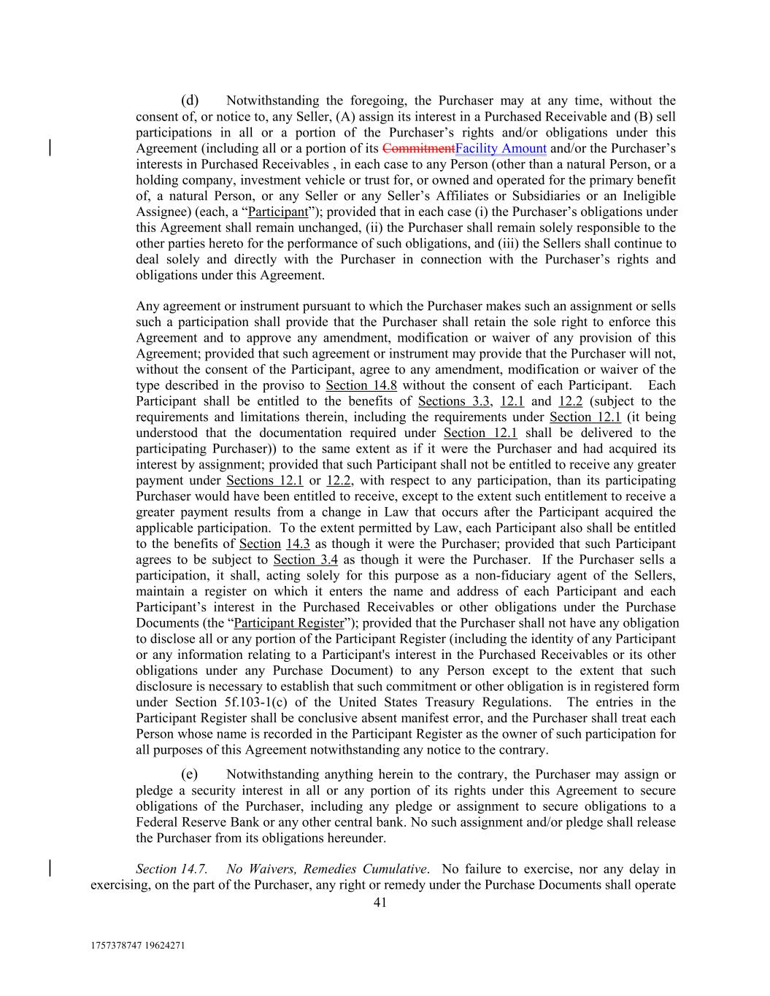
1757378747 19624271 41 (d) Notwithstanding the foregoing, the Purchaser may at any time, without the consent of, or notice to, any Seller, (A) assign its interest in a Purchased Receivable and (B) sell participations in all or a portion of the Purchaser’s rights and/or obligations under this Agreement (including all or a portion of its CommitmentFacility Amount and/or the Purchaser’s interests in Purchased Receivables , in each case to any Person (other than a natural Person, or a holding company, investment vehicle or trust for, or owned and operated for the primary benefit of, a natural Person, or any Seller or any Seller’s Affiliates or Subsidiaries or an Ineligible Assignee) (each, a “Participant”); provided that in each case (i) the Purchaser’s obligations under this Agreement shall remain unchanged, (ii) the Purchaser shall remain solely responsible to the other parties hereto for the performance of such obligations, and (iii) the Sellers shall continue to deal solely and directly with the Purchaser in connection with the Purchaser’s rights and obligations under this Agreement. Any agreement or instrument pursuant to which the Purchaser makes such an assignment or sells such a participation shall provide that the Purchaser shall retain the sole right to enforce this Agreement and to approve any amendment, modification or waiver of any provision of this Agreement; provided that such agreement or instrument may provide that the Purchaser will not, without the consent of the Participant, agree to any amendment, modification or waiver of the type described in the proviso to Section 14.8 without the consent of each Participant. Each Participant shall be entitled to the benefits of Sections 3.3, 12.1 and 12.2 (subject to the requirements and limitations therein, including the requirements under Section 12.1 (it being understood that the documentation required under Section 12.1 shall be delivered to the participating Purchaser)) to the same extent as if it were the Purchaser and had acquired its interest by assignment; provided that such Participant shall not be entitled to receive any greater payment under Sections 12.1 or 12.2, with respect to any participation, than its participating Purchaser would have been entitled to receive, except to the extent such entitlement to receive a greater payment results from a change in Law that occurs after the Participant acquired the applicable participation. To the extent permitted by Law, each Participant also shall be entitled to the benefits of Section 14.3 as though it were the Purchaser; provided that such Participant agrees to be subject to Section 3.4 as though it were the Purchaser. If the Purchaser sells a participation, it shall, acting solely for this purpose as a non-fiduciary agent of the Sellers, maintain a register on which it enters the name and address of each Participant and each Participant’s interest in the Purchased Receivables or other obligations under the Purchase Documents (the “Participant Register”); provided that the Purchaser shall not have any obligation to disclose all or any portion of the Participant Register (including the identity of any Participant or any information relating to a Participant's interest in the Purchased Receivables or its other obligations under any Purchase Document) to any Person except to the extent that such disclosure is necessary to establish that such commitment or other obligation is in registered form under Section 5f.103-1(c) of the United States Treasury Regulations. The entries in the Participant Register shall be conclusive absent manifest error, and the Purchaser shall treat each Person whose name is recorded in the Participant Register as the owner of such participation for all purposes of this Agreement notwithstanding any notice to the contrary. (e) Notwithstanding anything herein to the contrary, the Purchaser may assign or pledge a security interest in all or any portion of its rights under this Agreement to secure obligations of the Purchaser, including any pledge or assignment to secure obligations to a Federal Reserve Bank or any other central bank. No such assignment and/or pledge shall release the Purchaser from its obligations hereunder. Section 14.7. No Waivers, Remedies Cumulative. No failure to exercise, nor any delay in exercising, on the part of the Purchaser, any right or remedy under the Purchase Documents shall operate

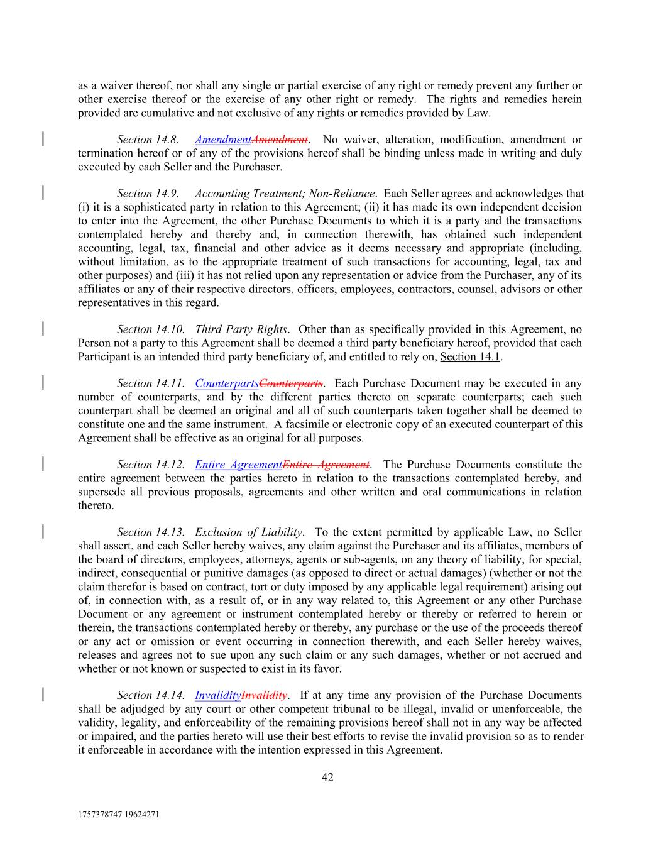
1757378747 19624271 42 as a waiver thereof, nor shall any single or partial exercise of any right or remedy prevent any further or other exercise thereof or the exercise of any other right or remedy. The rights and remedies herein provided are cumulative and not exclusive of any rights or remedies provided by Law. Section 14.8. AmendmentAmendment. No waiver, alteration, modification, amendment or termination hereof or of any of the provisions hereof shall be binding unless made in writing and duly executed by each Seller and the Purchaser. Section 14.9. Accounting Treatment; Non-Reliance. Each Seller agrees and acknowledges that (i) it is a sophisticated party in relation to this Agreement; (ii) it has made its own independent decision to enter into the Agreement, the other Purchase Documents to which it is a party and the transactions contemplated hereby and thereby and, in connection therewith, has obtained such independent accounting, legal, tax, financial and other advice as it deems necessary and appropriate (including, without limitation, as to the appropriate treatment of such transactions for accounting, legal, tax and other purposes) and (iii) it has not relied upon any representation or advice from the Purchaser, any of its affiliates or any of their respective directors, officers, employees, contractors, counsel, advisors or other representatives in this regard. Section 14.10. Third Party Rights. Other than as specifically provided in this Agreement, no Person not a party to this Agreement shall be deemed a third party beneficiary hereof, provided that each Participant is an intended third party beneficiary of, and entitled to rely on, Section 14.1. Section 14.11. CounterpartsCounterparts. Each Purchase Document may be executed in any number of counterparts, and by the different parties thereto on separate counterparts; each such counterpart shall be deemed an original and all of such counterparts taken together shall be deemed to constitute one and the same instrument. A facsimile or electronic copy of an executed counterpart of this Agreement shall be effective as an original for all purposes. Section 14.12. Entire AgreementEntire Agreement. The Purchase Documents constitute the entire agreement between the parties hereto in relation to the transactions contemplated hereby, and supersede all previous proposals, agreements and other written and oral communications in relation thereto. Section 14.13. Exclusion of Liability. To the extent permitted by applicable Law, no Seller shall assert, and each Seller hereby waives, any claim against the Purchaser and its affiliates, members of the board of directors, employees, attorneys, agents or sub-agents, on any theory of liability, for special, indirect, consequential or punitive damages (as opposed to direct or actual damages) (whether or not the claim therefor is based on contract, tort or duty imposed by any applicable legal requirement) arising out of, in connection with, as a result of, or in any way related to, this Agreement or any other Purchase Document or any agreement or instrument contemplated hereby or thereby or referred to herein or therein, the transactions contemplated hereby or thereby, any purchase or the use of the proceeds thereof or any act or omission or event occurring in connection therewith, and each Seller hereby waives, releases and agrees not to sue upon any such claim or any such damages, whether or not accrued and whether or not known or suspected to exist in its favor. Section 14.14. InvalidityInvalidity. If at any time any provision of the Purchase Documents shall be adjudged by any court or other competent tribunal to be illegal, invalid or unenforceable, the validity, legality, and enforceability of the remaining provisions hereof shall not in any way be affected or impaired, and the parties hereto will use their best efforts to revise the invalid provision so as to render it enforceable in accordance with the intention expressed in this Agreement.

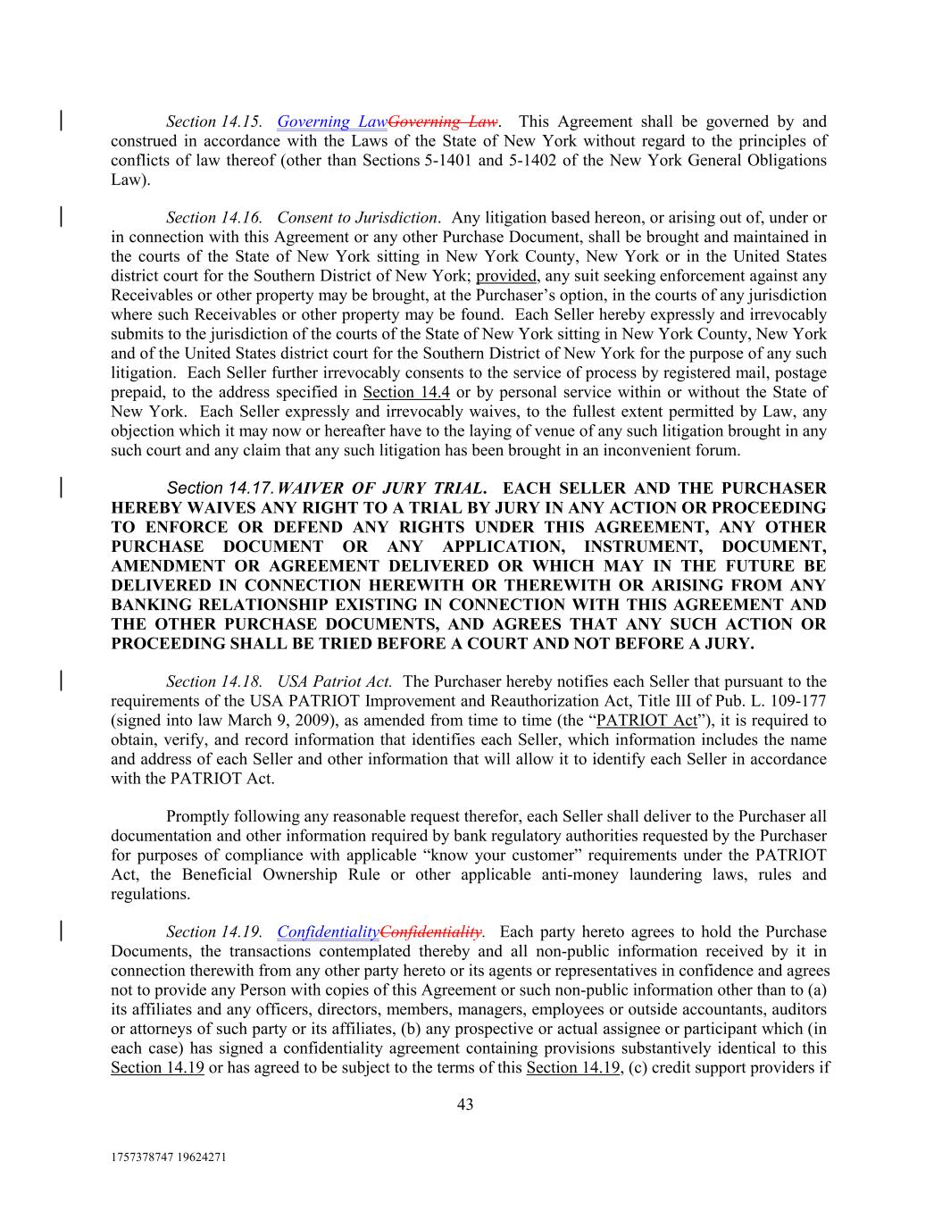
1757378747 19624271 43 Section 14.15. Governing LawGoverning Law. This Agreement shall be governed by and construed in accordance with the Laws of the State of New York without regard to the principles of conflicts of law thereof (other than Sections 5-1401 and 5-1402 of the New York General Obligations Law). Section 14.16. Consent to Jurisdiction. Any litigation based hereon, or arising out of, under or in connection with this Agreement or any other Purchase Document, shall be brought and maintained in the courts of the State of New York sitting in New York County, New York or in the United States district court for the Southern District of New York; provided, any suit seeking enforcement against any Receivables or other property may be brought, at the Purchaser’s option, in the courts of any jurisdiction where such Receivables or other property may be found. Each Seller hereby expressly and irrevocably submits to the jurisdiction of the courts of the State of New York sitting in New York County, New York and of the United States district court for the Southern District of New York for the purpose of any such litigation. Each Seller further irrevocably consents to the service of process by registered mail, postage prepaid, to the address specified in Section 14.4 or by personal service within or without the State of New York. Each Seller expressly and irrevocably waives, to the fullest extent permitted by Law, any objection which it may now or hereafter have to the laying of venue of any such litigation brought in any such court and any claim that any such litigation has been brought in an inconvenient forum. Section 14.17. WAIVER OF JURY TRIAL. EACH SELLER AND THE PURCHASER HEREBY WAIVES ANY RIGHT TO A TRIAL BY JURY IN ANY ACTION OR PROCEEDING TO ENFORCE OR DEFEND ANY RIGHTS UNDER THIS AGREEMENT, ANY OTHER PURCHASE DOCUMENT OR ANY APPLICATION, INSTRUMENT, DOCUMENT, AMENDMENT OR AGREEMENT DELIVERED OR WHICH MAY IN THE FUTURE BE DELIVERED IN CONNECTION HEREWITH OR THEREWITH OR ARISING FROM ANY BANKING RELATIONSHIP EXISTING IN CONNECTION WITH THIS AGREEMENT AND THE OTHER PURCHASE DOCUMENTS, AND AGREES THAT ANY SUCH ACTION OR PROCEEDING SHALL BE TRIED BEFORE A COURT AND NOT BEFORE A JURY. Section 14.18. USA Patriot Act. The Purchaser hereby notifies each Seller that pursuant to the requirements of the USA PATRIOT Improvement and Reauthorization Act, Title III of Pub. L. 109-177 (signed into law March 9, 2009), as amended from time to time (the “PATRIOT Act”), it is required to obtain, verify, and record information that identifies each Seller, which information includes the name and address of each Seller and other information that will allow it to identify each Seller in accordance with the PATRIOT Act. Promptly following any reasonable request therefor, each Seller shall deliver to the Purchaser all documentation and other information required by bank regulatory authorities requested by the Purchaser for purposes of compliance with applicable “know your customer” requirements under the PATRIOT Act, the Beneficial Ownership Rule or other applicable anti-money laundering laws, rules and regulations. Section 14.19. ConfidentialityConfidentiality. Each party hereto agrees to hold the Purchase Documents, the transactions contemplated thereby and all non-public information received by it in connection therewith from any other party hereto or its agents or representatives in confidence and agrees not to provide any Person with copies of this Agreement or such non-public information other than to (a) its affiliates and any officers, directors, members, managers, employees or outside accountants, auditors or attorneys of such party or its affiliates, (b) any prospective or actual assignee or participant which (in each case) has signed a confidentiality agreement containing provisions substantively identical to this Section 14.19 or has agreed to be subject to the terms of this Section 14.19, (c) credit support providers if

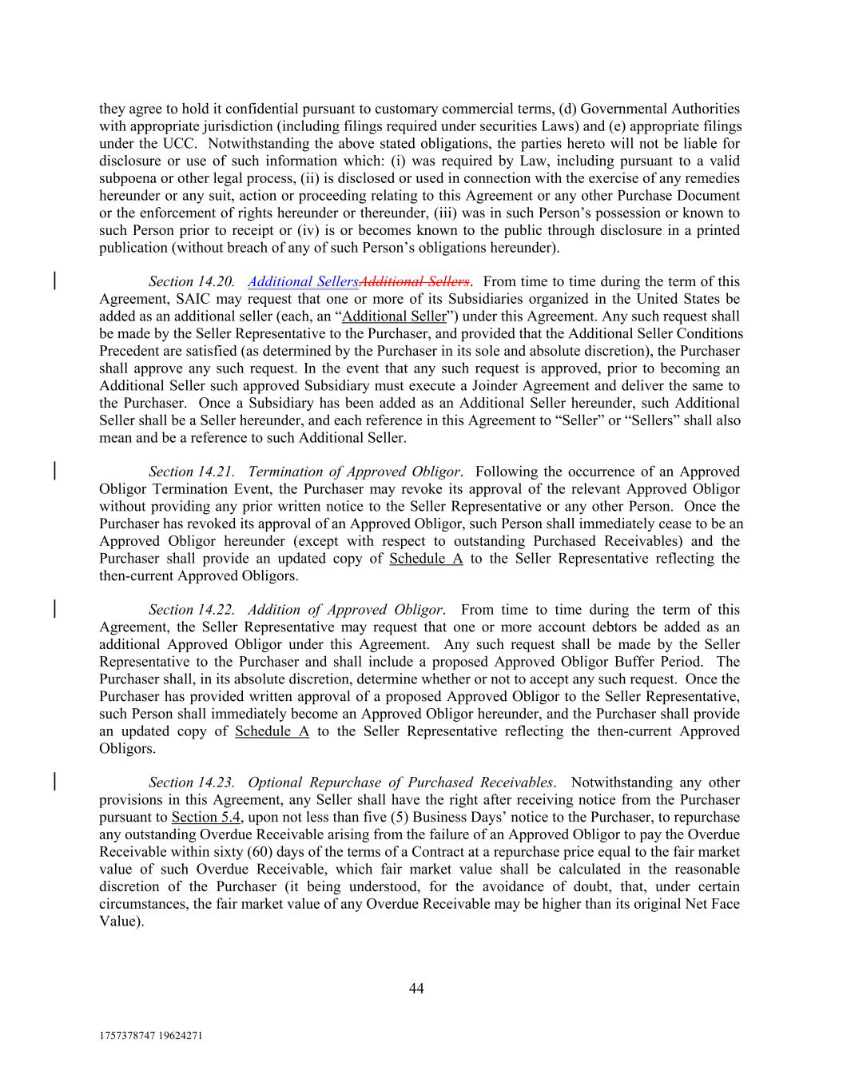
1757378747 19624271 44 they agree to hold it confidential pursuant to customary commercial terms, (d) Governmental Authorities with appropriate jurisdiction (including filings required under securities Laws) and (e) appropriate filings under the UCC. Notwithstanding the above stated obligations, the parties hereto will not be liable for disclosure or use of such information which: (i) was required by Law, including pursuant to a valid subpoena or other legal process, (ii) is disclosed or used in connection with the exercise of any remedies hereunder or any suit, action or proceeding relating to this Agreement or any other Purchase Document or the enforcement of rights hereunder or thereunder, (iii) was in such Person’s possession or known to such Person prior to receipt or (iv) is or becomes known to the public through disclosure in a printed publication (without breach of any of such Person’s obligations hereunder). Section 14.20. Additional SellersAdditional Sellers. From time to time during the term of this Agreement, SAIC may request that one or more of its Subsidiaries organized in the United States be added as an additional seller (each, an “Additional Seller”) under this Agreement. Any such request shall be made by the Seller Representative to the Purchaser, and provided that the Additional Seller Conditions Precedent are satisfied (as determined by the Purchaser in its sole and absolute discretion), the Purchaser shall approve any such request. In the event that any such request is approved, prior to becoming an Additional Seller such approved Subsidiary must execute a Joinder Agreement and deliver the same to the Purchaser. Once a Subsidiary has been added as an Additional Seller hereunder, such Additional Seller shall be a Seller hereunder, and each reference in this Agreement to “Seller” or “Sellers” shall also mean and be a reference to such Additional Seller. Section 14.21. Termination of Approved Obligor. Following the occurrence of an Approved Obligor Termination Event, the Purchaser may revoke its approval of the relevant Approved Obligor without providing any prior written notice to the Seller Representative or any other Person. Once the Purchaser has revoked its approval of an Approved Obligor, such Person shall immediately cease to be an Approved Obligor hereunder (except with respect to outstanding Purchased Receivables) and the Purchaser shall provide an updated copy of Schedule A to the Seller Representative reflecting the then-current Approved Obligors. Section 14.22. Addition of Approved Obligor. From time to time during the term of this Agreement, the Seller Representative may request that one or more account debtors be added as an additional Approved Obligor under this Agreement. Any such request shall be made by the Seller Representative to the Purchaser and shall include a proposed Approved Obligor Buffer Period. The Purchaser shall, in its absolute discretion, determine whether or not to accept any such request. Once the Purchaser has provided written approval of a proposed Approved Obligor to the Seller Representative, such Person shall immediately become an Approved Obligor hereunder, and the Purchaser shall provide an updated copy of Schedule A to the Seller Representative reflecting the then-current Approved Obligors. Section 14.23. Optional Repurchase of Purchased Receivables. Notwithstanding any other provisions in this Agreement, any Seller shall have the right after receiving notice from the Purchaser pursuant to Section 5.4, upon not less than five (5) Business Days’ notice to the Purchaser, to repurchase any outstanding Overdue Receivable arising from the failure of an Approved Obligor to pay the Overdue Receivable within sixty (60) days of the terms of a Contract at a repurchase price equal to the fair market value of such Overdue Receivable, which fair market value shall be calculated in the reasonable discretion of the Purchaser (it being understood, for the avoidance of doubt, that, under certain circumstances, the fair market value of any Overdue Receivable may be higher than its original Net Face Value).

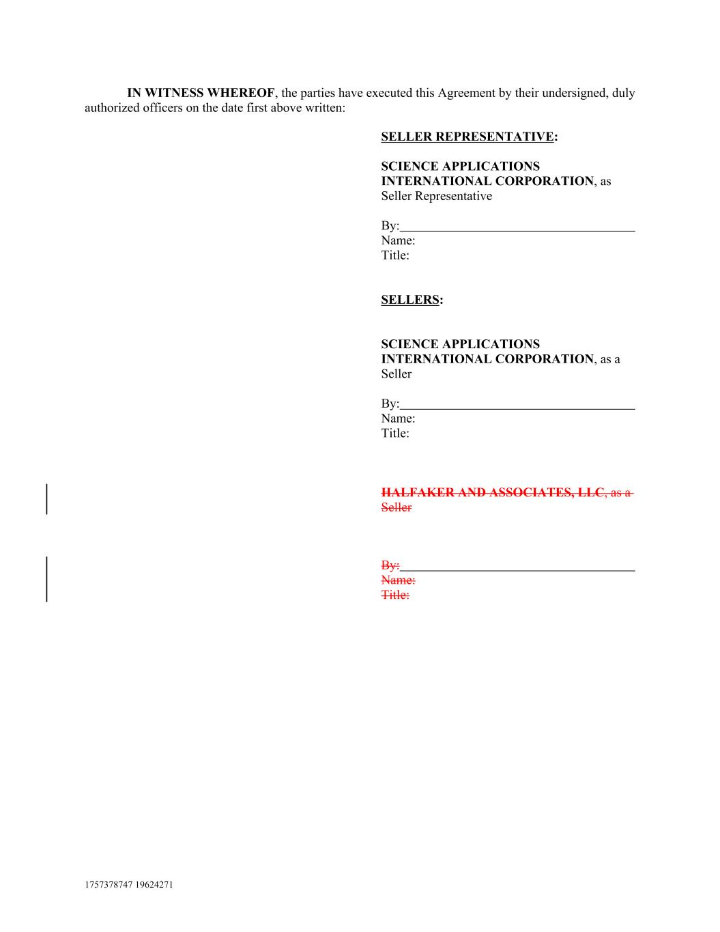
IN WITNESS WHEREOF, the parties have executed this Agreement by their undersigned, duly authorized officers on the date first above written: SELLER REPRESENTATIVE: SCIENCE APPLICATIONS INTERNATIONAL CORPORATION, as Seller Representative By: Name: Title: SELLERS: SCIENCE APPLICATIONS INTERNATIONAL CORPORATION, as a Seller By: Name: Title: HALFAKER AND ASSOCIATES, LLC, as a Seller By: Name: Title: 1757378747 19624271

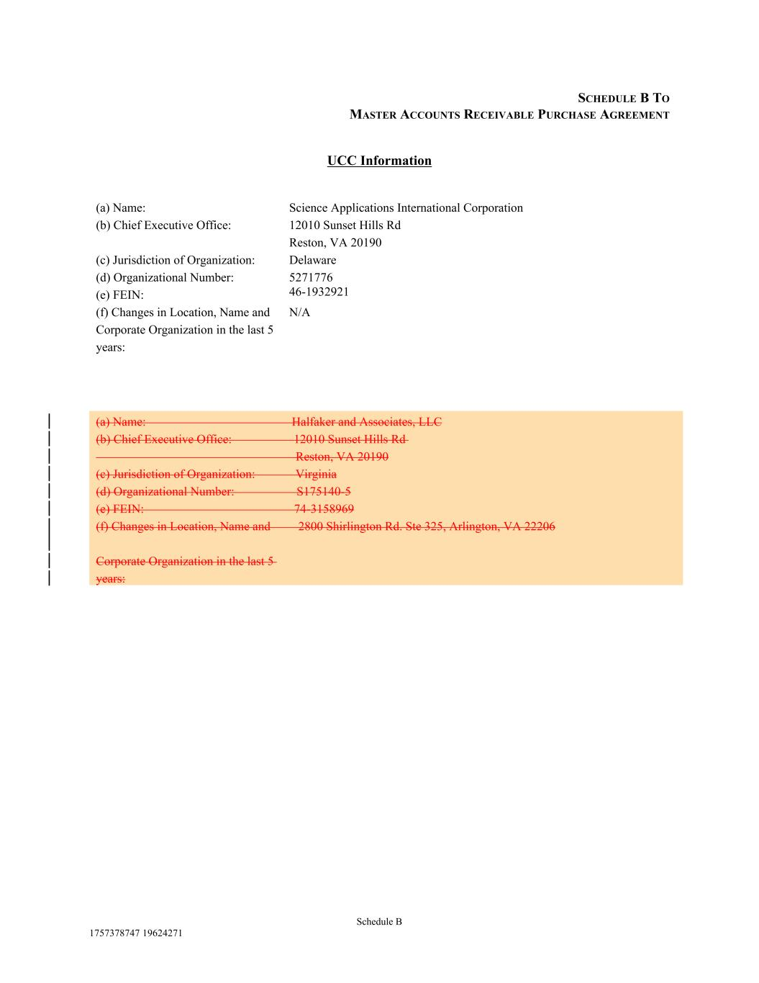
Schedule B 1757378747 19624271 46-1932921 12010 Sunset Hills Rd (f) Changes in Location, Name and Corporate Organization in the last 5 years: N/A (a) Name: (c) Jurisdiction of Organization: (a) Name: Halfaker and Associates, LLC Reston, VA 20190 Delaware (b) Chief Executive Office: 12010 Sunset Hills Rd Science Applications International Corporation Reston, VA 20190 (c) Jurisdiction of Organization: Virginia (d) Organizational Number: (d) Organizational Number: S175140-5 5271776 (e) FEIN: 74-3158969 SCHEDULE B TO MASTER ACCOUNTS RECEIVABLE PURCHASE AGREEMENT UCC Information (f) Changes in Location, Name and 2800 Shirlington Rd. Ste 325, Arlington, VA 22206 Corporate Organization in the last 5 years: (b) Chief Executive Office: (e) FEIN:

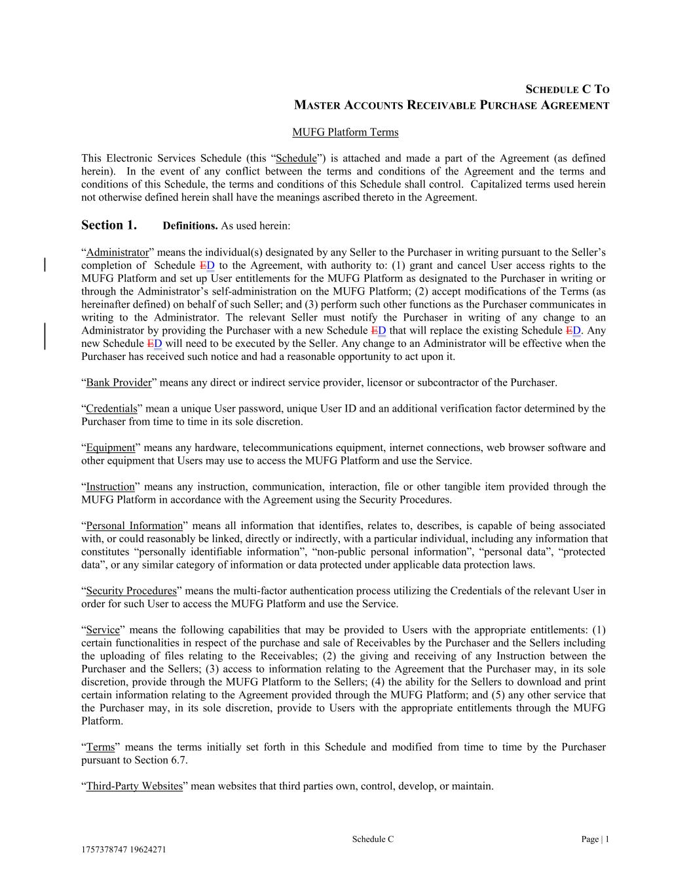
SCHEDULE C TO MASTER ACCOUNTS RECEIVABLE PURCHASE AGREEMENT MUFG Platform Terms This Electronic Services Schedule (this “Schedule”) is attached and made a part of the Agreement (as defined herein). In the event of any conflict between the terms and conditions of the Agreement and the terms and conditions of this Schedule, the terms and conditions of this Schedule shall control. Capitalized terms used herein not otherwise defined herein shall have the meanings ascribed thereto in the Agreement. Section 1. Definitions. As used herein: “Administrator” means the individual(s) designated by any Seller to the Purchaser in writing pursuant to the Seller’s completion of Schedule ED to the Agreement, with authority to: (1) grant and cancel User access rights to the MUFG Platform and set up User entitlements for the MUFG Platform as designated to the Purchaser in writing or through the Administrator’s self-administration on the MUFG Platform; (2) accept modifications of the Terms (as hereinafter defined) on behalf of such Seller; and (3) perform such other functions as the Purchaser communicates in writing to the Administrator. The relevant Seller must notify the Purchaser in writing of any change to an Administrator by providing the Purchaser with a new Schedule ED that will replace the existing Schedule ED. Any new Schedule ED will need to be executed by the Seller. Any change to an Administrator will be effective when the Purchaser has received such notice and had a reasonable opportunity to act upon it. “Bank Provider” means any direct or indirect service provider, licensor or subcontractor of the Purchaser. “Credentials” mean a unique User password, unique User ID and an additional verification factor determined by the Purchaser from time to time in its sole discretion. “Equipment” means any hardware, telecommunications equipment, internet connections, web browser software and other equipment that Users may use to access the MUFG Platform and use the Service. “Instruction” means any instruction, communication, interaction, file or other tangible item provided through the MUFG Platform in accordance with the Agreement using the Security Procedures. “Personal Information” means all information that identifies, relates to, describes, is capable of being associated with, or could reasonably be linked, directly or indirectly, with a particular individual, including any information that constitutes “personally identifiable information”, “non-public personal information”, “personal data”, “protected data”, or any similar category of information or data protected under applicable data protection laws. “Security Procedures” means the multi-factor authentication process utilizing the Credentials of the relevant User in order for such User to access the MUFG Platform and use the Service. “Service” means the following capabilities that may be provided to Users with the appropriate entitlements: (1) certain functionalities in respect of the purchase and sale of Receivables by the Purchaser and the Sellers including the uploading of files relating to the Receivables; (2) the giving and receiving of any Instruction between the Purchaser and the Sellers; (3) access to information relating to the Agreement that the Purchaser may, in its sole discretion, provide through the MUFG Platform to the Sellers; (4) the ability for the Sellers to download and print certain information relating to the Agreement provided through the MUFG Platform; and (5) any other service that the Purchaser may, in its sole discretion, provide to Users with the appropriate entitlements through the MUFG Platform. “Terms” means the terms initially set forth in this Schedule and modified from time to time by the Purchaser pursuant to Section 6.7. “Third-Party Websites” mean websites that third parties own, control, develop, or maintain. Schedule C Page | 1 1757378747 19624271

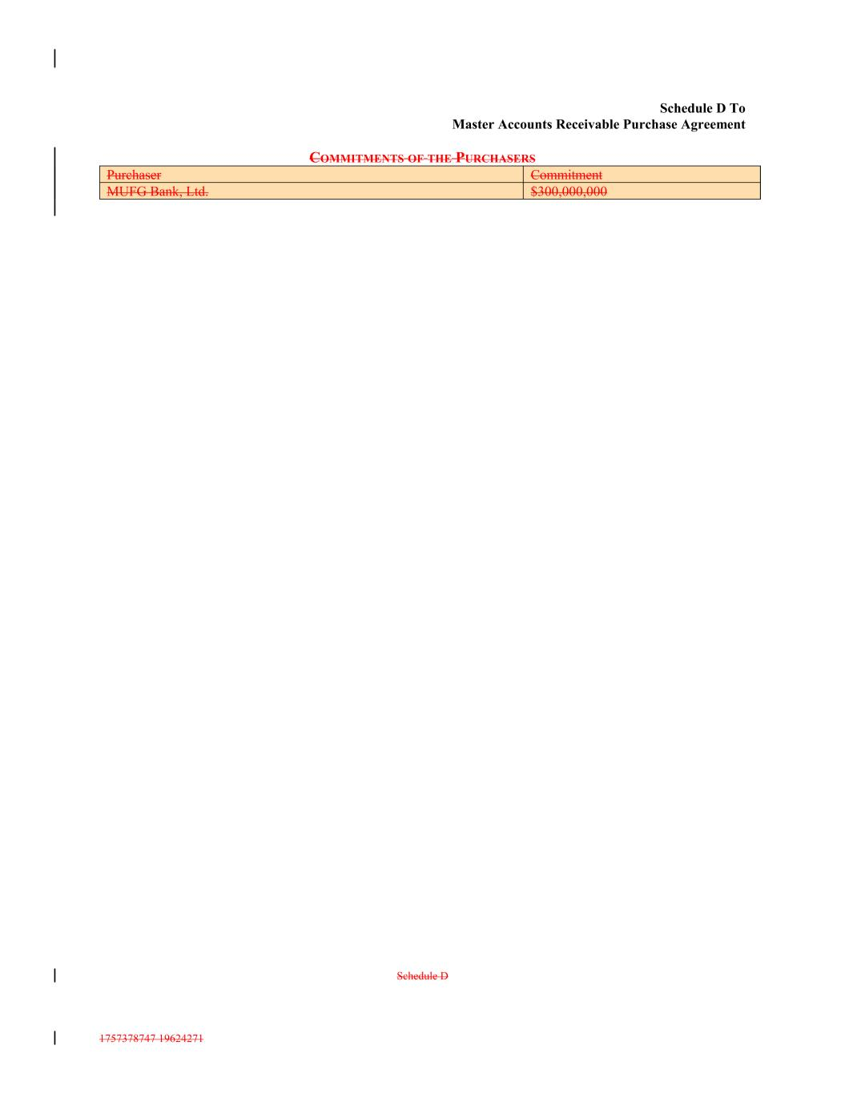
Schedule D 1757378747 19624271 Commitment Schedule D To Master Accounts Receivable Purchase Agreement COMMITMENTS OF THE PURCHASERS MUFG Bank, Ltd. $300,000,000 Purchaser

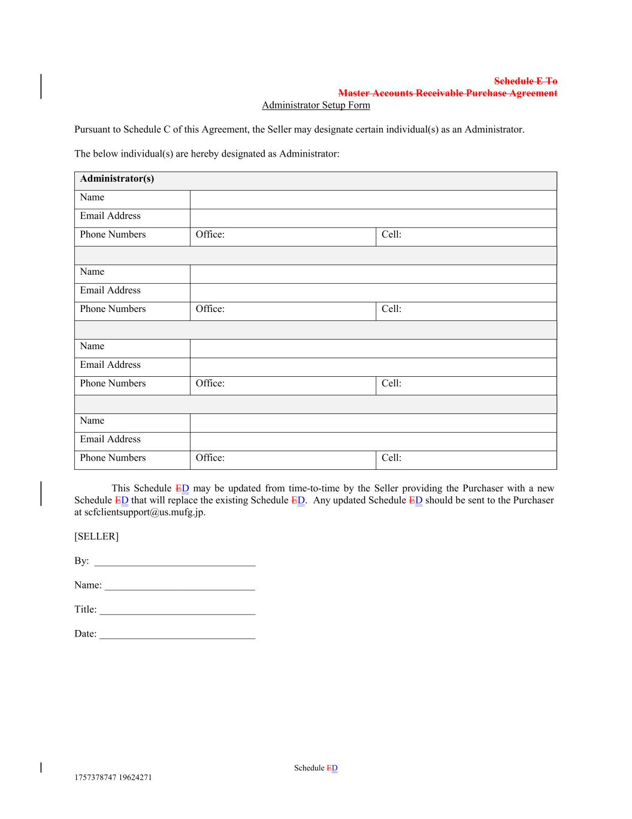
Schedule ED 1757378747 19624271 Cell: Office: Cell: Name Email Address Administrator(s) Phone Numbers Name Office: Email Address Cell: Name Email Address Email Address Schedule E To Master Accounts Receivable Purchase Agreement Administrator Setup Form Pursuant to Schedule C of this Agreement, the Seller may designate certain individual(s) as an Administrator. The below individual(s) are hereby designated as Administrator: Phone Numbers Phone Numbers Office: Phone Numbers Cell: Office: This Schedule ED may be updated from time-to-time by the Seller providing the Purchaser with a new Schedule ED that will replace the existing Schedule ED. Any updated Schedule ED should be sent to the Purchaser at scfclientsupport@us.mufg.jp. [SELLER] By: _______________________________ Name: _____________________________ Title: ______________________________ Date: ______________________________ Name

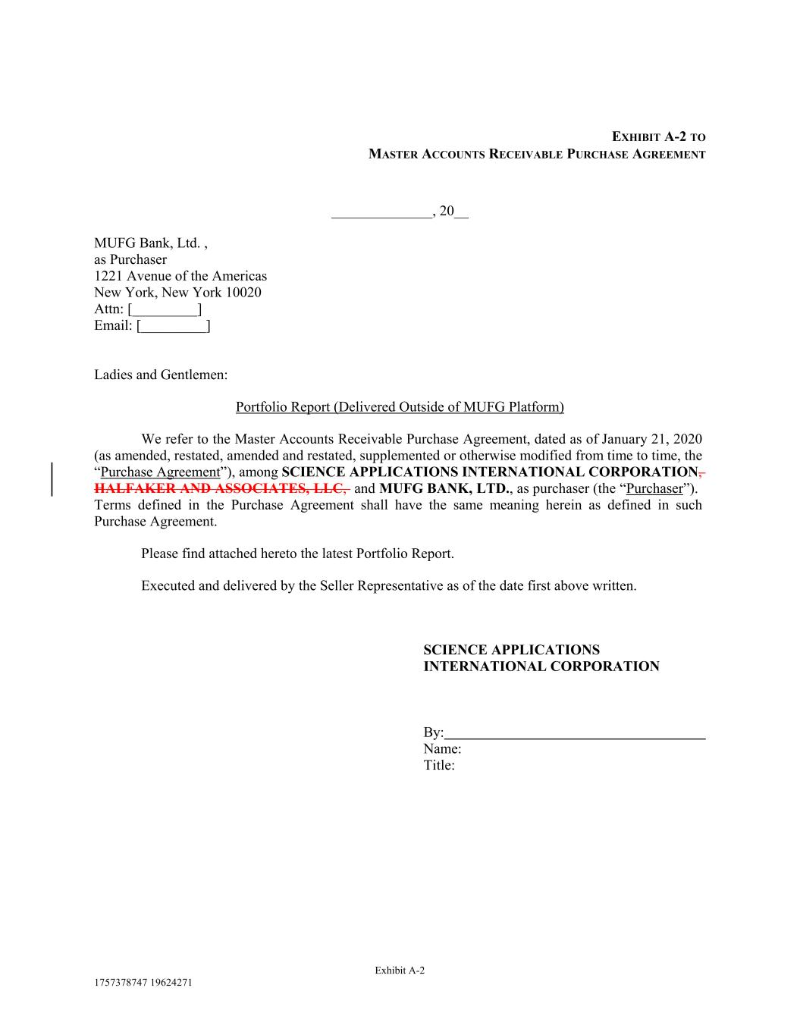
EXHIBIT A-2 TO MASTER ACCOUNTS RECEIVABLE PURCHASE AGREEMENT ______________, 20__ MUFG Bank, Ltd. , as Purchaser 1221 Avenue of the Americas New York, New York 10020 Attn: [_________] Email: [_________] Ladies and Gentlemen: Portfolio Report (Delivered Outside of MUFG Platform) We refer to the Master Accounts Receivable Purchase Agreement, dated as of January 21, 2020 (as amended, restated, amended and restated, supplemented or otherwise modified from time to time, the “Purchase Agreement”), among SCIENCE APPLICATIONS INTERNATIONAL CORPORATION, HALFAKER AND ASSOCIATES, LLC, and MUFG BANK, LTD., as purchaser (the “Purchaser”). Terms defined in the Purchase Agreement shall have the same meaning herein as defined in such Purchase Agreement. Please find attached hereto the latest Portfolio Report. Executed and delivered by the Seller Representative as of the date first above written. SCIENCE APPLICATIONS INTERNATIONAL CORPORATION By: Name: Title: Exhibit A-2 1757378747 19624271


EXHIBIT B UCC-3 Termination (Attached)

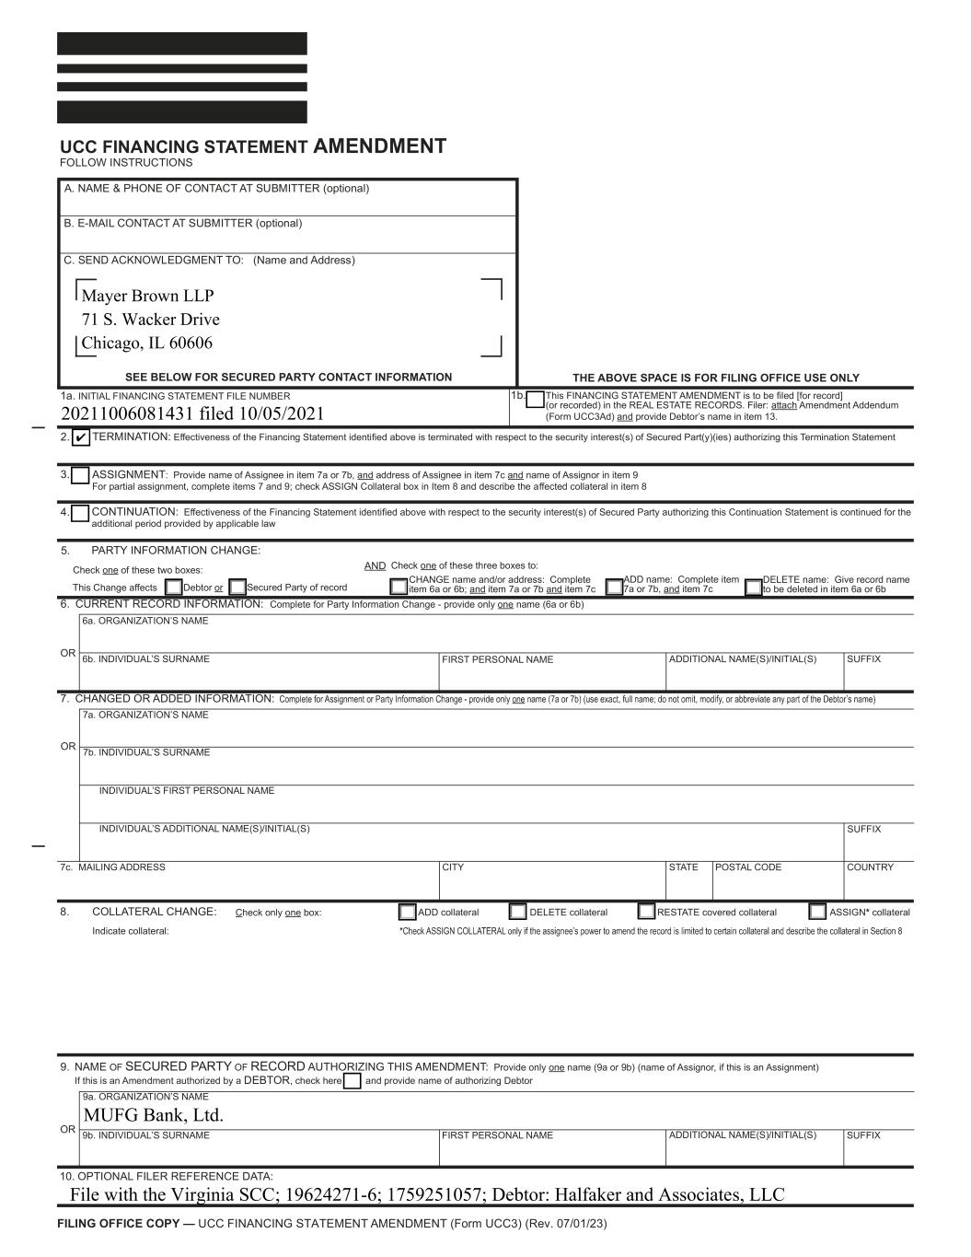
1b. This FINANCING STATEMENT AMENDMENT is to be ! led [for record] (or recorded) in the REAL ESTATE RECORDS. Filer: attach Amendment Addendum (Form UCC3Ad) and provide Debtor’s name in item 13. THE ABOVE SPACE IS FOR FILING OFFICE USE ONLY RESTATE covered collateral ASSIGN* collateral Check one of these three boxes to: FIRST PERSONAL NAME SUFFIXADDITIONAL NAME(S)/INITIAL(S) OR A. NAME & PHONE OF CONTACT AT SUBMITTER (optional) 1a. INITIAL FINANCING STATEMENT FILE NUMBER PARTY INFORMATION CHANGE: ASSIGNMENT: Provide name of Assignee in item 7a or 7b, and address of Assignee in item 7c and name of Assignor in item 9 For partial assignment, complete items 7 and 9; check ASSIGN Collateral box in Item 8 and describe the a ected collateral in item 8 TERMINATION: E ectiveness of the Financing Statement identi! ed above is terminated with respect to the security interest(s) of Secured Part(y)(ies) authorizing this Termination Statement CONTINUATION: E ectiveness of the Financing Statement identi! ed above with respect to the security interest(s) of Secured Party authorizing this Continuation Statement is continued for the additional period provided by applicable law 2. 3. 4. 6b. INDIVIDUAL’S SURNAME 6a. ORGANIZATION’S NAME DELETE name: Give record name to be deleted in item 6a or 6b 6. CURRENT RECORD INFORMATION: Complete for Party Information Change - provide only one name (6a or 6b) 7. CHANGED OR ADDED INFORMATION: 8. UCC FINANCING STATEMENT AMENDMENT FOLLOW INSTRUCTIONS ADD name: Complete item 7a or 7b, and item 7c OR FIRST PERSONAL NAME ADDITIONAL NAME(S)/INITIAL(S) SUFFIX 9a. ORGANIZATION’S NAME 9b. INDIVIDUAL’S SURNAME 10. OPTIONAL FILER REFERENCE DATA: 9. NAME OF SECURED PARTY OF RECORD AUTHORIZING THIS AMENDMENT: Provide only one name (9a or 9b) (name of Assignor, if this is an Assignment) If this is an Amendment authorized by a DEBTOR, check here and provide name of authorizing Debtor B. E-MAIL CONTACT AT SUBMITTER (optional) C. SEND ACKNOWLEDGMENT TO: (Name and Address) CHANGE name and/or address: Complete item 6a or 6b; and item 7a or 7b and item 7cDebtor or Secured Party of record Check one of these two boxes: AND This Change a ects 5. ADD collateral DELETE collateral COLLATERAL CHANGE: Check only one box: OR 7a. ORGANIZATION’S NAME POSTAL CODECITY7c. MAILING ADDRESS 7b. INDIVIDUAL’S SURNAME INDIVIDUAL’S FIRST PERSONAL NAME INDIVIDUAL’S ADDITIONAL NAME(S)/INITIAL(S) STATE SUFFIX COUNTRY Indicate collateral: FILING OFFICE COPY — UCC FINANCING STATEMENT AMENDMENT (Form UCC3) (Rev. 07/01/23) SEE BELOW FOR SECURED PARTY CONTACT INFORMATION Mayer Brown LLP 71 S. Wacker Drive Chicago, IL 60606 20211006081431 filed 10/05/2021 MUFG Bank, Ltd. File with the Virginia SCC; 19624271-6; 1759251057; Debtor: Halfaker and Associates, LLC

