UNITED STATES
SECURITIES AND EXCHANGE COMMISSION
Washington, D.C. 20549
_________________________________________________________
Form 8-K
_________________________________________________________
CURRENT REPORT
Pursuant to Section 13 or 15(d)
of the Securities Exchange Act of 1934
Date of Report (Date of earliest event reported): August 27, 2026

_________________________________________________________
Science Applications International Corporation
(Exact name of registrant as specified in its charter)
_________________________________________________________
Delaware |  |  |  |  |  | 001-35832 |  |  |  |  |  | 46-1932921
(State or other Jurisdiction  of Incorporation) |  |  |  |  |  | (Commission  File Number) |  |  |  |  |  | (IRS Employer  Identification No.)
12010 Sunset Hills Road, Reston, VA 20190
(Address of Principal Executive Offices) (Zip Code)
(703) 676-4300
Registrant’s telephone number, including area code
Not Applicable
(Former name or former address if changed since last report.)
Check the appropriate box below if the Form 8-K filing is intended to simultaneously satisfy the filing obligation of the registrant under any of the following provisions:
☐ |  |  | Written communications pursuant to Rule 425 under the Securities Act (17 CFR 230.425)
☐ |  |  | Soliciting material pursuant to Rule 14a-12 under the Exchange Act (17 CFR 240.14a-12)
☐ |  |  | Pre-commencement communications pursuant to Rule 14d-2(b) under the Exchange Act (17 CFR 240.14d-2(b))
☐ |  |  | Pre-commencement communications pursuant to Rule 13e-4(c) under the Exchange Act (17 CFR 240.13e-4(c))
Securities registered pursuant to Section 12(b) of the Act:
Title of each class |  |  | Trading Symbol(s) |  |  | Name of each exchange on which registered
Common Stock, par value $.0001 per share |  |  | SAIC |  |  | The Nasdaq Stock Market LLC
Indicate by check mark whether the registrant is an emerging growth company as defined in Rule 405 of the Securities Act of 1933 (§230.405 of this chapter) or Rule 12b-2 of the Securities Exchange Act of 1934 (§240.12b-2 of this chapter).
Emerging growth company ☐
If an emerging growth company, indicate by check mark if the registrant has elected not to use the extended transition period for complying with any new or revised financial accounting standards provided pursuant to Section 13(a) of the Exchange Act. ☐

Item 8.01. Other Events
On August 27, 2026, the Company’s Board of Directors declared a cash dividend of $0.37 per share of the Company’s common stock payable on October 23, 2026 to stockholders of record on October 9, 2026. A copy of the Company’s press release is furnished as Exhibit 99.1 to this Current Report on Form 8-K and is incorporated herein by reference.
Item 9.01. Financial Statements and Exhibits
(d) Exhibits.

Exhibit  Number |  |  |  |  |  | Description of Exhibit
99.1 |  |  |  |  |  | Press Release dated August 28, 2026
104 |  |  |  |  |  | Cover Page Interactive Data File, formatted as Inline XBRL

SIGNATURES
Pursuant to the requirements of the Securities Exchange Act of 1934, the registrant has duly caused this report to be signed on its behalf by the undersigned hereunto duly authorized.
Date: August 28, 2026
Science Applications International Corporation

By: |  |  |  |  |  | /s/ Hilary L. Hageman
 |  |  |  |  |  | Hilary L. Hageman
 |  |  |  |  |  | Executive Vice President, General Counsel and Corporate Secretary

Exhibit 99.1

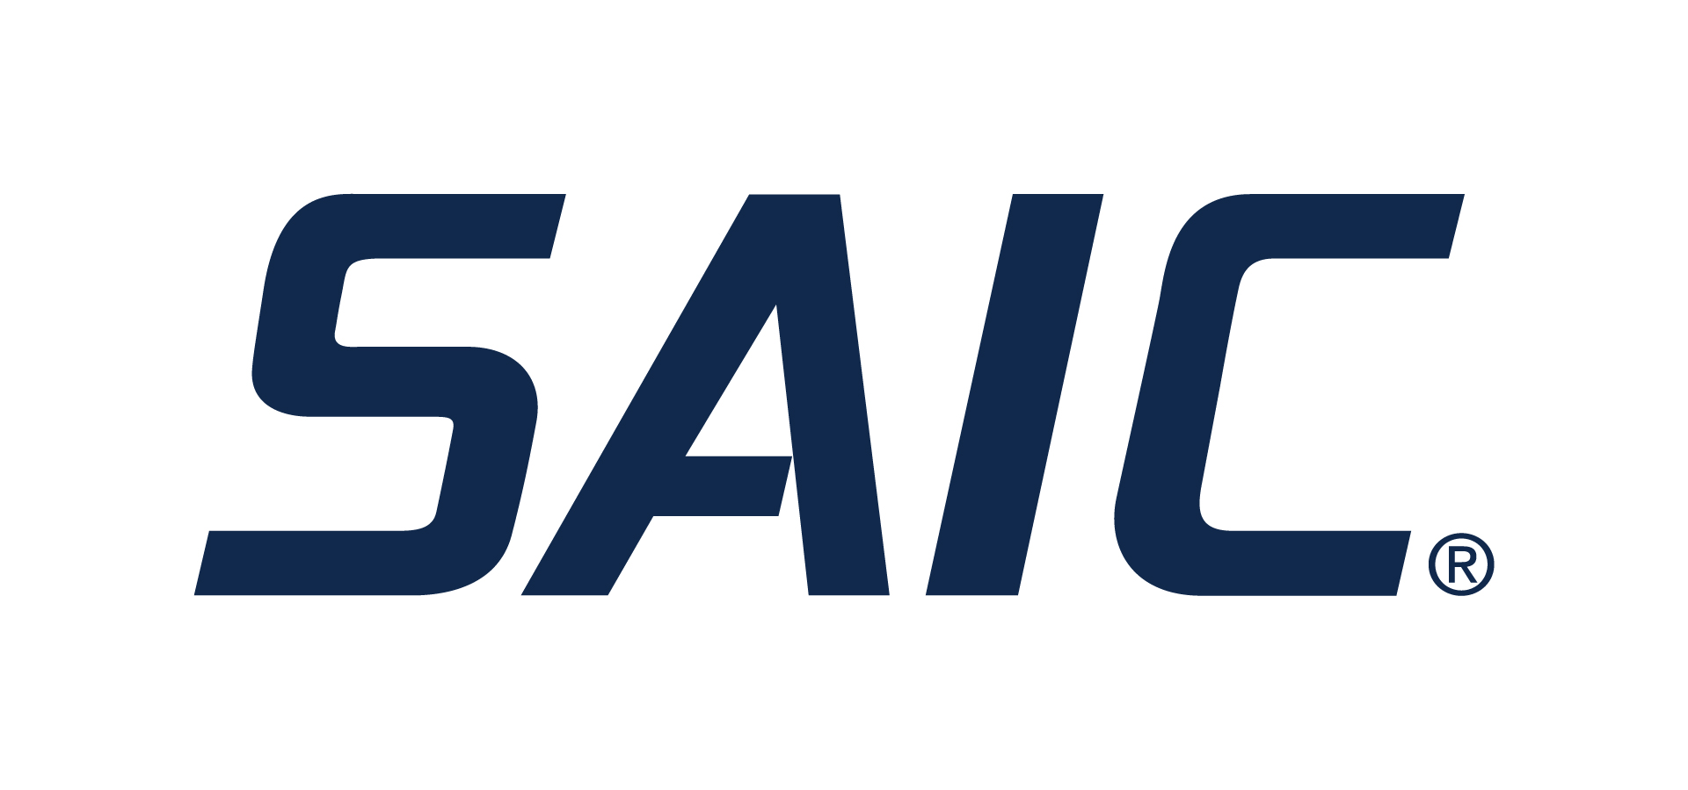
SAIC Board of Directors Declares Cash Dividend
RESTON, Va., August 28, 2026 – Science Applications International Corp. (NASDAQ: SAIC) announced today that the company’s board of directors declared a cash dividend of $0.37 per share of the company’s common stock payable on October 23, 2026 to stockholders of record on October 9, 2026.
SAIC intends to continue paying dividends on a quarterly basis, although the declaration of any future dividends will be determined by the board of directors each quarter and will depend on earnings, financial condition, capital requirements and other factors.
About SAIC
SAIC® is a premier mission integrator focused on advancing the power of technology and innovation to serve and protect our world. Our robust portfolio of offerings across the defense, space, intelligence, and civilian markets includes secure high-end solutions in mission IT, enterprise IT, engineering services, and professional services. We integrate emerging technology, rapidly and securely, into mission critical operations that modernize and enable critical national imperatives.
We are approximately 23,000 strong; driven by mission, united by purpose, and inspired by opportunities. Headquartered in Reston, Virginia, SAIC has annual revenues of approximately $7.3 billion. For more information, visit saic.com. For ongoing news, please visit our newsroom.
Forward-Looking Statements
Certain statements in this release contain or are based on “forward-looking” information within the meaning of the Private Securities Litigation Reform Act of 1995. In some cases, you can identify forward-looking statements by words such as “expects,” “intends,” “plans,” “anticipates,” “believes,” “estimates,” “guidance,” and similar words or phrases. Forward-looking statements in this release may include, among others, estimates of future revenues, operating income, earnings, earnings per share, charges, total contract value, backlog, outstanding shares and cash flows, as well as statements about future dividends, share repurchases and other capital deployment plans. Such statements are not guarantees of future performance and involve risk, uncertainties and assumptions, and actual results may differ materially from the guidance and other forward-looking statements made in this release as a result of various factors. Risks, uncertainties and assumptions that could cause or contribute to these material differences include those discussed in the “Risk Factors,” “Management’s Discussion and Analysis of Financial Condition and Results of Operations” and “Legal Proceedings” sections of our Annual Report on Form 10-K, as updated in any subsequent Quarterly Reports on Form 10-Q and other filings with the SEC, which may be viewed or obtained through the Investor Relations section of our website at www.saic.com or on the SEC’s website at www.sec.gov. Due to such risks, uncertainties and assumptions you are cautioned not to place undue reliance on such forward-looking statements, which speak only as of the date hereof. SAIC expressly disclaims any duty to update any forward-looking statement provided in this release to reflect subsequent events, actual results or changes in SAIC’s expectations. SAIC also disclaims any duty to comment upon or correct information that may be contained in reports published by investment analysts or others.
Media Contact:
Darryn James
publicrelations@saic.com
Investor Relations Contact:
Jon Raviv
investorrelations@saic.com

